We are excited to inform you that Hotel Fara ( Lighthouse ) has opened its doors and is awaiting its guests.
The hotel is part of the Marina Cape complex, with access to the two outdoor pools, water bar, restaurants, SPA center and gym.
It has 51 modernly furnished double rooms, studios, family rooms and apartments, from which a wonderful view of the sea bay is revealed, as well as three studios specially adapted for people with disabilities.
The Fara Hotel is located above the Fara Conference Center, which makes it convenient for holding various events, seminars and trainings.

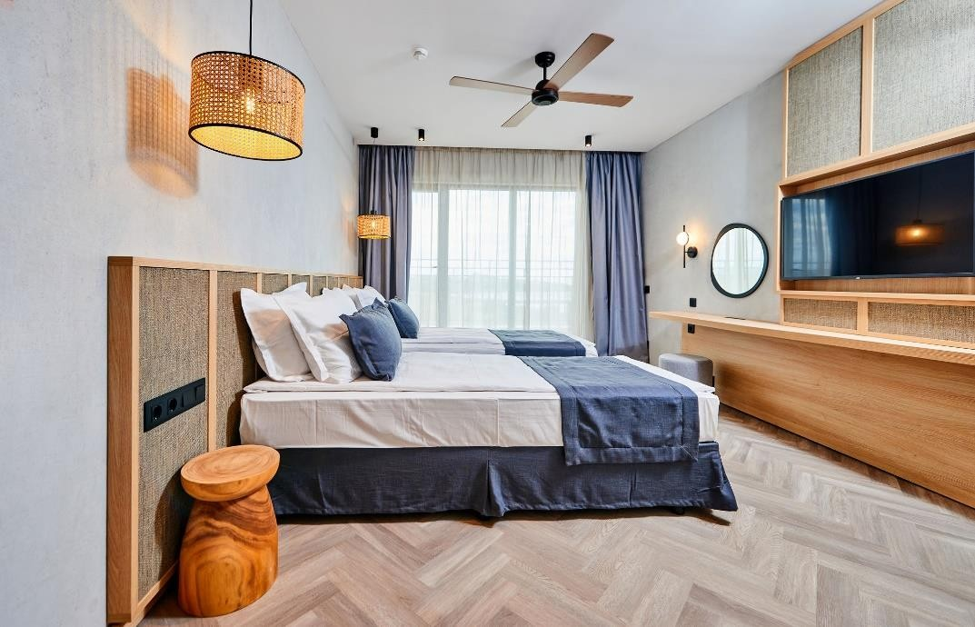
Double room with two single beds
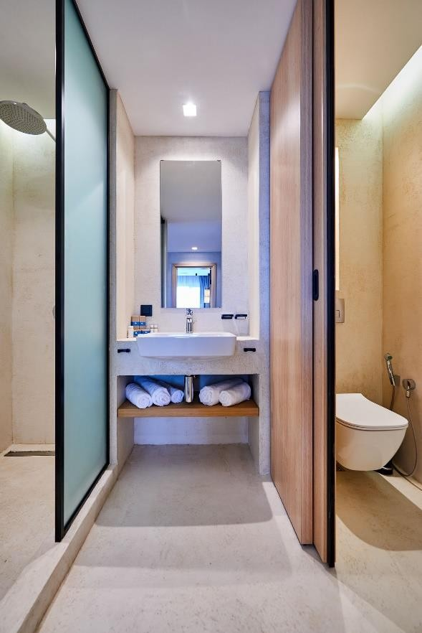

Double room with 1 bed for 2 pax

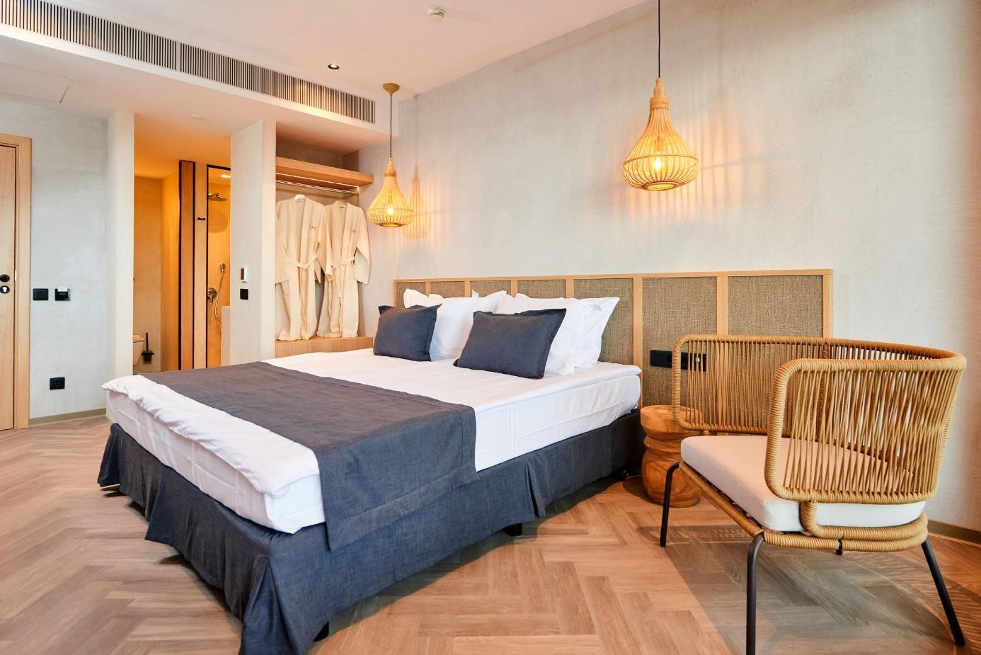

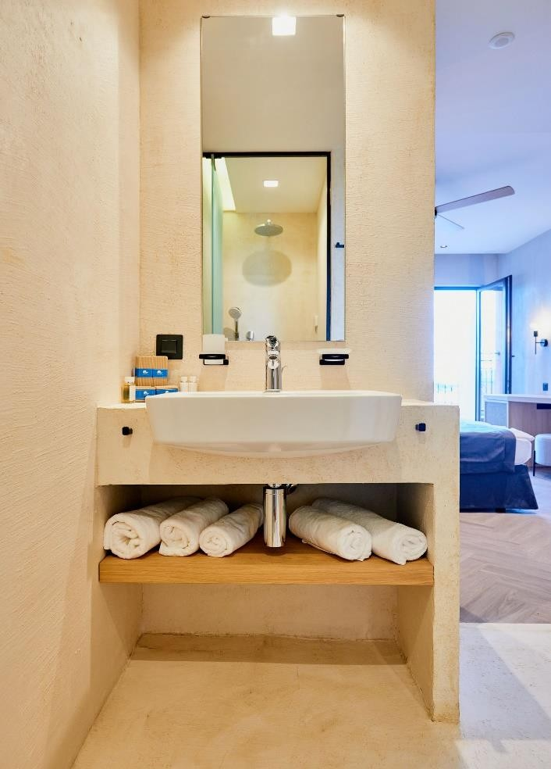
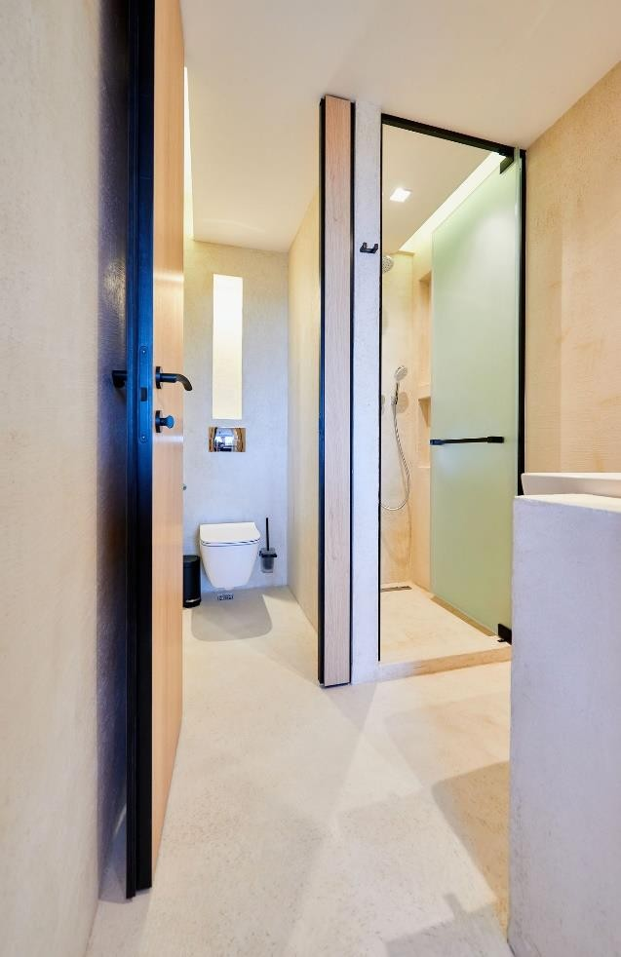

Studio

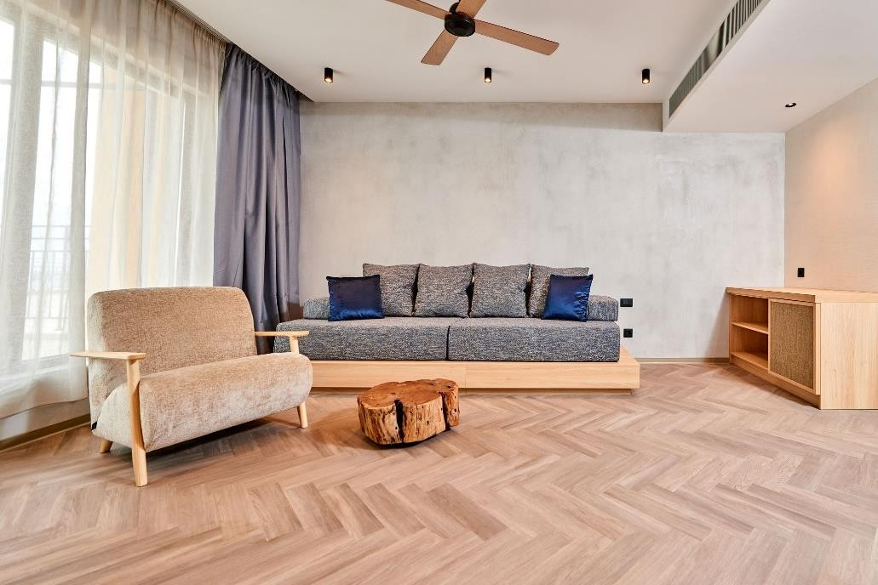
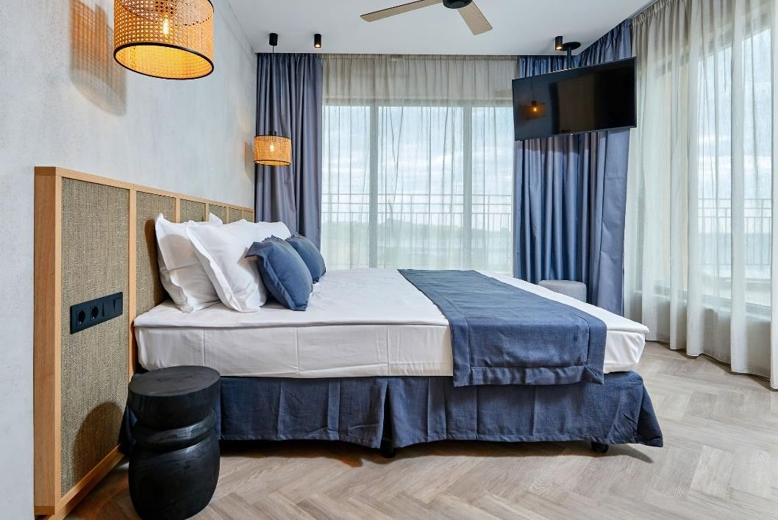
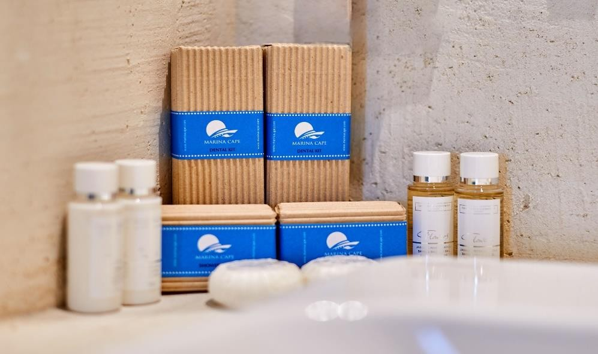

Apartment

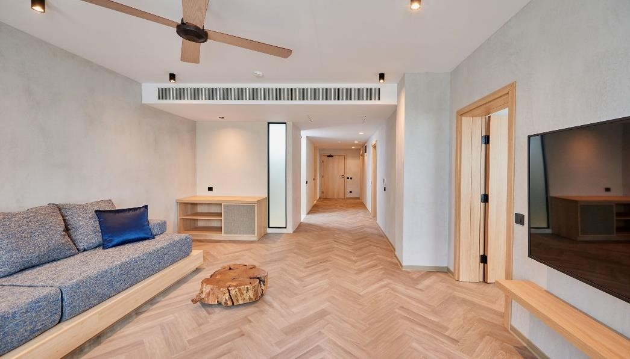
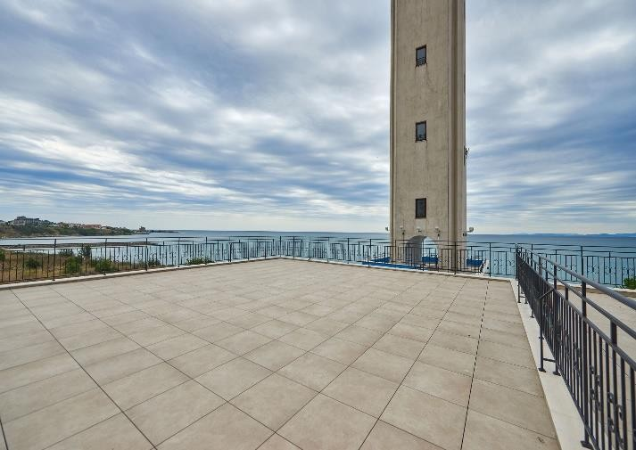
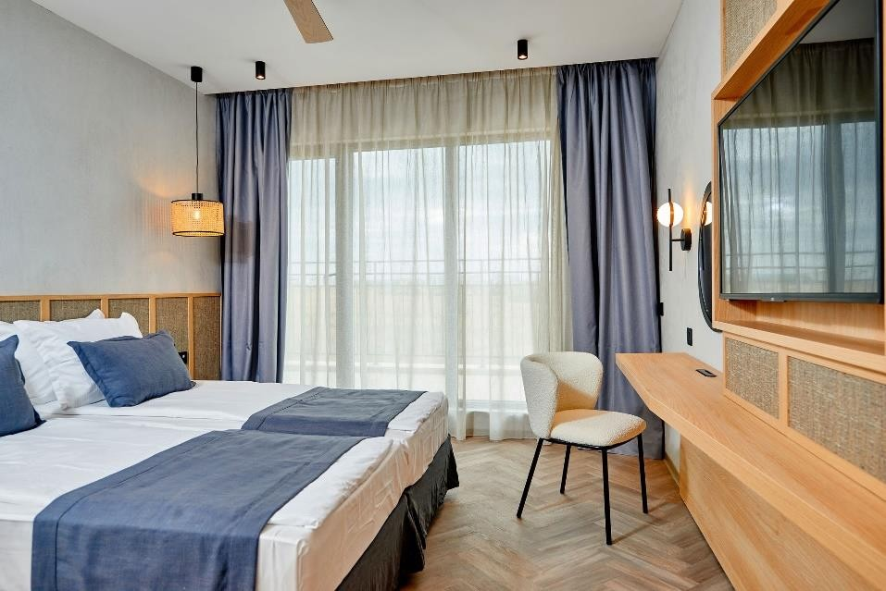
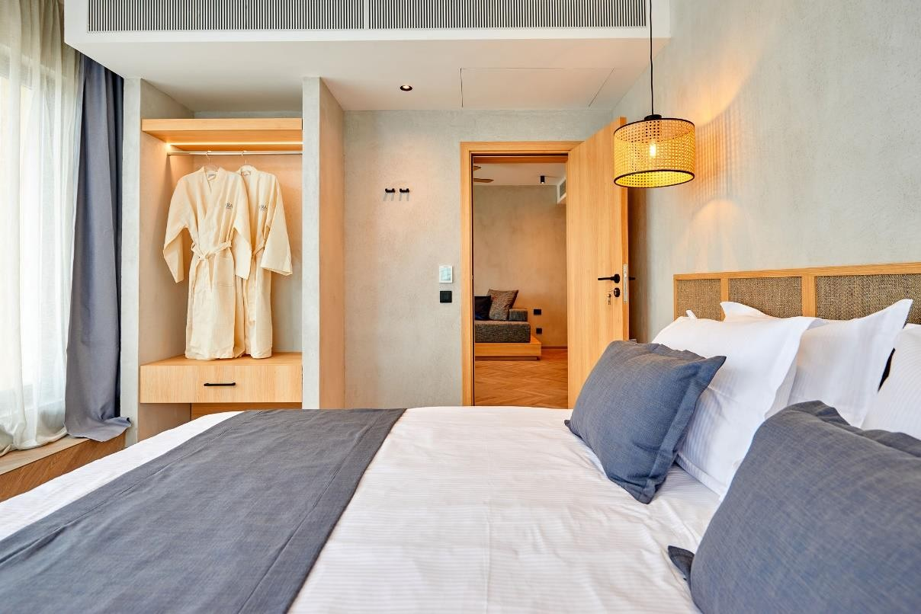

Family room

