White Rock Castle

ABOUT HOTEL
White Rock Castle — a unique suite hotel on the Bulgarian coast, with spacious rooms designed for both long stays and for a short week-end break. Great location, near the entrance to the Botanical Garden in Balchik, suitable to enjoy not only a beach vacation, but also to feel a part of the royal family of former Romanian Queen Maria, whose palace is located near the hotel.
All rooms White Rock Castle Suite Hotel are decorated in an elegant modern style. Every room is equipped with a flat screen TV, air conditioning system, working desk, personal safe, with Wi-Fi free of charge we also take care of slippers and a bathrobe in suite rooms.

Dogs under 10 kg are accepted with an extra supplement.

FAMILY HOLIDAY
Let the White Rock Castle be the center starting point of your exciting family holiday in Bulgaria.
Located in the seaside resort of Balchik and just 400 meters from the former Romanian Queen Maria’s Palace, otherwise known as “The Quiet Nest”, this summer palace and botanical garden, designed by Swiss gardener Jules Jany, can be visited year round and offers Europe’s 2nd largest collection of cacti behind Monaco.
Just 35 minutes by car to Varna, Bulgaria’s 3rd largest city and largest Black Sea city, one can visit the ruins of ancient Roman baths and harbor as well as walk along the Sea Gardens, visit the Aquarium or the 17th century metropolitan Dormition of the Theotokos Cathedral of the diocese of Varna and Veliki Preslav.
Kaliakra Point, a strategic fortress that was settled in the 4th century BC by a Thracian tribe known as the Tirizi and has remained a key stronghold ever since, is just 30 minutes by car and provides vistas up and down the Black Sea coast from Constanta to Burgas on a clear day, over 160km. A former monastery built under the Ottoman rule, this stone and cave fortress can still be visited today and will take you back centuries.
Local winery visits are some of the more modern activities one can include in a day visit just west of Varna, within a two hour drive from Balchik. With the European Union providing logistical and educational support, Bulgarian wine estates have begun producing some surprisingly good wines. Lunch in a vineyard is a fantastic opportunity not to be missed, along with picking up some native vintages.

SEASONAL OUTDOOR SWIMMING POOL
Acquire saving coolness on hot summer days at the outside open swimming pool of White Rock Castle, Suite Hotel. Relax in the sitting area with comfortable lounge chairs by the table, served on your taste, - it will complete the picture of your carefree vacation.
- Pool size: 25 meters in length, depth from 1.4 m to 2 m
- Separate children's section.
- The swimming pool is included in the room rate.
In our pool bar we are happy to serve you tasty & refreshing cocktails!
Choose the one you will enjoy the most from elegant banana with mint & ginger milkshake to our favorite strawberry mojito!
Hours: daily 10:00 – 18:00.

CHILDREN'S TOWN
White Rock Castle is a perfect place to spend a family holiday in Bulgaria. Beautiful nature, calm and cozy atmosphere, elegant interiors, high class service. Family holiday in Bulgaria will be unforgettable as you may find numerous options for outdoor activities! Select cheerful summer picnic on the sea or in the shade of bliss pool.
Kids'world is created here in a game space next to the pool and the game room: full of toys, bright colors and good mood of your child. White Rock Castle will give you and your family positive emotions and energy for the whole year.

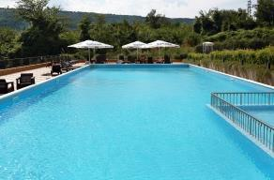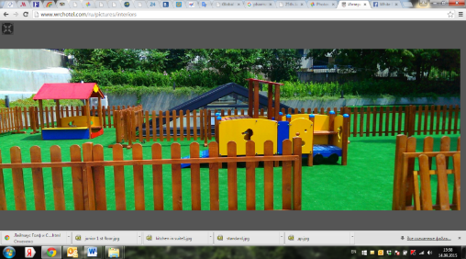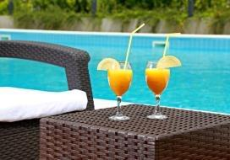

GARDEN HILL RESTAURANT
A new destination on the map of Bulgaria for lovers of juicy steaks and fish delicacies - this is Garden Hill Restaurant, with a sense of dignity, with its own character, predisposes to quiet lunch and dinners well as to business meetings, dates, family gatherings and birthdays. For establishing its reputation, a chef with international experience works hard, so attention is paid to every detail. By visiting the «Garden Hill Restaurant », you can choose any of your favorite dishes without worrying about how well they complement each other. This has already been taken care of by the chef, so your choices will be always harmonious, regardless of the selected dishes. A worthy complement to such exquisite dishes will be the drinks with a harmonious and rich flavor. Wines offered to your attention are the best addition to the unique dishes from the menu. Just a sip is enough to feel the sumptuous depth of flavor and the passion put in to every bottle.
Inside - 70 seats
Covered terrace - 50 seats
Open terrace - 40 seats

WEDDING. BIRTHDAY PARTY. EVENT SPACE.
Our banqueting team will make sure our guests get the best experience when celebrating a special event at White Rock Castle. You can choose from our panoramic roof top terrace with a sea view, private conference room or a cozy and elegant restaurant.

CONFERENCE ROOM
When you plan a business meeting in Balchik, White Rock Castle Suite Hotel will be the right option. With service delivered by caring professionals, your business meeting will turn into an event you won’t soon forget. Our conference room with natural daylight is located on the 1st floor and can accommodate up to 70 guests in the distribution type of theatre style. Also, there is a new conference hall by the pool for 100 people as a perfect space for meetings, trainings and presentations

CASTLE WELLNESS
It offers all the facilities for pure relaxation & rejuvenation: sauna, steam bath, adventure shower, relax zone, jacuzzi and professional fitness room.
Our experienced & certified therapist will create programs & treatments using the best products to match perfectly your individual needs. You can book a high quality massage with the best price in the region. We prepared an unforgettable rest for you.
Hours: depending on a season

FITNESS
The professionally equipped Fitness Room is a perfect place both for beginners and advanced sport lovers - work out actively and feel fulfilled with energy and a motion. Please feel free to contact our fitness instructor for any kind of assistance.
Hours: daily, 8:00 – 22:00

DESCRIPTION OF ROOMS

DOUBLE ROOM DBL no balconies

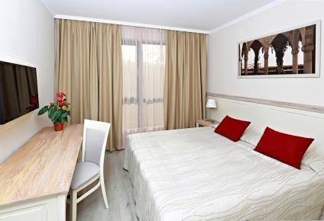
Standard rooms are cozy and bright, with classic interior. There are two twin beds or one double bed, made with excellent quality linens for your comfortable stay.
The hotel has 19 Standard rooms with size range from 16 to 20 sq. m.

Room facilities:
- 2 single regular beds (no extra bed) or 1 double bed
- air conditioning
- cable TV
- safe deposit box (free of charge)
- telephone
- mini fridge
- bathroom with a shower
- hair dryer
- no balcony
- floor coverage – laminated parquet
- room tidying up – daily
- bed-clothes change – every 3d day
- towels change – every day

STUDIO WITH KITCHEN STU 1st floor only
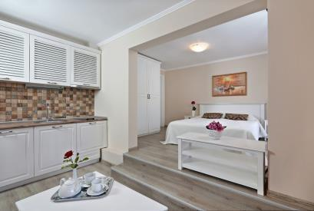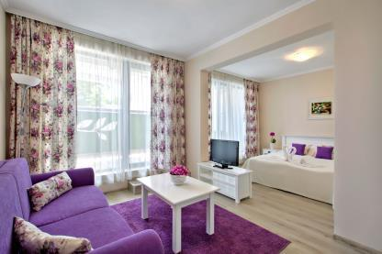
All rooms have a hallway, sleeping area, bathroom and guest toilet. There are two twin beds or one double bed in the sleeping area. In each room you will find: a kitchenette, extendable sofa and chairs. At the open balconies you can relax on the chairs made of rattan.
Room size - 30 sq.m

All rooms are equipped with:
- at first floor (no view)
- air conditioning
- cable TV
- safe deposit box (free of charge)
- telephone
- mini fridge
- kitchenette (electric kettle)
- bathroom with a bath
- hair dryer
- balcony
- floor coverage – laminated parquet
- room tidying up – daily
- bed-clothes change – every 3d day
- towels change – every day

JUNIOR SUITE JSU
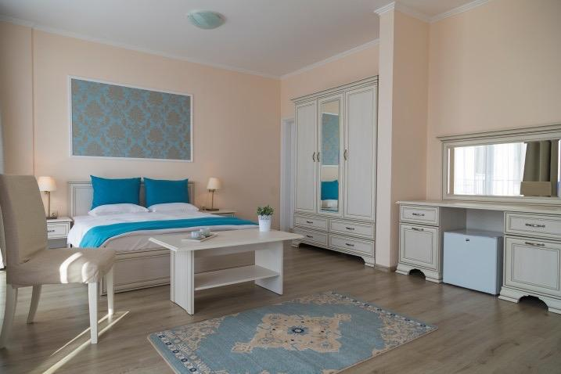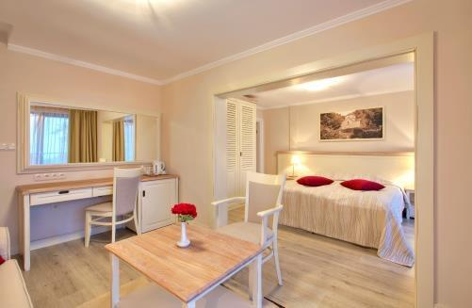

Junior Suites are spacious and bright, with classic interior.
All rooms have a hallway, sleeping area, bathroom and guest toilet. There is one double bed in the sleeping area. In each room you will find: a comfortable work desk, extendable sofa and chairs. Large windows offer panoramic views of the pool. At the open balconies you can relax on the chairs made of rattan.
Room size - 37 sq.m

All rooms are equipped with:

- air conditioning
• cable TV
• safe deposit box (free of charge)
• telephone
• mini fridge
- bathroom with a bath
- hair dryer
• balcony
• floor coverage – laminated parquet
• room tidying up – daily
• bed-clothes change – every 3d day
• towels change – every day

JUNIOR SUITE Sea View JS SEA
Junior Suites are spacious and bright, with classic interior.
All rooms have a hallway, sleeping area, bathroom and guest toilet. There is one double or twin bed in the sleeping area. In each room you will find: a comfortable work desk, extendable sofa and chairs. Large windows offer panoramic views of the sea. At the open balconies you can relax on the chairs made of rattan.
Room size - 37 sq.m

All rooms are equipped with:

- air conditioning
• cable TV
• safe deposit box (free of charge)
• telephone
• mini fridge
- bathroom with a bath
- hair dryer
• balcony
• floor coverage – laminated parquet
• room tidying up – daily
• bed-clothes change – every 3d day
• towels change – every day
- sea view

1 BEDROOM APARTMENT SUI
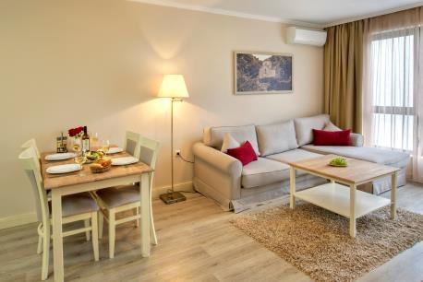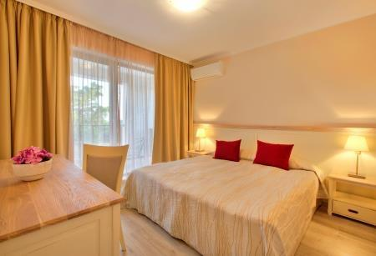

Suite consists of two rooms, so it is ideal for a family of 3-4 people.
In all rooms you will be met with entrance hall leading to working area, living room with kitchenette, bathroom and balcony. Double bed is awaiting for you in the bedroom. Upholstered furniture in the living room - sofa and chairs - allows you to organize an extra bed. Open balconies are equipped with rattan chairs and a table, which can be served at your request. Room size varies from 43 to 47 sq.m.

All rooms are equipped with:

- living room and one bedroom (interconnecting door)
- air conditioning
- cable TV
- safe deposit box (free of charge)
- telephone
- mini fridge
- kitchenette: pot, forks, spoons, knifes, plates, glasses, tea cups, kettle, oven, hot plate, microwave
- bathroom with a shower
- hair dryer
- balcony
- floor coverage – laminated parquet
- room tidying up – daily
- bed-clothes change – every 3d day
- towels change – every day

1 BEDROOM SEAVIEW APARTMENT SUI-SEA
Suite consists of two rooms, so it is ideal for a family of 3-4 people.
In all rooms you will be met with entrance hall leading to working area, living room with kitchenette, bathroom and balcony. Double bed is awaiting for you in the bedroom. Upholstered furniture in the living room - sofa and chairs - allows you to organize an extra bed. Suites overlook the sea. Open balconies are equipped with rattan chairs and a table, which can be served at your request. Room size varies from 43 to 47 sq.m.

All rooms are equipped with:

- living room and one bedroom (interconnecting door)
- air conditioning
- cable TV
- safe deposit box (free of charge)
- telephone
- mini fridge
- bathroom with a shower
- hair dryer
- balcony
- floor coverage – laminated parquet
- room tidying up – daily
- bed-clothes change – every 3d day
- towels change – every day

only some with kitchenette & dining table:
- equipment of the kitchenette: pot, forks, spoons, knifes, plates, glasses, tea cups, kettle
- microwave
- dining table
+
- tea station
- sea view

SEAVIEW QUEEN ROOM QR
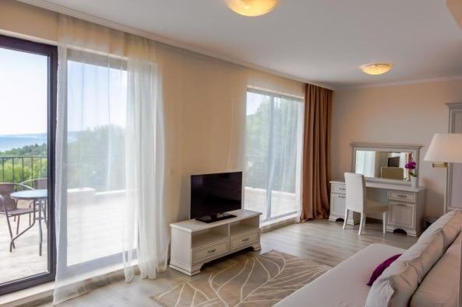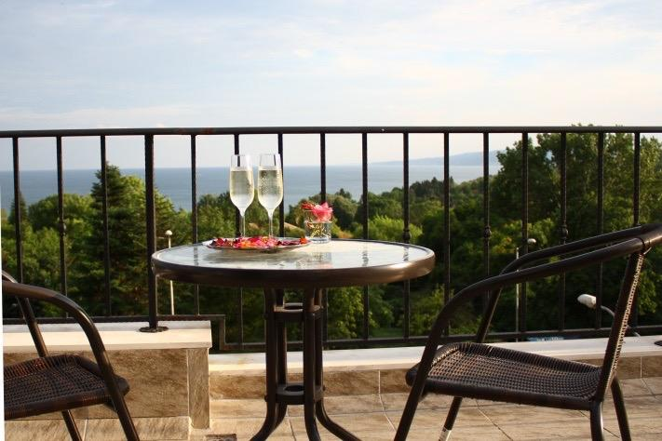
Queen room consists of 1 spacious room, so it is ideal for a honeymooners or couples on romantic escape.

Double bed is awaiting for you in the bedroom. Upholstered furniture allows to organize an extra bed. Even from your bed can observe the Black Sea and the trees of Balchik Botanical Garden, where the Palace of Queen Maria is.

Open large terrace with a sea view is equipped with rattan chairs and a table, which can be served at your request. Room size varies from 43 to 47 sq.m.

All rooms are equipped with:
- air conditioning
- cable TV
- safe deposit box (free of charge)
- telephone
- mini fridge
- tea station
- bathroom with a shower
- hair dryer
- balcony
- floor coverage – laminated parquet
- room tidying up – daily
- bed-clothes change – every 3d day
- towels change – every day
- large terrace with sea view

2 BEDROOM APARTMENT ES

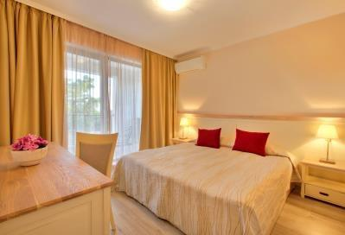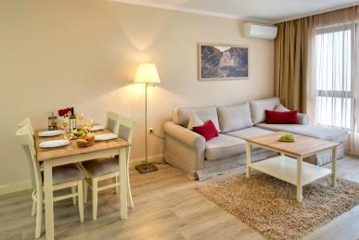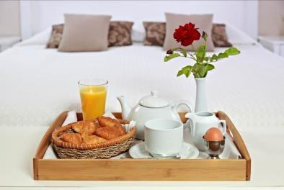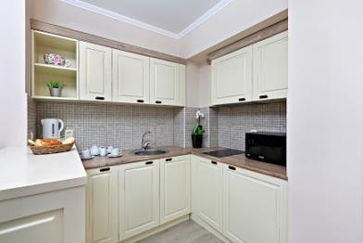

Executive Suites with cozy home interior are ideal for long stay guests.
Rooms are suitable for a family of 3-5 people. Executive Suite starts with entrance hall, and then you will find living room, two bedrooms, and kitchen with all necessary equipment, bathroom and two exits to the balcony. Double beds are in the bedrooms. Nice furniture in the living room - chairs and sofa – allows arranging an extra bed.

Some Executive Suites offer sea view. Room size varies from 62 to 69 sq.m.

Executive Suite facilities:
- living room and two bedrooms
- air conditioning
- cable TV
- safe deposit box (free of charge)
- telephone
- mini fridge
- kitchenette: pot, forks, spoons, knifes, plates, glasses, tea cups, kettle, oven, hot plate, microwave
- two bathrooms with a shower
- hair dryer
- balcony
- floor coverage – laminated parquet
- room tidying up – daily
- bed-clothes change – every 3d day
- towels change – every day

WEDDING ROOM WD
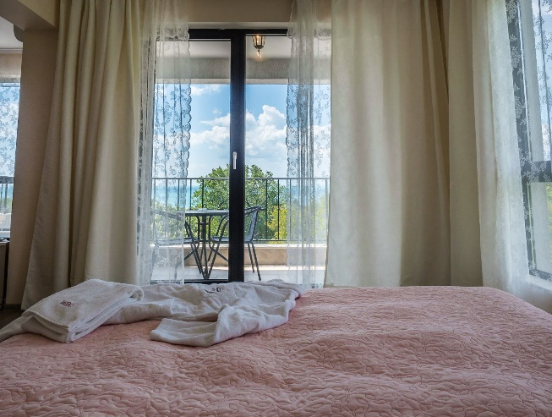
Wedding room consists of 1 spacious room, so it is ideal for a honeymooners or couples on romantic escape. Double bed is awaiting for you in the bedroom. Upholstered furniture allows to organize an extra bed. The room overlook the sea and the trees of Balchik Botanical Garden. Open balconies are equipped with rattan chairs and a table, which can be served at your request. Room size varies from 43 to 47 sq.m.

All rooms are equipped with:
- living room
- air conditioning
- cable TV
- safe deposit box (free of charge)
- telephone
- mini fridge
- tea station
- bathroom with a shower
- hair dryer
- balcony
- floor coverage – laminated parquet
- room tidying up – daily
- bed-clothes change – every 3d day
- towels change – every day
- sea view
Room types amount

19 – Standard Double Rooms
12 – Studio
12 – Junior Suite
18 – Junior Suite Sea View
10 – One-bedroom Suite / apartments
5 - One-bedroom Suite Sea View / apartments
5 – Queen Room Sea View
1 - Wedding room Sea View
2 - Royal (on request)
9 - Superion (on request)

Connecting room: One-bedroom Suite + Double Room =
15 – Two-bedroom & living room apartments / Executive suite (can be Sea View)

White Rock Castle Suite & SPA is the best choice for couples, friends, families, travelers, artists, business people & explores.
Located next to Balchik Botanical Garden and to the former
Romanian Queen Maria’s Palace
WELCOMING. RELAXING. CAPTIVATING.
22, Akad.Daki Jordanov Str., 9600, Balchik, Bulgaria
GPS: 43.408086, 28.148760

DISTANCE TO ATTRACTIONS
Swimming Pool 25 m – in house (June - September)
SPA area – in house
Botanical Garden, protected by UNESCO – 200 m
Mud-curing field “Tuzlata” – 6 km
Bowling – 50 m
Billiard & Snooker – 500 m
Target and Skeet Shooting range – 5 km
3 Golf Courses– within 9 km
Queens Winery – 200 m
Tennis Court – 300 m
Soccer/Fussball field – 1 km
Balchik Harbor Boat rental – 500 m
Diving – 500 m
Fishing – 500 m

