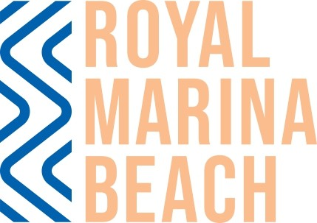
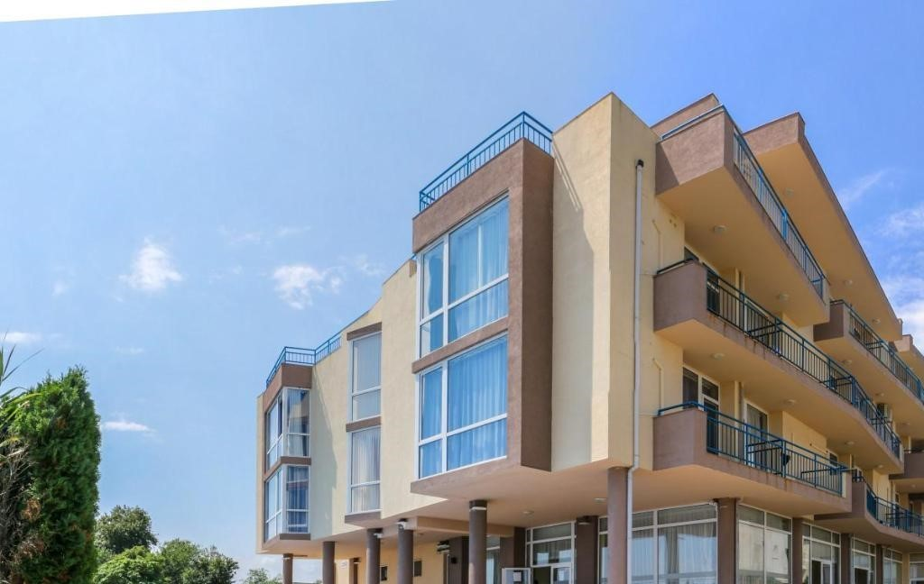
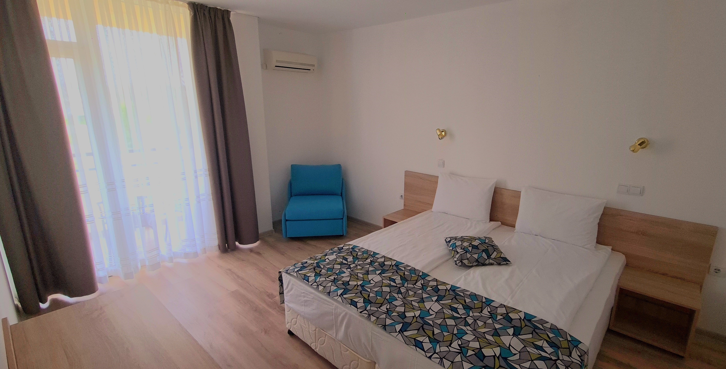

Royal Marina Beach Aparthotel, Chernomorets
Season Summer 2024

Location

The hotel is located in the Akladi area at the very beginning of the town of Chernomorets, on the first line of one of the most popular beaches on the Southern Black Sea coast - Gradina. The distance to Sozopol is only 6 km, and to Burgas airport – 37 km. Its spacious and well-appointed rooms, together with its incredible location just steps from the golden sands and the relaxing sound of the waves, provide a wonderful opportunity for a fulfilling summer holiday, whether individual, romantic or family.

Hotel amenities and services

Aparthotel Royal Marina Beach offers accommodation in 88 rooms, studios and apartments spread over 4 floors.

A cozy restaurant is available to all tourists for breakfast and dinner (buffet or menu, depending on the number of tourists), offering a lunch menu as well. Guests can enjoy a variety of drinks in the cozy lobby bar.

In addition to the sea, which is a few meters from the building, the hotel provides conditions for coolness through its outdoor pool with umbrellas and sunbeds. There is also a shallow part for the little ones, and at the same time they can have fun safely on the playground next to the pool.

Also available are:

- 24-hour reception,
- Free wireless internet throughout the hotel
- Paid parking with 50 places (5 BGN per day).
- Restaurant with a capacity of 80 seats indoors
- Garden to the restaurant with 48 seats
- Lobby bar
- Outdoor pool with children's section
- Umbrellas and sunbeds by the pool
- Playground
- Daily cleaning
- Elevator
- Change of towels and bed linen - every 3 days.

www.royalmarinabeach.com

The hotel has a total of 88 rooms - 47 double rooms, some with sea view, 6 triple rooms, 29 studios and 6 apartments with sea view.

Economy Double Room - Unrenovated low floor double room with 2 single/1 double bed,
which, if necessary, can be loaded with an extendable chair for 1 child. The furniture includes
a wardrobe, TV with cable TV, wireless internet and air conditioning. There is also a balcony with a table and chairs and a private bathroom with a shower. Size 25-32 sq.m.
Maximum capacity 2+1.

Luxury Double Room - Renovated room on a high floor with completely new furnishings, including a double bed, an extensible arm chair for a child, a wardrobe, cable TV, wireless internet and air conditioning. There is also a private bathroom with a shower, as well as a balcony with a table and chairs. Size ~ 32 sq.m. Maximum capacity 2+1.

Luxury double room with side sea view - renovated and very sunny room on a high floor with a wonderful side view of the sea. The furniture is brand new and includes a dbl bed,extendable chair for a child, wardrobe, cable TV, wireless internet and air conditioning. There is also a stylish en suite bathroom with a shower, as well as a balcony with a table and chairs.Size ~ 32 sq.m. Maximum capacity 2+1.

Economy Triple room – non – renovated, but comfortable room for accommodation of three people on three separate beds. It is furnished with a wardrobe, cable TV and air conditioning. Wireless internet and a balcony with a table and chairs are among the other amenities. The room has a private bathroom with a shower. Its size is 33 sq.m. Maximum capacity 3+0

Studio is a spacious room with 2 single/1 double bed, an extensible arm chair for a child and a kitchenette, which makes the studio extremely suitable for long stays. The equipment of the kitchenette includes a hot plate, a microwave, a refrigerator, a kettle for hot water and enough utensils for 3 pax. A dining area, a wardrobe, cable TV and air conditioning complete the furnishings, and wireless internet, a balcony and a private bathroom with a shower are also available. Size ~ 33 sq.m. The maximum capacity is 2+1.

Apartment with side sea view – renovated, on a high floor, consisting of a bedroom for 2 pax, a living room with a sofa bed for two, air conditioning, a wardrobe, a TV, 2 private bathrooms with shower, a balcony with a side sea view with access from both rooms, furnished with a table and chairs. Size 65 sq.m.
The maximum capacity is 2+2.

Premium Double Room with Sea View - luxuriously furnished room on a high floor with a dbl bed for
two people and an extensible arm chair for a child. The furniture consists of a large TV, air conditioning, a wardrobe and a small refrigerator. Wireless internet is available and private bathroom with shower. Thanks to a French window, guests can enjoy the unique frontal sea view or to relax on the cozy balcony with a table, chairs and a side sea view. Size 32 sq.m. Maximum capacity 2+1.

Premium apartment with sea view - a luxury high-floor apartment consisting of a high-class furniture: a bedroom for two, a wardrobe, a living room with a large TV, a sofa bed for two and kitchenette, equipped with hot plates, microwave, refrigerator, kettle for hot water and enough utensils for four. The comfort in each room is provided by 1 air conditioner and 1 private bathroom with shower, as well as 2 balconies - the smaller one has a side sea view, and the large one has a frontal sea view. In some apartments the balcony is furnished with an umbrella and 2 deckchairs.
Size 65-100 sq.m. Maximum capacity 2+2.
.
In the premises

• Flat screen TV
• Cable television
• Wireless Internet
• Extendable armchair (without triple rooms and apartments)
• Extendable sofa (in apartments)
• Kitchenette (in studios and Premium apartments)
• Private bathroom
• Hairdryer
• Balcony with table and chairs
• Individual air conditioning
• Toiletries

www.royalmarinabeach.com

