
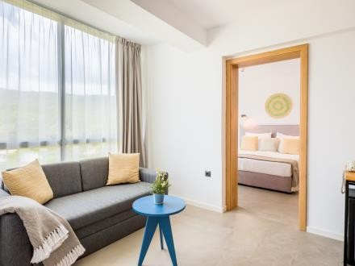

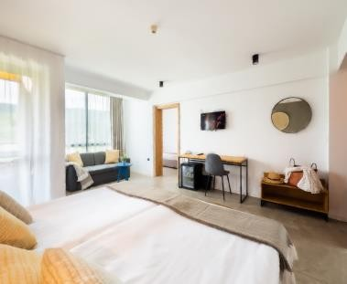
EXCELSIOR ****
Description for summer 2024
DESCRIPTION

- Category – 4 stars

Location

Excelsior is a 4 star hotel fully renovated for the 2021 season, located in the central part of Golden Sands resort, on the main promenade and only 300 m away from the center and the beach. Surrounded by greenery and with a wonderful view of the sea, it offers comfort and a cozy atmosphere for its guests, A wonderful choice for families with children for whom entertainment and surprises are offered, and with a perfect location for all tourists , who are looking for peace and quiet for their holidays in a friendly environment. Close to the hotel are shops, entertainment venues, a bank and a bus stop, For its guests the hotel offers a free shuttle service to the beach.

Description

The hotel has 200 rooms, some of them with sea view.

The fully renovated hotel has:
- 12 x APP one-bedroom apartments
- 126 x DBL double rooms park or sea view
- 42 x Double DBLS rooms
- 10 x Double Deluxe sea view
- Single rooms
- Economy rooms

  - One Bedroom Suite/ 36 -42 m2 - two separate rooms separated by a door and have:
    - 1 x Bedroom with double bed
    - 1 x Bedroom with twin beds and sofa bed or armchair
    - Individual air conditioning
    - 32" LCD TV
    - Satellite TV
    - Telephone
    - Mini fridge
    - Bathroom with shower, hairdryer and toiletries
    - Separate toilet with sink
    - Balcony

    - Hot water jug with first fill of tea and coffee upon arrival

  - Double room / 20- 24 m2 - Spacious, renovated and stylishly furnished has:
- 2 twin beds with the possibility to combine
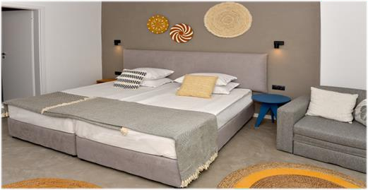
  - Additional bed – extendable armchair
  - Individual air conditioning
  - 24" LCD TV
  - Satellite TV
  - Telephone
  - Bathroom with shower and toiletries
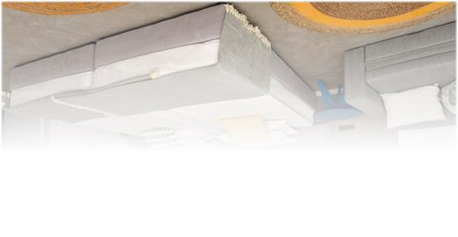
  - Mini fridge
  - Balcony

  - Double Extended Room/ 24-28 m2 - stylishly furnished as the standard double rooms, but has 2 extra beds - sofa bed and has:
    - Two single beds with the possibility to combine
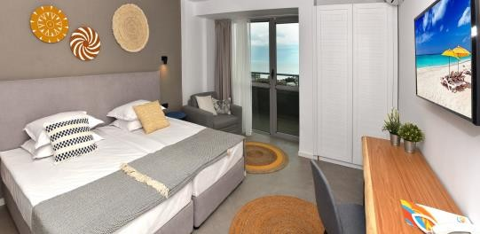
    - Individual air conditioning
    - Satellite TV
    - 24-inch LCD TV
    - Telephone
    - Bathroom with shower and toiletries
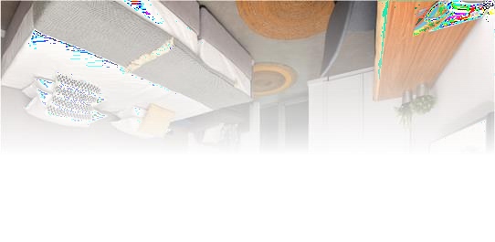
    - Mini fridge
    - 2 extra extendable armchairs
    - Balcony

  - Single rooms / 11-15 sq.m.- stylishly furnished like the standard double rooms and have:
    - Bedroom size 160/190
    - Individual air conditioning
    - Satellite TV
    - 24-inch LCD TV
    - Telephone
    - Bathroom with shower and toiletries
    - Mini fridge
    - Balcony

  - Double Deluxe Room/ 30 -32 m2 - the newest rooms in the hotel located on the 7th floor with designer furniture and have 2 extra beds - sofa bed and sea view. Features:
    - Two single beds with the possibility to combine
    - Individual Air Conditioning

    - Satellite TV
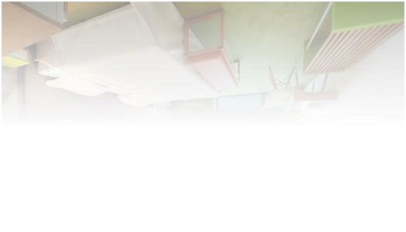
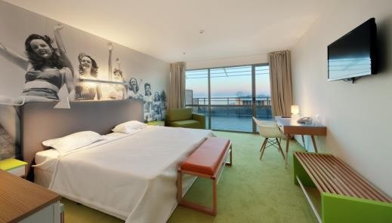
    - 32-inch LCD TV
    - Telephone
    - Bathroom with bath and shower and toiletries
    - Mini fridge
    - 2 extra extendable armchairs
    - Balcony
    - Hot water jug and first refill on arrival with tea and coffee
    - Sea view

  - Economy rooms / 10-15 sq.m.- stylishly furnished like the standard double rooms and have:
    - Double Bed size 160/190
    - Individual air conditioning
    - Satellite TV
    - 24-inch LCD TV
    - Telephone
    - Bathroom with shower and toiletries
    - Mini fridge
    - NO Balcony

All Inclusive concept

- Bars and restaurants
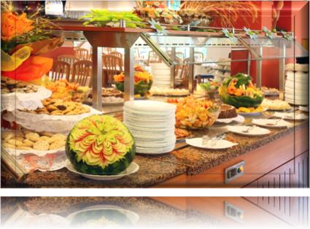
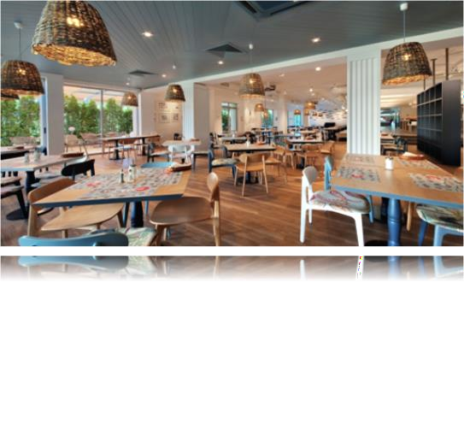
The following are available to hotel guests:
    - Fully renovated All Inclusive restaurant with 240 seats
    - Lobby bar
    - Pool bar

- Swimming pools

https://hotel-excelsior.net

    - Two swimming pools - for adults and a separate small pool for children, swimming section


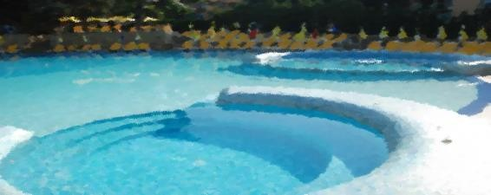
    - Jacuzzi by the pool
    - Sun loungers, parasols and towels - free to use

- Children's entertainment centre

The Excelsior Hotel is honoured to offer its youngest guests play and entertainment. It has:
    - Kids club for children from 4 to 12 years
    - Children's playground /fully renovated for season 2024 /
    - Children's buffet for lunch and dinner for children over 3y.o.

- Services
    - Free:
      - 24-hour reception and "Guest Relation" staff
      - Swimming pool for adults and children
      - Jacuzzi by the pools
      - All Inclusive restaurant
      - Pool bar
      - Lobby bar
      - Kids club and play area
      - Animation with day and evening program 6 days in the week
      - Wireless internet throughout the hotel
      - Baby cot (on prior request)
      - Luggage room

With extra charge:

      - Mini bar on request
      - Arrangement of transfer from airport to hotel and back
      - Excursions
      - Currency exchange
      - Taxi service, etc.
      - Parking near the hotel and subject to availability

- Location
Hotel Excelsior is located in a central and convenient location in the most beautiful resort on the northern Bulgarian Black Sea coast - Golden Sands, 300 m from the beach.
Golden Sands resort complex is easily accessible from Varna city: airport, railway station, bus station, marina.
- Airport - 25 km from Golden Sands.
- Varna - 17 km from Golden Sands.

- Contact
Hotel Excelsior, resort. Golden Sands, 9007 Varna, Bulgaria
Reception +359 52 357 114
Fax +359 52 355 255
Reservations & Sales +359 894 302 328 reservations@hotel-excelsior.net reservations.excelsior@gmail,com
GPS координати :
43.28658° N, 28.03969° E

H O T E L E X C E L S I O R - 4*
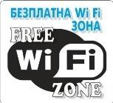 DESCRIPTION “ ALL INCLUSIVE” PACKAGE from 10.00 to 22.30
www.hotel-excelsior.net

ACCOMMODATION:

- Fully renovated for the 2021 season, the hotel is located in the central quiet part of the Golden Sands resort, on the main promenade and only 300m away from the centre of the complex and the beach. Surrounded by greenery and with a wonderful view of the sea , the hotel offers comfort and cosy atmosphere. A wonderful choice for families with children and for all those looking for peace and quiet for their holidays in a friendly environment.
- 200 comfort and cosy , single, double standard rooms with balcony /24 sq.m./ and apartments /42 sq.m./, part of them with a sea view, suitable for accommodation of families with 2 to 4 members .

Check-in after 14.30, check-out until 11.30. On the day of arrival guests start with an afternoon snack
- Mini bar - on request, for a fee MEALS: MAIN RESTAURANT
- BREAKFAST - 7.30am - 10.00am buffet breakfast, wide variety of pastries, croissants, assortment of jams and Bulgarian honey, cheeses, cold and hot sausages. For the perfect start of the day we offer a wide assortment of hot drinks: instant coffee, cocoa, cappuccino, espresso, tea, post mix juice, table water

- INTERMEDIATE STORAGE - 11.00 - 17.00. FAST FOOD, pizza or hot dog, fries, waffles, ice cream / from 12.00 to 16.00 o`clock /

- LUNCH - 12.30pm - 2.30pm buffet - international cuisine , including an assortment of fresh salads and appetizers, soups, fish, pasta, various types of meats, prepared including in front of you. Vegetarian dishes , fresh fruit, desserts are also available. Drinks with lunch - soft drinks, beer , wines on tap and hot drinks .

Children buffet for children over 3 y.o.

- DINNER - 18.00h. - 21.00h. buffet . Combines the tastes of European and world cuisines with an offer of an extensive salad bar , show cooking , barbecue , two themed dinners per week including vegetarian dishes . A wide range of desserts , fresh fruit. Drinks with dinner: soft drinks, wines on tap , beer and hot drinks

Children buffet for children over 3 y.o.

Takeaway food from the restaurant during breakfast, lunch and dinner is charged at on- site prices!
Bars: 10.00 am. - 10.30 p.m. - LOBBY BAR AND BASE BAR - ALL ICLUSIVE DRINKS

- Tea, instant coffee, espresso coffee, cocoa from vending machine, table water, non- carbonated and carbonated drinks from post-mix machine
- BULGARIAN ALCOHOLIC DRINKS - beer on tap, wine on tap/white, rosé, red, mastic, brandy, vodka, gin, rum, whisky, brandy, mint, summer cocktails

Dining water 24 hours at the lobby bar!
No alcoholic beverages served to persons under 18! Imported drinks are available for a fee!

SWIMMING POOL - Hotel Excelsior has 2 swimming pools –

- one for adults / depth from 22 to 160 cm / and
- a separate small pool for children / depth 55 cm / ,
- Jacuzzi at the pool
Free use of sun loungers, umbrellas and towels/ while stocks last/ pool towels are available with no deposit or payment. Towels left on sun loungers for more than 1 hour will be removed by a member of staff.
The pool is guarded by a lifeguard from 9.00 to 18.00.

Please follow the instructions for using the pool!

ENTERTAINMENT, SPORT AND ANIMATION - 6 day program for children and adults

- Kids club for children from 4 to 12 years, children's playground, mini disco 6 days in the week starting at 20.30
- SPORTS ANIMATION -Water gymnastics, water ball, stretching, aerobics, darts, table tennis, Zumba,pilates , quiet games
- Evening show - 5 times a week

OTHER SERVICES INCLUDED IN THE "ALL INCLUSIVE" PROGRAMME

- Free Wi - Fi access throughout the hotel
- Shuttle bus, scheduled shuttle service to/from the hotel to/from the beach schedule around starting at 9 o`clock till 16 o`clock

- 24-hour reception, baby cot on request, luggage room,
- Children's corner and high chairs in the restaurant

PAID SERVICES
- Parking / subject to availability /
- Late room check-out available
- Safe deposit box and mini bar available on request
- Pet fee /30 BGN / subject to internal rules .
- Rent-a-car and excursions
- Medical service - on call
- Taxi services and transfer arrangements

We wish you a pleasant holiday!

