Umani Hotel & Beach 4*, Golden Sands, 2024

HOTEL POLICIES
Check-in time | After 14:00 on the day of arrival.
Check-out time | 12:00 upon day of departure.
Smoking | Smoking is not allowed.
Pets | No pets allowed

HOTEL DETAILS
Number of rooms | 52 rooms & suites
Star rating (official) | 4*
Number of floors | 5 + underground level
Elevators | 2 within the hotel, 1 at the outdoor parking
Pool | Seasonal outdoor pool, not heated, sunbeds & umbrellas, free of charge for hotel guests. Dimensions 10.5 x  3.3 m.; depth of main section: 1.5 m; shallow section for kids with dimensions 2 x 3.3 m, depth is 0.6 m. Please note that the shallow section is not fenced, thus supervision from adults is required at all times.
Parking | Outdoor and underground parking options available, free of charge for hotel guests with limited spaces (upon availability at time of arrival); additional free option for parking on the street in front of the hotel;
Internet | Free Wi-Fi available in the rooms and public areas
Restaurant | Sea Salt Restaurant: the main restaurant, with indoor and open-air seating, located at lobby level, offers international cuisine. Serves breakfast, lunch and dinner, and a class selection of wines, beer and spirits.
Bars | The Concept Lobby Bar, Pool Menu available
Room Service | Available
For Kids | Please note that the hotel may not be the best choice for families with babies or toddlers due to the landscape and denivelation of the area. The beach is accessible via a trail with stairs, with no ramp for strollers. The hotel yard is on a hill, with the outdoor pool accessible via stairs or with the lift through the underground parking.
Accessibility | The hotel offers an accessible guest room, however the property and the nearby Umani Beach are not suitable for wheelchair and stroller access.
Beach | Umani Beach is located 280 m away and offers free sunbeds and umbrellas to Hotel Umani guests (1 umbrella per room and 1 sunbed per person included in the rate). Access to the beach is via a path with 50- m stairs, thus not suitable for wheelchairs, strollers and physically challenged persons.

Umani Hotel & Beach is located in a quiet area of the South part of Golden Sands resort, Bulgaria, where the guests can enjoy both the lively spirit of the resort, and the tranquility of the surrounding trees and sea. Inspired by nature, Hotel Umani is designed for the ultimate comfort and relax. The name ‘Umani’ means ‘humans’ in Italian, and was precisely selected among all options as the unity of our concept is devised entirely around the guest experience.

Open in 2022, the 4* hotel offers 52 elegant rooms and suites with relaxed and natural ambiance, and captivating design. The sea view rooms reveal a fantastic panorama. The contemporary and inspiring architectural design was immediately recognized and the project received seven awards, among which is Building of the year Bulgaria 2022 in category Holiday and Spa Hotels.

All rooms offer free Wi-Fi, a Nespresso machine, minibar, flat screen TV, air conditioning, safe box, and a balcony (courtyard for the Double rooms Ground Floor). Our guests are welcome to enjoy free of charge sunbeds and umbrellas at Umani Beach, an outdoor seasonal unheated pool (10.5 x 3.3 m, max depth 1.5 m), and free parking (upon availability at time of arrival).
Treat yourself to a culinary journey with our selection of local, Mediterranean and international dishes, hand-picked fish and seafood meals, wines, craft beers and more. The hotel features one restaurant in the hotel, a concept lobby bar, and a selected pool menu for the outdoor pool.

ROOM DETAILS

DOUBLE ROOM – SEA VIEW
Beautifully appointed spacious boutique rooms offering various designs, for up to 4 guests, and a stunning Sea view. Ideal for both couples and families, the rooms offer a king size bed (1.80 x 2.00 m), with some rooms featuring an extendable double sofa (1.40 x 1.90 m). All rooms have a spacious balcony, free Wi-Fi, a flat screen TV, a safe deposit box and a minibar. The bathroom is equipped with a shower, a toilet and a hair dryer. For your fresh mornings, a Nespresso coffee machine is available.

DOUBLE ROOM – POOL SIDE
Modern and spacious boutique rooms offering a variety of designs, for up to 4 guests (2 adults and 2 children up to 11 years). The rooms are at the sea side of the hotel, located above the outdoor pool, and on the first floors of Hotel Umani.
Ideal for both couples and families, the rooms offer a king size bed (1.80 x 2.00 m), with some rooms featuring an extendable double sofa (1.40 x 1.90 m). All rooms have a spacious balcony, free Wi-Fi, a flat screen TV, a safe deposit box and a minibar. The bathroom is equipped with a shower, a toilet and a hair dryer. For your fresh mornings, a Nespresso coffee machine is available.

DOUBLE ROOM – PARK VIEW
Enjoy a cozy Park view room, offering a king size bed (1.80 x 2.00 m), free WiFi, a flat screen TV, a safe deposit box, a minibar and a balcony. Maximum occupancy is 2 adults. The bathroom is equipped with a shower, toilet and a hair dryer. For your fresh mornings, a Nespresso coffee machine is available.

NEW: DOUBLE ROOM GROUND FLOOR – INLAND VIEW
Enjoy a cozy Park view room, offering a king size bed (1.80 x 2.00 m), free Wi-Fi, a flat screen TV, a safe deposit box, a minibar and a courtyard. Maximum occupancy is 2 adults. The bathroom is equipped with a shower, toilet and a hair dryer. For your fresh mornings, a Nespresso coffee machine is available.

These Double rooms are located on the ground floor and offer a courtyard (not a balcony). One of the rooms is accessible and is suitable for people with reduced mobility.

Room Type | Double Room – Sea View | Double Room – Pool Side | Double Room – Park View  NEW! Double Room Ground Floor  – Inland View
Photos | 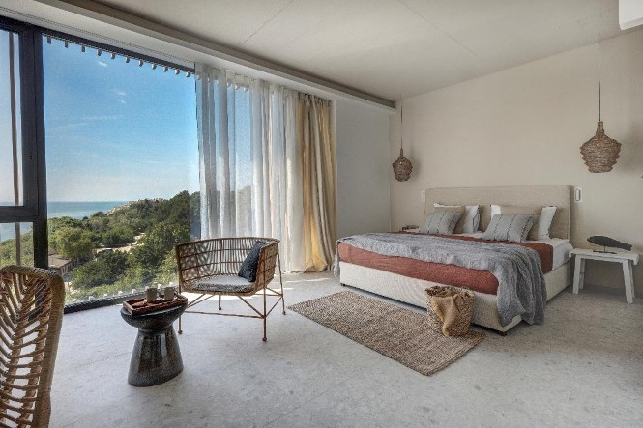 | 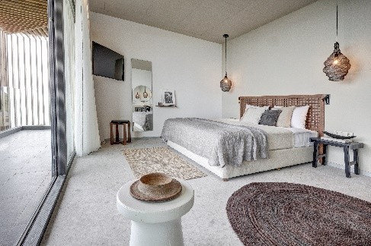 | 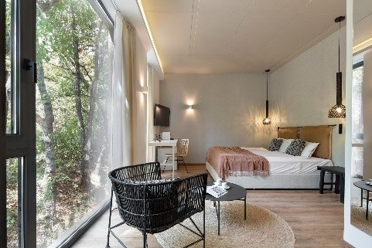
View: | Sea | Park (Pool side) | Park – for Park View room
 |  |  | Park/Inland – ground floor rooms
Size: | 33 sq.m. | 33 sq.m. | 28 sq.m.
Capacity (max) | up to 4 guests, max. 3 adults + 1 child or 2 adults + 2 children | up to 4 guests, max. 3 adults + 1 child or 2 adults + 2 children | 2 adults
Beds: | 1 king size bed (1.80 x 2.00 m) OR  1 king size bed (1.80 x 2.00 m) and 1 extendable double sofa (1.40 x 1.90 m) | 1 king size bed (1.80 x 2.00 m) OR  1 king size bed (1.80 x 2.00 m) and 1 extendable double sofa (1.40 x 1.90 m) | 1 king size bed (1.80 x 2.00 m)
Bathroom: | 1 bathroom with shower and hair dryer | 1 bathroom with shower and hair dryer | 1 bathroom with shower and hair dryer
Room essentials: | Free Wi-Fi | Free Wi-Fi | Free Wi-Fi
Room essentials: | Nespresso coffee machine | Nespresso coffee machine | Nespresso coffee machine
Room essentials: | Minibar | Minibar | Minibar
Room essentials: | Flat screen TV 43’’ | Flat screen TV 43’’ | Flat screen TV 43’’
Room essentials: | Air conditioning | Air conditioning | Air conditioning
Room essentials: | Safe deposit box | Safe deposit box | Safe deposit box
Room essentials: | Balcony | Balcony | Balcony - Double room Park View Courtyard - Double room Ground floor

ADDITIONAL SERVICES – ALL ROOM TYPES

- Free of charge sunbeds & umbrellas at Umani Beach*
- Free outdoor pool access & sunbeds
- Free outdoor parking option at Dimitar Hadzhiyanev Str. in front of the hotel’s main entrance, upon availability at arrival
- Beach towels upon request
- Quality toiletries
- Wake-up service
- Room Service – extra charge
- Laundry & ironing options – extra charge

*One beach umbrella per room and one sunbed per person included in the rates.

PLEASE NOTE: Our rooms are with boutique design and feature different styles, furniture and arrangements. Please specify any preferences you may have at time of booking – we will do our utmost to suit your requirements, however it will be subject to availability. As the hotel is usually quite busy, it may not be possible to adhere to your requests, especially if made upon arrival

MEALS:
- Bed & Breakfast includes: accommodation, buffet breakfast with coffee, tea and soft drinks, Wi-Fi access, free of charge sunbeds & umbrellas at Umani Beach*, outdoor pool & sunbeds, option for free parking for guests (upon availability), beach towels upon request.

- Half Board includes: accommodation, buffet breakfast with coffee, tea and soft drinks, a-la-carte dinner by a selected menu (beverages not included), Wi-Fi access, free of charge sunbeds & umbrellas at Umani Beach*, outdoor pool & sunbeds, option for free parking (upon availability) beach towels upon request.

- Full Board includes: accommodation, buffet breakfast with coffee, tea and soft drinks, a-la-carte lunch and dinner by a selected menu (beverages not included), Wi-Fi access, free of charge sunbeds & umbrellas at Umani Beach*, outdoor pool & sunbeds, option for free parking (upon availability) beach towels upon request

