

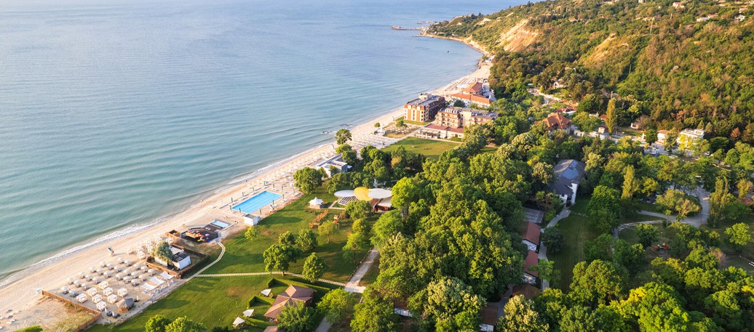


ULTRA ALL INCLUSIVE DESCRIPTION 2026
EFFECT ALGARA BEACH RESORT ****

RESTAURANTS AND BARS

Main Restaurant "Algara"

2 Themed dinners

BBQ night with a folklore program
(ONCE PER WEEK)

Sushi Station
(ONCE PER WEEK)
Breakfast: at a buffet from 7:30 to 10:00 (free - water, juice, and hot drinks)
Lunch: at a buffet from 12:30 to 14:30 (free - wine, beer, water, juice, soft and hot drinks)
Dinner: at a buffet from 18:30 to 21:00 (free - wine, beer, water, juice, soft and hot drinks)
Baby Corner Healthy buffet
Bulgarian alcohol, beer, wine, recognizable imported alcohol from the Ultra All-Inclusive menu.
Bottled drinks are paid extra.


Fish a-la-carte restaurant "Kosara"
Contemporary fish restaurant: 6 times per week
Dinner: from 18:30 to 22:30
1 dinner is included in the Ultra All Inclusive price. Applicable for a minimum stay of 4 nights. Reservation in advance is required; Additional dinner is possible subject to availability and at an additional cost.
Lorem ipsum dolor sit amet, consectetur adipiscing elit.
Vivamus ac consectetur urna. Duis eget interdum ipsum. Praesent quis maximus elit, non mattis neque.
Shorter stays (less than 4 nights) can be booked subject to availability and at an additional cost.
Bulgarian alcohol, beer, wine, recognizable imported alcohol, hot drinks, cocktails from the Ultra All Inclusive menu.
Bottled drinks are paid extra.

Snack bar "Kosara"
Bar Opening hours: 10:00 - 23:00
Lunch: 11:00 - 15:00
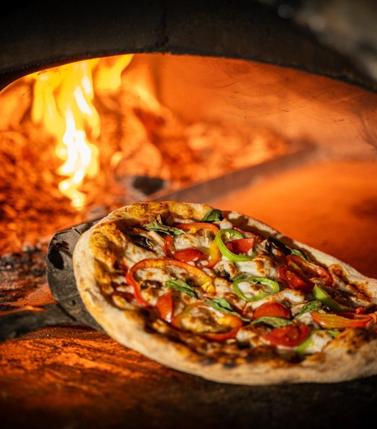
Light snack: 15:00 - 17:00

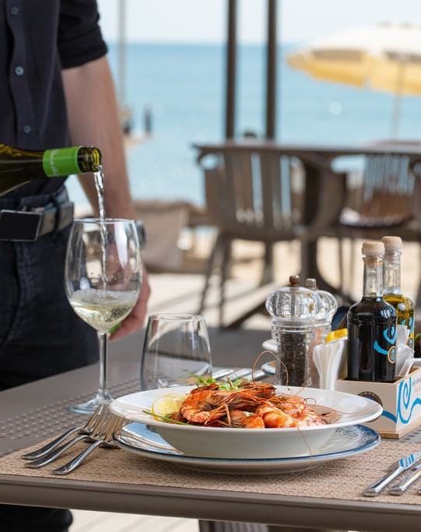
Italian a-la-carte restaurant "Casa mia"
Contemporary Italian restaurant: 6 times per week
Dinner: from 18:30 to 22:30
1 dinner is included in the Ultra All Inclusive price. Applicable for a minimum stay of 4 nights. Reservation in advance is required; Additional dinner is possible subject to availability and at an additional cost.
Shorter stays (less than 4 nights) can be booked subject to availability and at an additional cost.
Bulgarian alcohol, beer, wine, recognizable imported alcohol, hot drinks, cocktails from the Ultra All Inclusive menu.
Bottled drinks are paid extra.

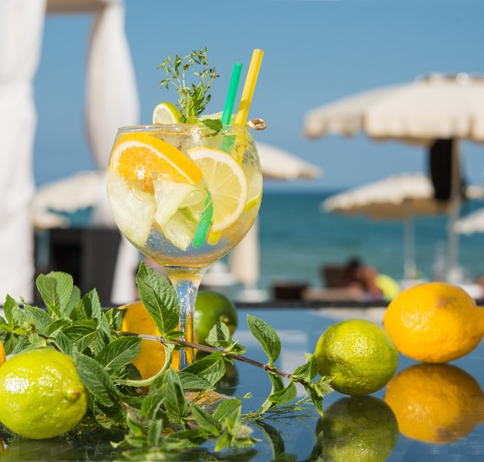
Beach bar "Algara"
EFFECT ALGARA BEACH RESORT ****
Opening hours: 10:00-18:00.
Bulgarian alcohol, beer, wine, recognizable imported alcohol, cocktails, hot drinks, juices, soft drinks from the Ultra All Inclusive menu.

Lobby bar

Opening hours: 24/7
Confectionery corner offering cakes, pastries and sweets
Late Snack, including cold packaged sandwiches, fruit and small sweets
Bulgarian alcohol, beer, wine, recognizable imported alcohol, cocktails, hot drinks, juices, soft drinks from the Ultra All Inclusive menu.
Bottled drinks are paid extra.


Swimming Pool
- Outdoor pool for adults
- Free parasols and sunbeds (upon availability)
- Children's splash zone

Beach
- Free parasols and sunbeds (upon availability)
- Beach towels against a deposit



Sports and entertainment
EFFECT ALGARA BEACH RESORT ****
- Multifunctional field with artificial grass (tennis, football, basketball)
- Animation - 6 times a week - children's animation, sports, mini disco and evening shows;
- Mini club - children over 4 years old
- Fitness, Beach volleyball and Table tennis
- Bicycles for rent
- Water sports on the beach - for an additional fee (external company)
- Children's facilities for children over 4 years of age
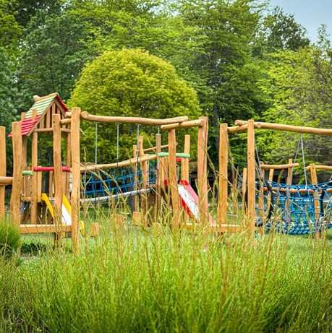
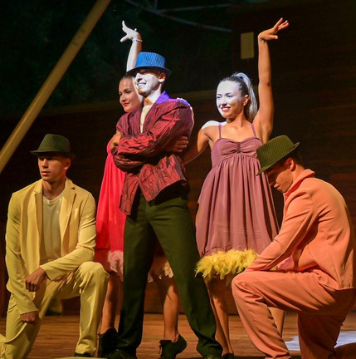
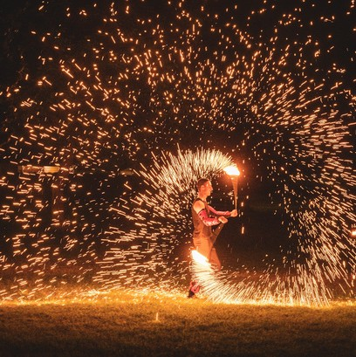

General information
Free daily replenishment of the mini bar in the rooms - beer, soft drinks, water
Free parking (1 parking space per room)
Wi-Fi
Check-in after 15:00 and check-out before 11:00
Early check-in and late check-out - subject to availability; against extra payment.
Ultra All Inclusive starts with lunch on the day of arrival and ends with breakfast on the last day
Rent-a-car
Baby cot - upon request and depends on the availability.



Royal Club
EFFECT ALGARA BEACH RESORT ****
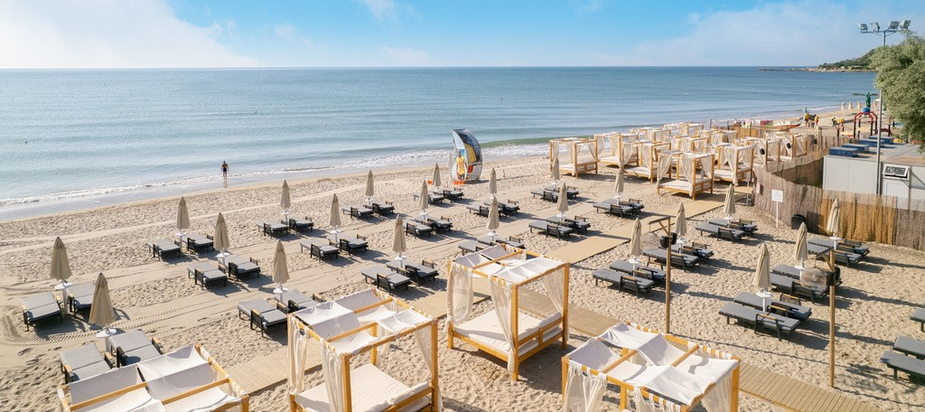

- Accommodation in Royal rooms, apartments or villas

Royal beach area
The Royal Club concept provides our guests with an access to a private beach area created to ensure their comfort and harmonious rest. They will find a premium drink menu at the dedicated Royal Beach Bar, which offers an innovative digital approach towards service. The Royal Beach Area is a unique masterpiece focused on providing the highest quality service and an unforgettable stay.
- A wider selection of imported alcohol from a special menu
- Free mini bar (wider selection of alcoholic and non-alcoholic beverages) with daily replenishment - (water, beer, non-alcoholic, juice)
- Coffee machine with capsules in the room - refilled daily
- Discount on the "Washing and Ironing" service
- Baby package - on request, free of charge; for non-Royal guests – at an additional cost.

The hotel reserves the right to change the hours of breakfast, lunch and dinner, the working hours of bars and restaurants, as well as the prices of additional services. Changes to services offered and opening times may occur in low season or
due to force majeure.

