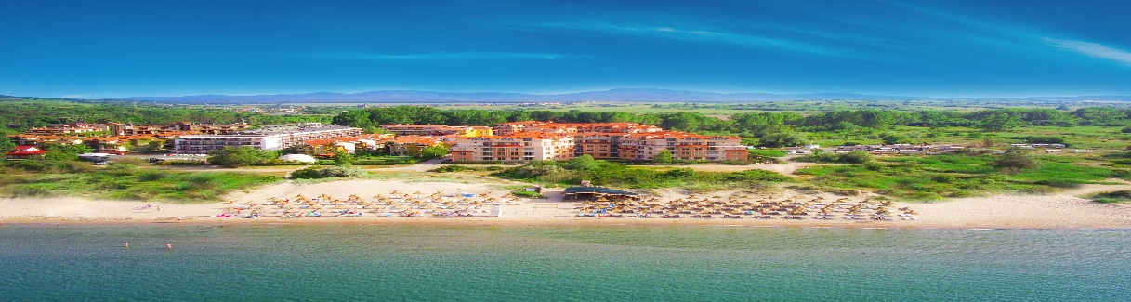
HACIENDA BEACH RESORT
Nestled in the warm embrace of “Golden Fish” Bay, 30 km south of Bourgas and 6 km from the Ancient town of Sozopol. Hacienda Beach Resort unveils serene and beautiful surroundings with sunny beaches and panoramic view of the sea.
Close to the hotel are situated the popular camping sites “Gradina” and “Golden Fish”, which are amongst the most desired places for summer vacation on Bulgaria’s southern Black Sea coast.

LOCATION  - GPS Coordinates: 42.698965.27.71709  - Distance to Airport: Burgas-40км.; Varna-165км.; Sofia - 413км.  - Distance to nearby towns: Sozopol-4км.; Burgas-31км  - Distance to Bus Station: 500м. Bus to Sozopol on every 10 min.  - Distance to „Golden Fish“beach -100м.; Beach in camping site “Gradina”-2.5 км |  |  | HOTEL DETAILS  - 4 stars  - Total Surface: 3600 м2  - Number of apartments: 200  - Build in 2012  - Last renovation: 2023  - 5 buildings by 4 flours  - Elevator – one in each building.

PARKING  - Secured parking with limited parking slots.  - Price -10 Euro per day, per vehicle.  - Advanced reservations is not possible.  INTERNET  - Wi-Fi free of charge in the entire property. |  |  | GENERAL SERVICES  - Room cleaning: once daily  - Towels change: once daily  - Bedsheets change: twice per week  - Amenities – once per stay  - Accepted Credit Cards: VISA § MasterCard  - Rent-a-car: For additional payment  - Doctor Visit: Paid/ on request.

SWIMMING POOL AND BEACH  - Outdoor pool, free, working hours 09:00-18:00.  - Sunbed and umbrella by the pool, free of charge and subject to availability.  - Sunbed & umbrella at the beach, paid service. |  |  | RECEPTION  - Check-in: 03:00 p.m.  - Check-out: 12.00 p.m.  - Late Check-out subject to availability and additional payment  - Reception: from 08:00 a.m. to 12:00 a.m.

RESTAURANTS  - Main Restaurant “Atia” offers Buffet for Breakfast, Lunch and Dinner, according to the meal plan booked  with serv. time:  Breakfast 07:30 a.m. - 10:00 a.m.,  Lunch: 12:00 p.m. - 2:30 p.m.,  Evening: 06:30 p.m. - 09:00 p.m. |  |  | BARS  - Pool Bar: Opening hours 11:00 a.m. - 11:00 p.m..  - Snack Bar: Opening hours 03:00 p.m. - 05:00 p.m.  *In proximity to the hotel are located some iconic Beach bars, which could be visited for an extra charge

CHILDREN  - Baby chairs in the restaurant: Free of charge.  - Kids Menu: Paid  - Baby Cot, free of charge, on request.  - Outdoor Children Playground: free of charge |  |  | PET POLICY  - Pets are allowed.  - Price: up to 10 kg. - 20 BGN per day, over 10 kg - 40 BGN per day.  - Pre-order is required.  - The hotel is not responsible for meals.  - Pets are not allowed on the territory of the restaurant.

1-BEDROOM APARTMENT  - Size: 45-60 sq.m.  - View: Park View  - Minimum occupancy Adults + Childs: 2+0  - Maximum occupancy Adults + Childs: 2+3 / 3+1  - Comprised of Bedroom, Sitting room & Bathroom  - Bed types: Queen size bed( 160x200) and Sofa (160x190) |  |  | APARTMENT FACILITIES  - Balcony  - Air-Condition  - Phone  - TV  - Cable TV  - Safety Box  - Floor type: tiles  - Mini fridge  - Electric kettle  - Hairdryer  - Shower or Bathtub  - Amenities: once per stay  - Iron on request  *Please note that the apartments does not offer paid channels and CD or DVD players
2-BEDROOM APARTMENT
- Size: 75 sq.m.
- View: Park view
- Minimum Occupancy Adults + Childs: 4+0
- Maximum occupancy Adults + Childs: 4+1/5+0
- Comprised of two bedrooms, sitting room and one bathroom
- Bed types: two queen size beds(160x200) and sofa(110x180)
DELUXE APARTMENT  - Size: 50 sq.m.  - View: Sea view  - Minimum occupancy: 2  - Maximum occupancy: 2/2+1/3+0  - Comprised of bedroom, sitting room, bathroom and kitchen  - Bed types: queen size bed(160x200) & sofa(110x180)  - Reservations only on request  SUPERIOR APARTMENT  - Size: 65 sq.m.  - View: side Sea view  - Minimum occupancy: 2  - Maximum occupancy: 2/2+1/3+0  - Comprised of 1 bedroom, living room with kitchenette (without oven and hobs) and dining table, bathroom  - Bed types: queen size bed(160x200) & sofa(110x180)  - Reservations only on request |  |  | MEDIA KIT  - Hi-resolution images ca be found and downloaded on  https://haciendabeach.bg/gallery/  - *Please note that the most updated information for the resort and its services may be found in the present document, therefore please use only the information available in the present fact sheet..
*Please note that the following services are not available at the resort: Safe on the reception, Room Service, Washing and dry cleaning.

HACIENDA BEACH ALL-INCLUSIVE PACКAGE

SUNBEDS & UMBRELLAS BY THE POOL  Working time is 09:00 to 18:00 hrs  Sunbeds and umbrellas are located around the swimming pool and are subject to availability. Kindly note that it is not acceptable to block intentionally the sunbeds by leaving personal belongings, while rooming around the resort. Such situations are having a negative impact on the service and prevents our dedicated staff to provide the needed comfort to all our guests. Beach towels left unattended on the sunbeds will be collected by our staff.  *Please note that the Golden Fish bay beach front is managed by a concessioner and the usage of sunbeds and umbrellas are paid services, which is to be settled on the spot. An advanced booking is not possible.  SPORT ACTIVITIES AND ANIMATION  Outdoor Children Playground  Children animation  Tennis table  OTHER SERVICES  Safety box free of charge in all apartments.  WiFi Internet connection free of charge in all the hotel.  Use of off-site parking |  |  | RESTAURANTS & BARS  All guests booked on All-Inclusive package will be given bracelets for identification. The bracelets must be returned to the reception upon check-out. If the bracelet is lost an additional charge of 30lv will apply. Upon check-in the guests will be given a Hotels passport, which will serve as identification and should be presented in the restaurant for Breakfast, Lunch and Dinner.  Main Restaurant „Atia“  For Breakfast, Lunch and Dinner, the restaurant offers Buffet set up with Salad Bar, Soups, Appetizers, 4-5 Main course, Fruits and desserts. There is a choice of Bulgarian non-alcoholic and alcoholic beverages, Beer and Wine. *Tea and coffee for Breakfast.  Opening hours:  Breakfast: 07:30 – 10:00 hrs.  Lunch: 12:00 – 14:30 hrs.  Dinner: 18:30 – 21:00 hrs  Snack Bar (Opening hours: 15:00 – 17:00 hrs.)  - The Snack bar offers a choice of Ice cream, Donuts, Pizza, Bulgarian Non-Alcoholic beverages, Beer and wine.

