

ULTRA ALL INCLUSIVE DESCRIPTION 2026
EFFECT GRAND VICTORIA HOTEL
****
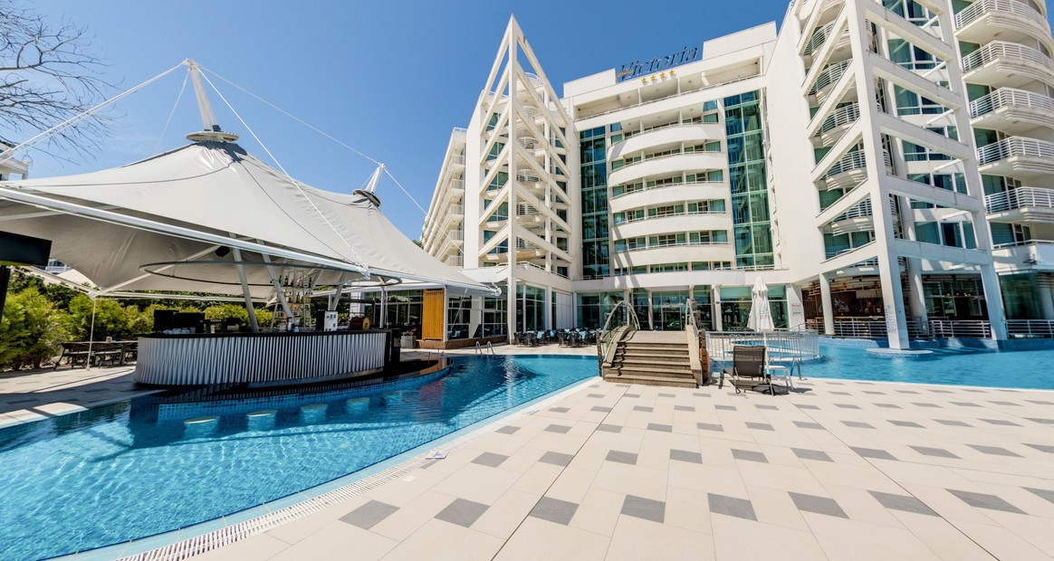

Restaurants and bars

Main Restaurant "Victoria"

3 Themed evenings

Healthy corner

Baby corner
- Breakfast: at a buffet from 7:30 to 10:00 (water, coffee, non- alcoholic, cold and hot drinks).
- Lunch: at a buffet from 12:30 to 14:30 (wine, beer, water, non- alcoholic drinks).
- Dinner: buffet from 18:30 to 21:00 (wine, beer, water, non- alcoholic drinks).
- Recognizable brands of imported and Bulgarian alcohol.

All bars and restaurants have a mandatory smart-casual dress code. Guests wearing towels, swimsuits, or any type of beachwear are not allowed.
For à la carte reservations, guests are not permitted to visit the main restaurant on the same evening.
During periods of high occupancy, meals may be organized in two seatings; guests will be informed of their designated time upon check-in. At the beginning and end of the season, meals may be served as a set menu when the hotel occupancy is low.
For the convenience of all guests, it is recommended to avoid peak hours in the main restaurant.


Italian a-la-carte restaurant "Bella Italia"

Dinner: from 18:30 to 22:30
1 dinner at one of the à la carte restaurants for the entire stay in the Ultra All Inclusive price. Applicable for a minimum stay of 5 nights. Reservation in advance is required, subject to availability.
Shorter stays (less than 5 nights) can be booked subject to availability and at an additional cost.
Beer, wine, non-alcoholic, hot drinks, recognizable brands of imported and Bulgarian alcohol.
Bottled drinks are charged extra.

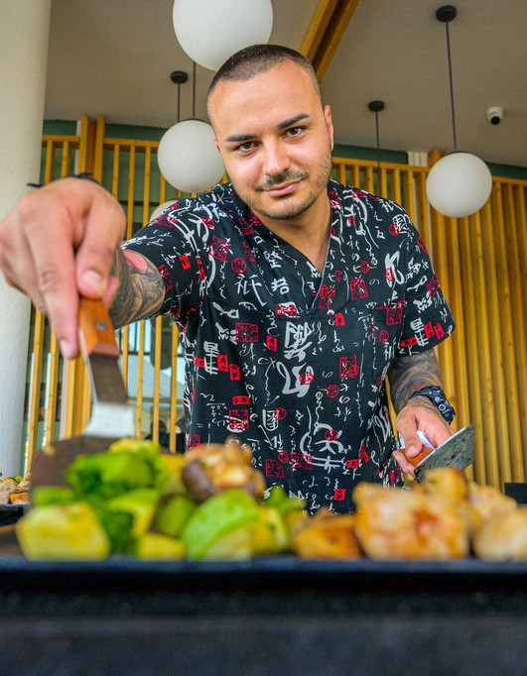
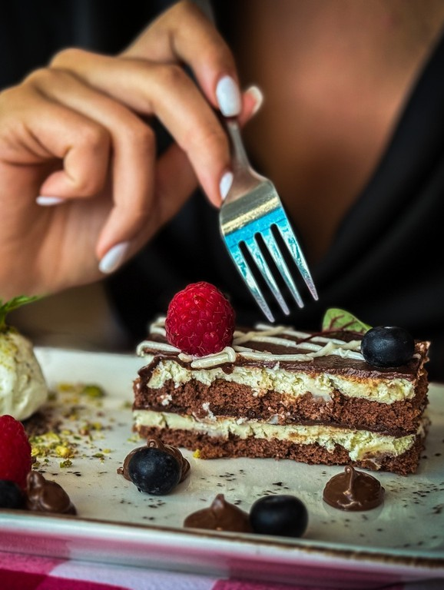
Asian a-la-carte restaurant "Hanaya" (Teppanyaki and Sushi corner)
Lorem ipsum dolor sit amet, consectetur adipiscing elit.
Vivamus ac consectetur urna. Duis eget interdum ipsum. Praesent quis maximus elit, non mattis neque.
Dinner: from 18:30 to 22:30
1 dinner at one of the à la carte restaurants for the entire stay in the Ultra All Inclusive price. Applicable for a minimum stay of 5 nights. Reservation in advance is required, subject to availability.
Shorter stays (less than 5 nights) can be booked subject to availability and at an additional cost.
Beer, wine, non-alcoholic, hot drinks, recognizable brands of imported and Bulgarian alcohol.
Bottled drinks are charged extra.

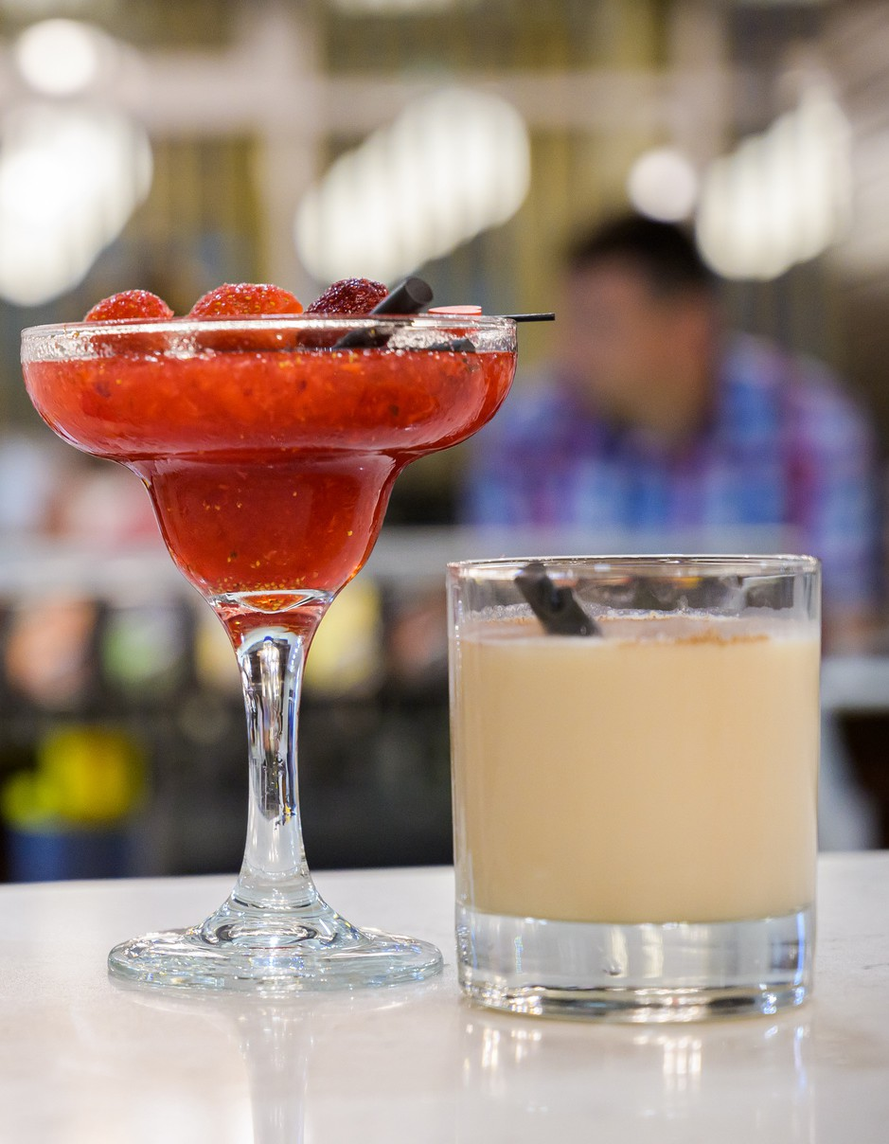
Lobby bar
- Opening hours: 24/7
- Recognizable brands of imported and Bulgarian alcohol, soft drinks and cocktails, high- quality coffee.

Coffee shop and pastry
- Opening hours: from 10:00 to 17:00.
- Selection of pastries and desserts.

Snack bar
Opening hours: 11:00 to 17:00
Lunch: 11:00 to 15:00
Light snack: 15:00 to 17:00 Sandwiches, burgers, pizza

Pool Bar "Aqua"
Opening hours: 10:00 to 23:00
Non-alcoholic and alcoholic cocktails, soft drinks, juice, hot drinks and recognizable brands imported and Bulgarian alcohol.

Lounge Bar
Opening hours: 10:00 to 23:00
Non-alcoholic and alcoholic cocktails, soft drinks, juice, hot drinks and recognizable brands imported and Bulgarian alcohol.
Shisha - charged extra

Pool Bar

ВАШИЯТPOТOЕКLСBТAВR АБЗАЦ

Snack Bar

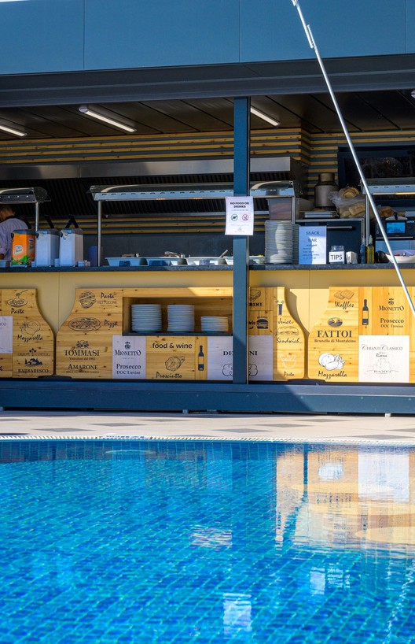
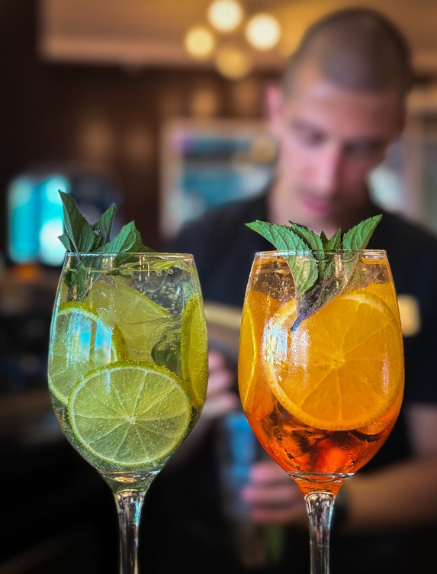
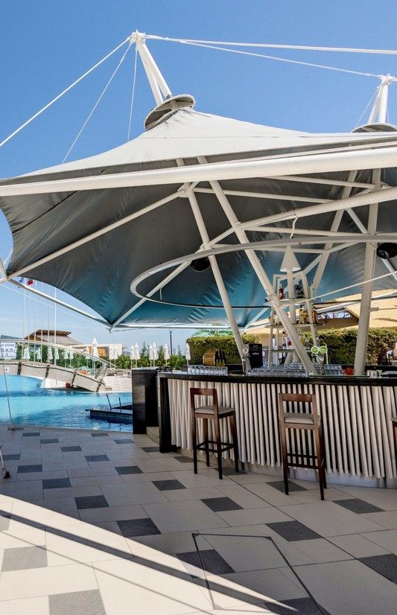
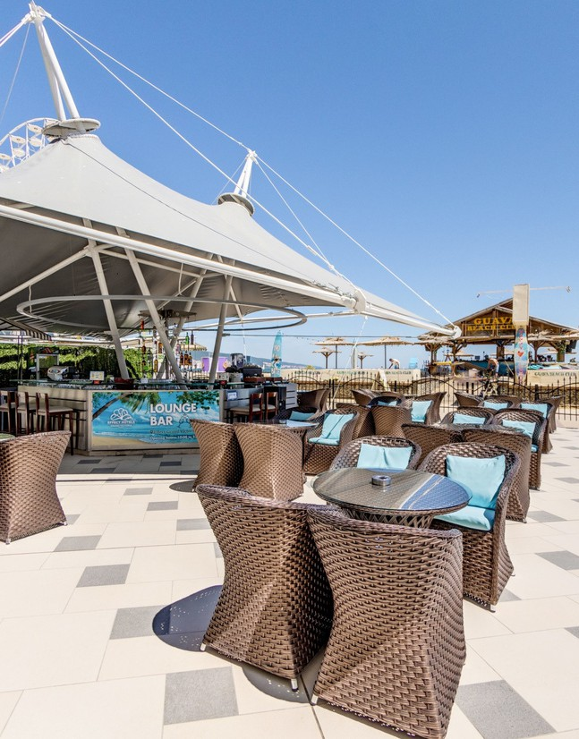

Lobby Bar Lounge Bar



Beach and Pool
EFFECT GRAND VICTORIA HOTEL
****
- Beach – free set of one umbrella and two sun loungers, subject to availability.
- Beach towels available with a deposit.
- Beach volleyball organized by the hotel’s entertainment team.
- Outdoor swimming pool for adults.
- Children’s outdoor pool (separate section of the main outdoor pool).
- Umbrellas and sun loungers at the pool (subject to availability).

Entertainment
  - Animation for children - 6 days per week, fun games, workshops, children's disco.
  - Animation for adults - 6 days per week, sports animation, evening and show programs.

General information
- Check-in after 14:00 and Check-out before 11:00
- The Ultra All Inclusive program starts with lunch on the day of arrival and ends with breakfast on the last day.
- Minibar (water, soft drinks, beer) in the room - refilled daily.
- Tea and coffee making facilities in the room
- 1 parking space per room (subject to availability). The parking space may be in front of the hotel or nearby (depending on availability)
- Wi-Fi
- Fitness



Services for an additional fee
EFFECT GRAND VICTORIA HOTEL
****

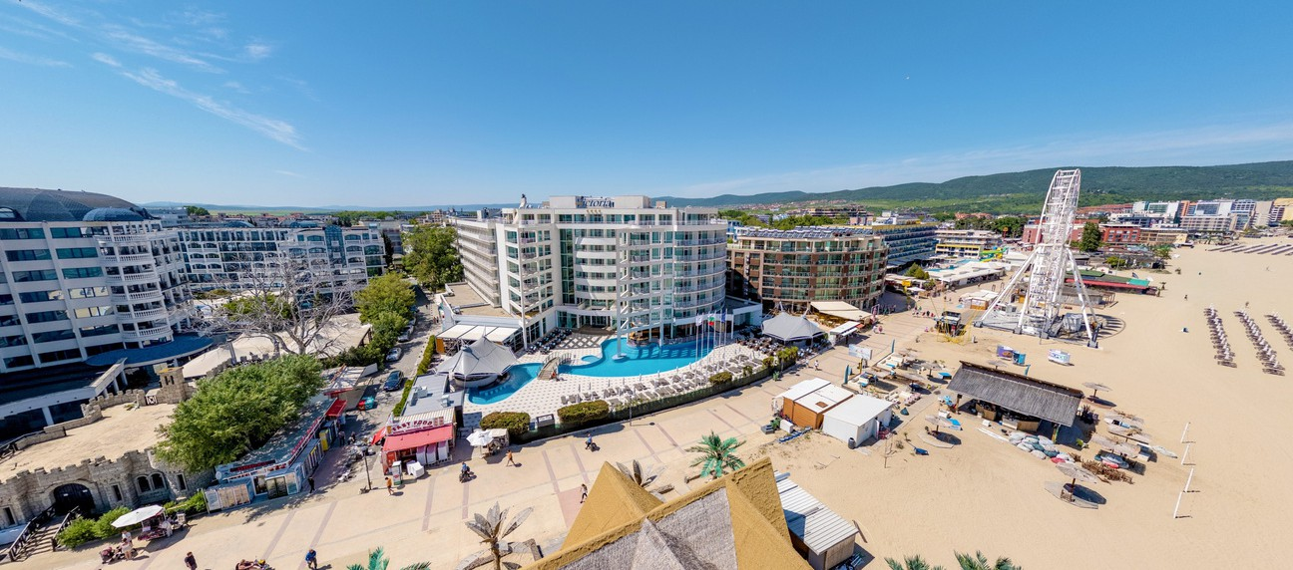


ATM

Sauna

Massages

Taxi and Transfers
Washing and ironing
Early check-in and late check- out - subject to availability; extra charge
Bicycles for rent
Rent-a-car

The hotel reserves the right to change the hours of breakfast, lunch and dinner, the opening hours of bars and restaurants, as well as the prices of additional services. Changes to services offered and opening times may occur in low season or due to force majeure.

