ESTREYA RESIDENCE AND ESTREYA PALACE
There is a place on the Bulgarian Black Sea coast that has preserved its nature, tranquility, and calmness over the years. In this place, the unique combination of forest and sea once attracted priests to build the "St. Constantine and Helena" monastery. Today, in close proximity to this sacred land, are the hotels "Estrea Palace" and "Estrea Residence." They are located in the heart of the resort, only 250 meters from the seashore and 200 meters from the resort center.
ACCOMMODATION
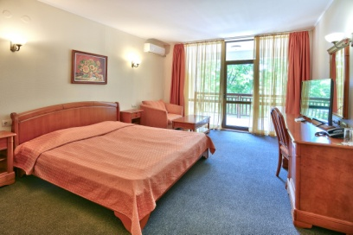
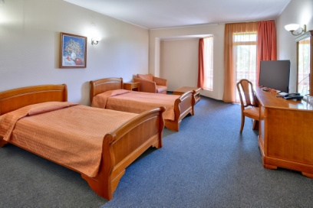
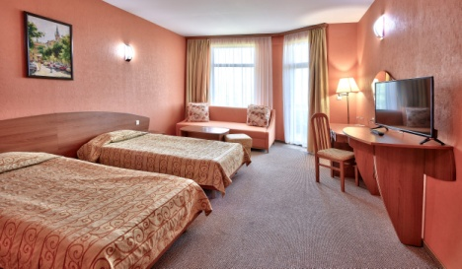
Estreya Palace Hotel has 104 rooms and 11 apartments, while Estreya Residence Hotel has 60 rooms and 15 apartments, all furnished in a classic style.

ROOM ESTREYA RESIDENCE ROOM ESTREYA PALACE
Double Room Estreya Residence
The very spacious and classically furnished double room in Estreay Residence is 30 sq.m. It has 1 double bed or 2 single beds and a sofa. Each bathroom features a shower, a bathtub, and a hairdryer. There is wireless internet and regular internet, satellite TV, and air conditioning. The safe is available for an additional charge. Maximum occupancy is 2 adults and 1 child or 3 adults.
Apartment Estreya Residence
A classically furnished apartment with a bedroom and living room separated by a door. It has 1 double bed and 1 sofa bed for two. The bathroom has a shower and a bathtub, as well as a hairdryer. There is a kitchenette equipped with a stove and refrigerator. Each apartment has a private terrace, air conditioning, a safe (for an additional charge), satellite TV, wireless internet, and a local network. Maximum occupancy is 3 adults and 1 child or 4 adults.
Double Room Estreya Palace
The double rooms at Estreya Palace are pleasant and comfortable. All of them have 2 single beds and 1 sofa bed. Most bathrooms have a shower, and only on the 4th floor are there bathtubs. Each room is equipped with a hairdryer, satellite TV, air conditioning, and a small balcony. The safe is located at the reception for an additional charge. Maximum occupancy is 2 adults and 1 child or 3 adults.
Studio Estreya Palace
The studios at Estreya Palace are 45 sq.m. and combine a bedroom and living room into one space. It has 1 double bed and a double sofa bed or two pull-out armchairs. All bathrooms in the studios have a shower and a hairdryer. There is a small balcony, satellite TV, and air conditioning. The safe is located at the reception for an additional charge. Maximum occupancy is 2 adults and 2 children.

RESTAURANTS
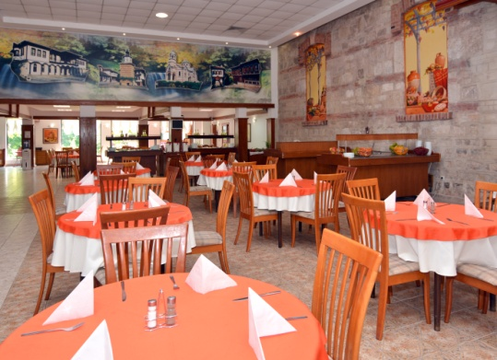
The hotels have a main restaurant with 2 dining halls – one with 100 seats and the other with 150 seats, each with a terrace. The restaurant offers a wide variety of dishes from international and traditional Bulgarian cuisine. As a pleasant and refreshing addition to every menu, there is a selection of white and red wines produced in the hotel's cellar from organic grapes grown in the "Belogradets" vineyards. Guests can choose from different meal plans – breakfast, half board, and all-inclusive.

LOBBY BAR AND POOL BAR
Guests at the Estreya hotels can enjoy a wide selection of alcoholic and non-alcoholic cocktails in the cozy atmosphere of the lobby bar at the "Estreya Residence" hotel. During the summer heat, guests of both hotels can quench their thirst with cold beer or refreshing drinks from the Pool Bar.

WINERY ESTREYA
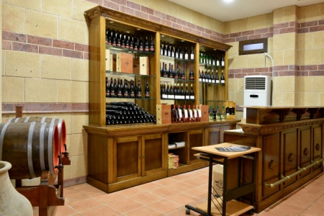
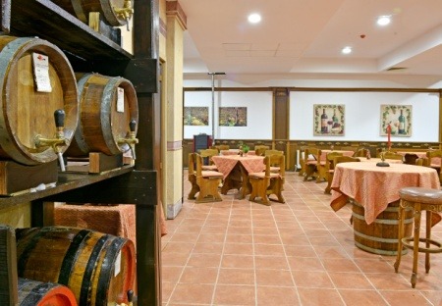
The winery surprises with its authentic interior and cozy atmosphere, where the warmth of wood and the strength of stone are beautifully combined. The collection of authentic items takes us back in time to when the Thracians tended their vineyards and produced the sacred drink – wine. The winery offers wines from the Belogradets cellar, which has gathered the experience and traditions of cultivating its own vineyards with red and white grape varieties for many years.

MEDI SPA CENTER ESTREYA
The Medi SPA Center Estreya offers a wide range of therapies for maintaining good physical health, relaxation, and recovery. The spa menu includes restorative therapies with modern equipment and natural products such as:
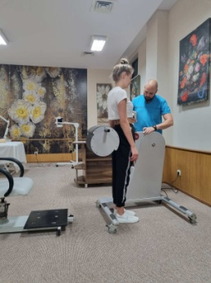
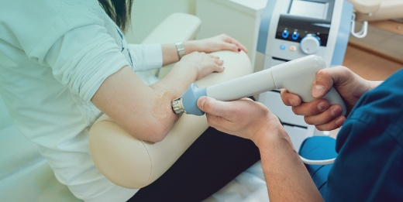
Biomechanical Stimulation (BMS) is a non-invasive external mechanical stimulation applied to the skin, connective tissue, and muscles with a specific amplitude and frequency. It is a 100% natural and safe method for restoring the body’s natural rhythms to the connective tissue, extracellular matrix, and musculoskeletal connections of the bones, which can be treated through this biomechanical stimulation using a mechanotherapeutic approach in medicine for cellular biological regulation, employing the BMS device. Complex localized disorders, imbalances, pain, and weakness can be effectively managed or avoided with BMS matrix therapy, in combination with existing therapies.
Thermal Massage Bed provides a precise and relaxing massage to vital points of the body around the spinal column, combining therapeutic massage, acupressure, and infrared heating. The spa bed helps reduce stress and muscle tension, improves circulation, and boosts energy levels. The special arrangement of jade stones enhances the effects of the heating therapy through massage, stretching, and traction of the lumbar vertebrae, benefiting the entire body. Tourmaline has several key properties – it emits negative ions, generates bioenergy, is rich in mineral elements, eliminates body odors, and kills harmful bacteria.
Aromatherapy is a type of alternative medicine that uses aromatic essential oils to address a variety of health issues or to prevent others. The core ideology of aromatherapy is that aromas do not treat the symptoms of a disease, but instead have a beneficial effect on the entire body. The choice of a specific oil is complex and primarily depends on the researched and described effects expected after its application. The essential oils used in aromatherapy are extracted from a wide range of plants – herbs, flowers, roots, and trees – that grow in various parts of the world. These oils have proven, powerful effects on our physical, mental, and emotional well-being. Aromatherapy has been studied and applied to a wide range of health problems, including some serious illnesses, where it is used as an additional therapy with favorable results. Here are a few examples:
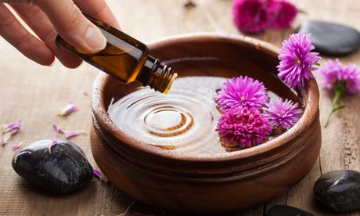
• Chronic stress and anxiety
• Panic disorder
• Depression
• Insomnia and general sleep issues
• Joint and muscle pain
• Respiratory inflammations
• Digestive problems
• Syndromes associated with menopause
• Skin problems and inflammations
• Chronic fatigue
• Blood pressure issues

In the Medispa Center Estreya, aromatherapy is performed in a specially designed room where a selected aromatic oil is dispersed using ventilation devices. Up to 4 people can stay in the room, with a recommended duration of the procedure up to 30 minutes.
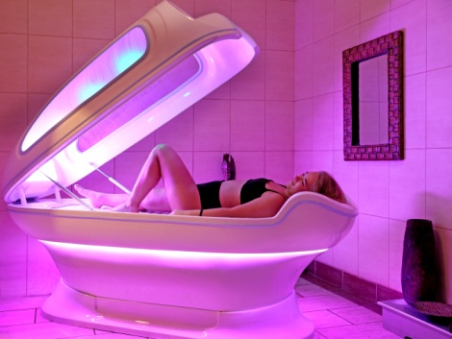
Lipo Laser is for those who wish to remodel their body, lose weight, and achieve an attractive shape. The device helps reduce fat, smoothens cellulite, reduces body measurements, and provides a skin-smoothing and lifting effect.
The Spa Capsule offers a variety of functions – infrared sauna, steam bath, aromatherapy, "Vichy" shower, vibrating surface, chromotherapy, tangentor, handheld shower, pearl massage, music system, facial airflow, and water jets. Some of the main benefits of the capsule include: detoxification, improvement of skin texture, enhanced metabolism, weight loss, stress and fatigue reduction, prevention and treatment of certain conditions, and improved sleep quality.
Hydromassage Bath combines the thermal and mechanical effects of water on the body. The hydromassage bath is suitable after physical exertion and can be prescribed by a doctor for various conditions such as neuroses, post-stress, muscle injuries, vegetative-vascular, metabolic issues, and more. The hydromassage bath also has a strong relaxing and toning effect on the body. The duration of the procedure is 25 minutes.
Wine Therapy is a ritual that includes a body peeling with an exfoliant made from ground grape seeds, applications of wine mud, and a bath with mineral water and wine sediment. The ritual is performed in a special room for Wine Therapy and concludes with a glass of red wine.
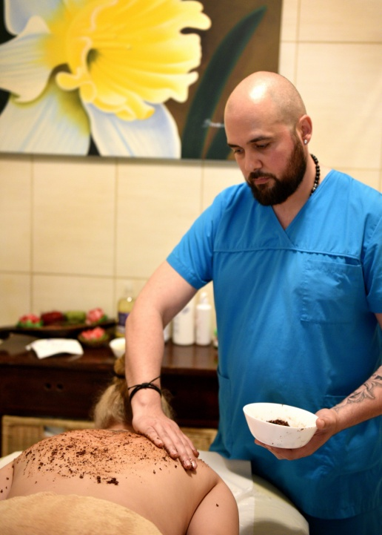
Wine and wine mud are the elixir of youth! They are rich in glucose, fructose, vitamins A, C, and P, as well as B vitamins, essential minerals, and amino acids. Grapes contain a large amount of polyphenols – active ingredients that help bind free radicals, which are known to be the main culprits for aging the body. The rejuvenating and regenerating effect of wine therapy is due to the polyphenols. Wine therapy has a beneficial impact on the skin due to its detoxifying effect, leaving the skin visibly toned and firm after the treatment. The baths and massages improve blood circulation and aid in the dispersal of accumulated toxins. Thanks to the antioxidants found in wine, it is a powerful tool in the fight against scars, uneven skin, and the damage caused by environmental factors and the sun.
It has been proven that grape seeds contain biologically active substances with 50 times more powerful antioxidant action than vitamin E. Grape seeds also contain linoleic acid, which helps slow down and suppress inflammatory processes. They work very well for problematic skin with acne, and for dry skin, they have a regenerating effect, hydrating the skin and slowing down the overall aging process. Additionally, grape seeds help reduce cholesterol, strengthen the inner layer of arteries and capillaries, prevent the formation of blood clots in blood vessels, and also have the ability to normalize high blood pressure. Grape seeds have strong anti-allergic and anti-inflammatory effects on the entire body.
Mud applications are a therapeutic method that has been used since ancient times. Therapeutic mud is an extremely valuable natural resource, rich in biological and chemical components, including ions, vitamins, microelements, and biologically active substances, each of which has beneficial effects on the body. The therapeutic mud has the following physiological effects:
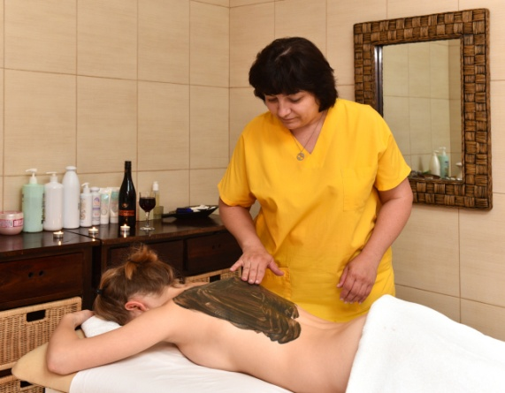
• Dilation (expansion) of blood vessels
• Acceleration of systemic blood circulation
• Acceleration of metabolic processes
• Improvement of cell, tissue, and organ trophism
• Improvement of tissue respiration
• Enhancement of the body's immune defenses
• Anti-inflammatory and antimicrobial effects
• Acceleration of resorption processes and reduction of underlying edematous conditions
• Stimulation of natural tissue regeneration
• Slowing down the aging process
• Stimulation of hematopoiesis and the renewal processes of red and white blood cells
• Stimulation of protein, fat, and carbohydrate metabolism, improving overall metabolism
• Normalization of the stomach's secretory function
• Facilitation and improvement of the formation and secretion of bile acids
Mud applications can be either local (targeting a specific area of the body, such as boots, gloves, belt, collar, or face) or general (covering the entire body). In this method, the mud is preheated to a temperature of 38 to 42 degrees Celsius (in certain conditions, the temperature may be lower, but not below 25 degrees). It is then applied to the designated area or the entire body. The mud is wrapped with plastic, and a blanket is placed on top. The duration of the procedure ranges from 15 to 30 minutes. After the procedure, the mud is washed off, and it is recommended to rest in bed for about half an hour to an hour.
Massages – The Medi SPA Center Estreya offers a wide variety of massages and therapies for the face and body, including: classic massage, relaxing massage, therapeutic massage, Balinese massage, Thai massage, chocolate massage, anti-cellulite massage, and Bulgarian rose therapy for the face.
SWIMMING POOLS
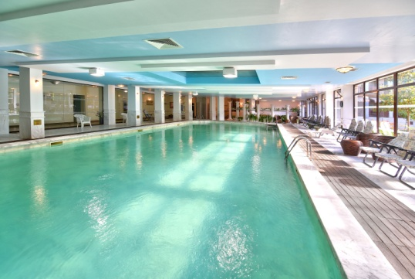
The Estreya Hotels feature 1 indoor and 2 outdoor mineral pools. The pools are supplied with mineral water from a local spring. Based on the physicochemical analysis and studies conducted on the mineral water used in the Medi Spa Center Estreya, it has been found to be beneficial for balneotherapy of:
- The musculoskeletal system
- Joint diseases
- The peripheral nervous system
- Orthopedic and traumatological conditions

During the summer months, guests can enjoy the two outdoor pools, one of which has a children's section. Free loungers and umbrellas are available around the pools.

REHABILITATION CLINIC
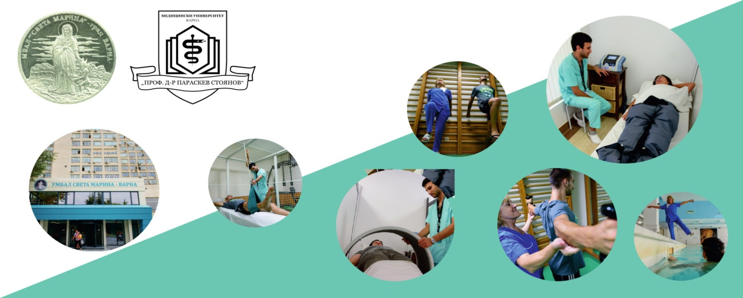
In the building of Estreya Residence, there is a department of the Clinic of Physical Therapy and Rehabilitation Medicine of St. Marina University Hospital – Varna. Patients can benefit from the unique combination of marine climate, sea water, and mineral water from a local source with a temperature of 42-46 degrees, which is extremely valuable for the treatment and prevention of numerous conditions.
The mineral water in the complex is low in minerals and contains calcium and magnesium, making it highly beneficial for treating musculoskeletal disorders and central and peripheral nervous system conditions. The treatment is carried out by qualified doctors, rehabilitation specialists, physiotherapists, and nurses, with excellent facilities and modern equipment.
The clinic offers rehabilitation for the following conditions:
Musculoskeletal Disorders:
Degenerative joint diseases: coxarthrosis, gonarthrosis, spondyloarthrosis, generalized deforming osteoarthritis.
Intervertebral disc injuries: discopathies, herniated discs.
Inflammatory joint diseases: mono- and polyarthritis, periarthritis, bursitis, insertionitis, joint syndromes related to systemic diseases.
Post-fracture conditions and surgical treatment.
Post-arthroscopy and joint replacement surgery (hip, knee, shoulder).
Central Nervous System Diseases:
Consequences of cerebrovascular diseases: stroke, cerebral hemorrhage, multiple sclerosis, Parkinson's disease.
Peripheral Nervous System Diseases:
Mono- and polyneuropathy.
Radiculitis, plexitis.
Consequences of peripheral nerve injuries.
Cardiovascular System Diseases:
Rehabilitation after myocardial infarction and heart surgeries such as bypass and heart valve replacement.
Rehabilitation Programs Include:
Physical therapy using modern technologies.
Kinesiotherapy and specialized exercises.
Mineral water therapy to accelerate recovery.
The results achieved through specialized treatment combined with the natural resources of the region lead to significant improvement in patients' conditions and faster recovery.

CONFERENCE HALLS
DOBRUDZHA HALL
Located in Estreya Residence, with an area of 300 m², natural daylight, professional sound equipment, and four 108 cm displays. This versatile space is ideal for hosting wedding and family celebrations, as well as corporate conferences, meetings, and cocktail events.
- Capacity: 240 seats (theater-style setup)
- Flooring: Natural wood parquet
- Professional Equipment: Multimedia, screen, sound system
ESTREYA HALL
With an area of 180 m², this hall is equipped with a sound system, blackout curtains, or natural daylight. Multimedia, microphones, a screen, and a flip chart can be rented. It is perfect for hosting training sessions and conferences.
- Capacity:
  - 100 seats (cinema-style setup)
  - 60 seats (workshop-style setup)
FLORA HALL
Surrounded by flowers and greenery, this hall offers a perfect setting for training, meetings, or team-building activities.
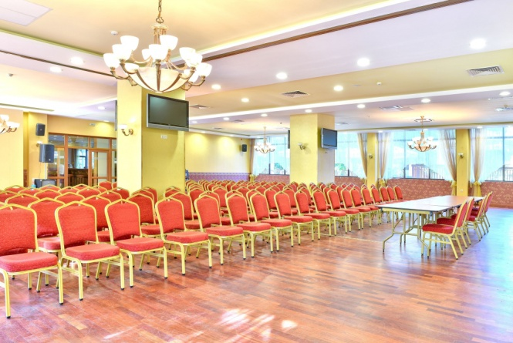
- Capacity: 60 seats (workshop-style setup)

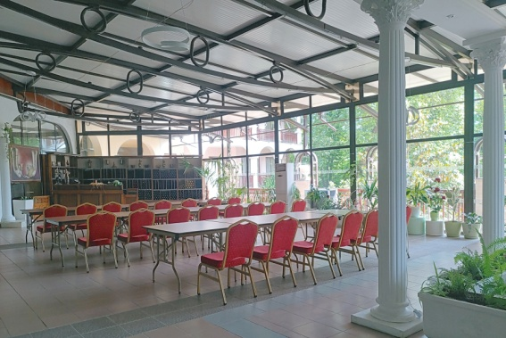
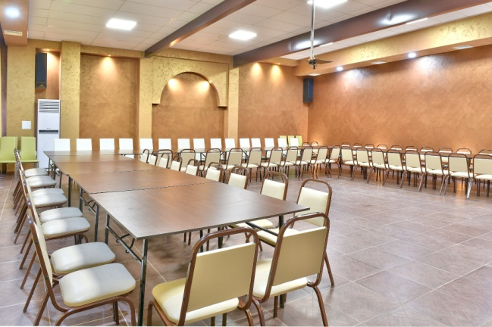
ЗАЛА ДОБРУДЖА

ЗАЛА ЕСТРЕЯ ЗАЛА ФЛОРА

EVENTS
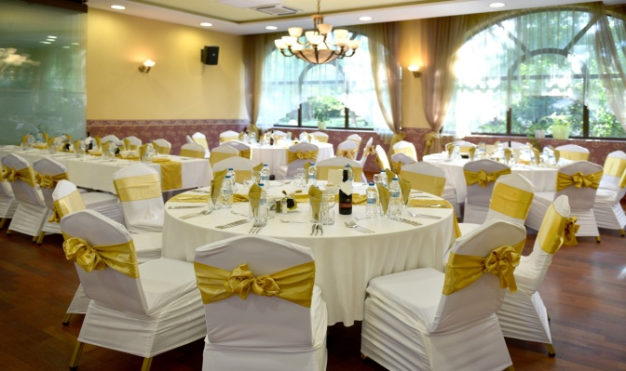
Over the years, Estreya Residence and Estreya Palace Hotels have hosted numerous events and festive celebrations. The team at Estreya Hotels has proven expertise in organizing weddings, family, and corporate events. The elegantly equipped Dobrudzha Hall offers a perfect blend of comfort and grandeur for any occasion.
- Weddings
- Family Celebrations
- Graduation Balls
- Corporate Events

KIDS PLAYGROUND

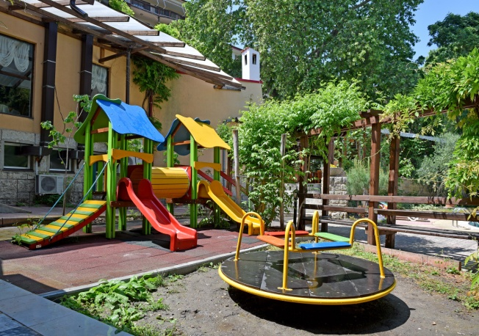
The entertainment for children takes place outdoors in the green garden of Estreya Hotels.
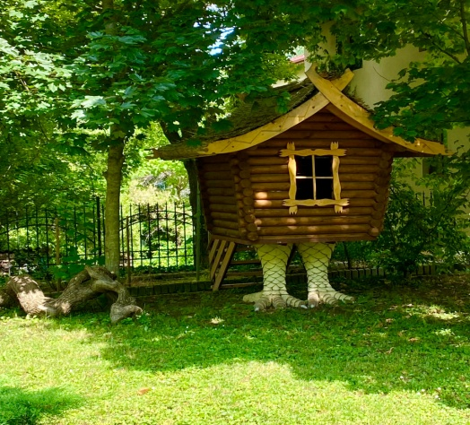

WINE SHOP
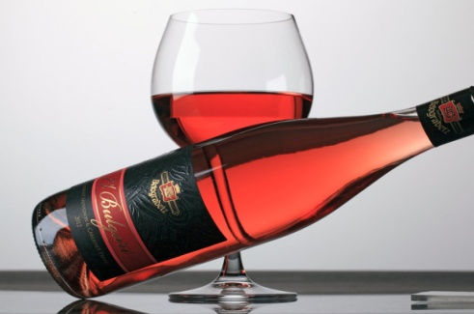
At Estreya Residence Hotel, one of the company’s wine shops selling wine from Belogradets Winery is located.



