
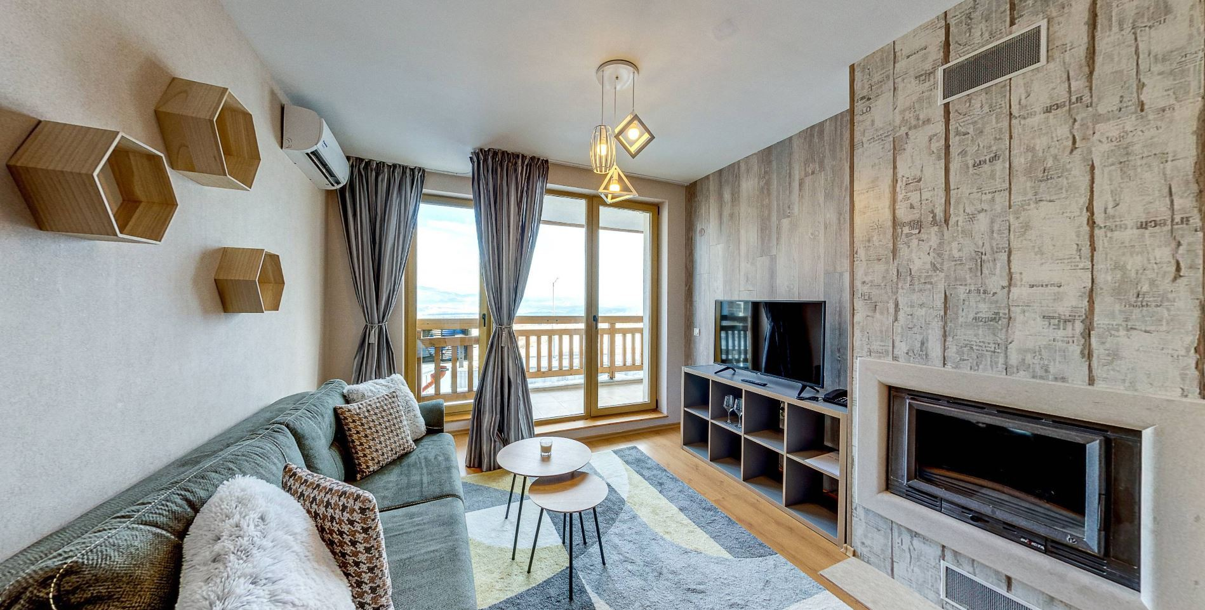
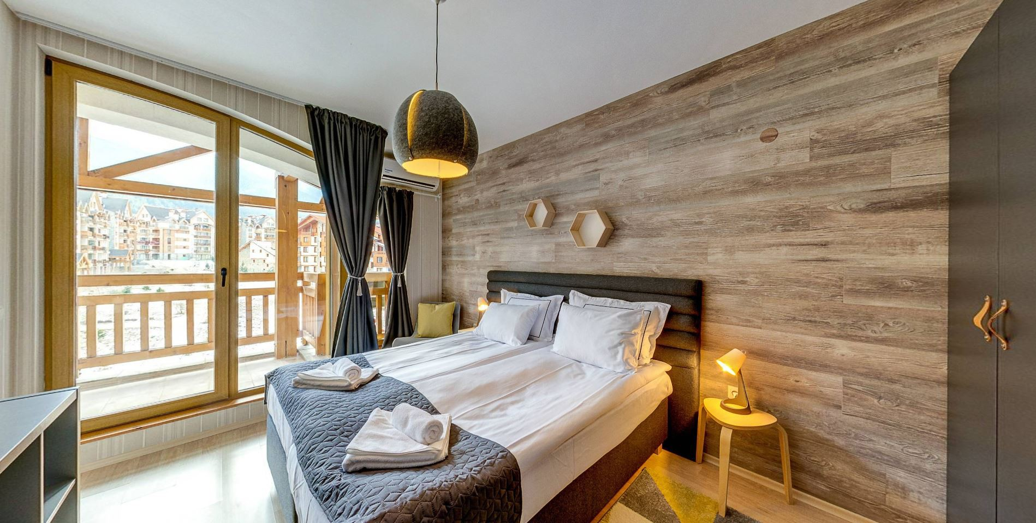

Location

“Boutique Hotel Entry E”, Bansko

Boutique Hotel Entry E is a new year-round boutique hotel, which elegantly combines modern interior and cozy atmosphere. It is located in Bansko – the biggest Bulgarian ski resort. The distance to the town center and the starting station of the ski-lift is 1.5 km, while the distance to the main Bulgarian cities Sofia and Plovdiv and their airports is less than 160 km. The hotel lies in a quiet and peaceful area in the newest and highest point of the town, which allows the guests to enjoy a truly fulfilling holiday and magnificent views towards Pirin and Rila mountains.

Hotel services and facilities

Boutique Hotel Entry E has 5 floors with 39 light and spacious types of accommodation with a first-class furniture and unique "chalet" finish.

At all guests ‘disposal is the fine “Garlic” restaurant. It consists of 2 separate halls and offers delicious dishes from the national and world cuisine. Food and beverages can be consumed in the cozy lobby bar as well, enjoying the atmosphere of a beautiful fireplace and relaxing background music.

Boutique Hotel Entry E offers great conditions for an escape from the hectic everyday life and for complete relaxation after an exciting day on the ski slopes. Sauna with a panoramic garden view and steam bath are available, as well as a relax zone and an outdoor hot tub. The water temperature in it is as high as 38°С. There is also a multifunctional gym for individual or group fitness training, crossfit classes and yoga practices. For the youngest guests there is a large children's center with a labyrinth, a play area and other means of entertainment. Winter sports lovers can take advantage of a free ski wardrobe.

Among the other available conveniences and facilities are a multifunctional conference hall with daylight, free wireless internet throughout the hotel, free outdoor and paid indoor parking and scheduled transfers to/from the starting station of the ski lift in winter.

www.entrye.eu

- A la carte restaurant with 2 halls
- Lobby bar
- Sauna
- Steam bath
- Outdoor barrel- shaped hot tub
- Relax zone
- Massages

Accommodation
- Children’s center
- Outdoor and indoor parking
- Wi-Fi
- 50-seat conference room
- Everyday cleaning
- Elevator
- Transfer to/from the starting station of the ski lift in Bansko
- Ski storage room
- Change of bed linen and towels – every 3 days

There is a total of 39 room types in the hotel - 11 studios, 22 one-bedroom и 6 two-bedroom apartments.

Studio – elegantly furnished room with 1 double or 2 single beds, armchair and well equipped kitchenette with a table and 2 chairs. Fireplace, cable TV, Wi-Fi and air-conditioner are also available. Private bathroom with a shower cabin. No balcony. The size of the studio is 45 sq.m. Maximum capacity of 2+0/2+1.

Studio Deluxe – spacious room with balcony and a wonderful view towards the Pirin mountain, 1 double bed and 1 sofa-bed for 1 adult or 1 child. It has a well-equipped kitchenette with a table for 2 or 4. There is also a fireplace, TV, Wi-Fi and air-conditioner. Private bathroom with a bathtub. Size - 45-55 sq.m. Maximum capacity 3+0/2+1.

Junior 1-bedroom apartment – compact and modernly furnished apartment with a balcony, living room with a kitchenette and a sofa-bed for 1 adult or 1 child, bedroom with a double bed, accessible from the living room. Each of the two rooms has a separate A.C., and there is also a washing machine, TV and fireplace in the living room. Wi-Fi and bathroom with a bathtub are also available. Size of the apartment - 70 sq.m. Maximum capacity 3+0/2+1.

Senior 1-bedroom apartment – spacious apartment which has a balcony with an unique mountain view, living room with a fireplace, TV, A.C., kitchenette, washing machine and a big sofa-bed. Bedroom with 1 double or 2 single beds and an A.C. The bathroom has a bathtub. Its entrance is from the lobby of the apartment and it is the same with both the living room and the bedroom. Wi-Fi is also available. Size - 85 sq.m. Maximum capacity 3+0/2+2.

Loft 1-bedroom apartment – an irregularly shaped apartment on the top floor, perfect for families. It has a walk-through bedroom with 1 double bed and an A.C., living room and a second open bedroom for 1 adult or 2 children above the living room, reachable by climbing vertical stairs. The living room offers a kitchenette, TV, fireplace, washing machine and a little couch. There is a balcony with mountain view, Wi-Fi, and bathroom with a bathtub. Size of the apartment - 85 sq.m. Maximum capacity 3+0/2+2.

2-bedroom maisonette – a luxury duplex apartment. On the first floor there is a living room with a kitchenette, washing machine, fireplace, A.C., sofa-bed and a wide-screen TV. From the living room guests can go out at the balcony or to the second floor, accessible by stairs. Two bathrooms with bathtubs are available there and two bedrooms as well – with 1 double or 2 single beds. Each of them has an A.C. Wi-Fi is available in the apartment. Size 120 sq.m. Maximum capacity 5+0/4+2.

2-bedroom apartment – the most spacious apartment. It consists of a living room with a sofa- bed and a kitchenette, washing machine, TV, A.C., fireplace, and 2 bedrooms with double beds and air-conditioners – the first one is a walk-through bedroom with bigger size, TV and private bathroom. From the lobby of the apartment there is an access to the second bedroom, the living room and the second bathroom, which has a bathtub. A large balcony and Wi-Fi are at guests’ disposal. Size 125 sq.m. Maximum capacity 5+0/4+2.

Room equipment

  - Flat screen TV
  - Cable television
  - Wi-Fi
  - Fireplace
  - Extendable armchair/sofa-bed
  - Kitchenette
  - Kitchen table and chairs
  - Washing macine (excluding studios and studios deluxe)
  - Private bathroom
  - Hair-dryer
  - Balcony (excluding studios)
  - Individual air- conditioner in each room
  - Housekeeping service – daily
  - Toiletries

* Entry E Boutique Hotel photos are available here: https://www.dropbox.com/scl/fo/6fmpqvl9z15halru9qmwe/h?rlkey=lalv3yx2wnq823txd3kzn38ay&d l=0

