Transport in Albena 2024

Getting around the resort
Free eco-friendly transport in Albena is available during the whole day: shuttle bus and electric bus. The escalator to the upper area is for a fee. Getting around the resort with a hop-on train is also worth it. You can order a taxi at the following number +359 885 853 660. The resort has a number of conveniently located parking lots.

Where to park your car in Albena?

Within the first 30 minutes you can leave the resort without paying a parking fee
We have 4 different parking zones. The ticket ensures one single pass - entering and parking for 24 h, except for Lazur parking, which is offered to you for free. The parking prices differ depending on the zone as follows:
from 10.04.2024 to 24.04.2024:
- Green and blue zone: BGN 5 - entry and parking for 24 hours
- Parking "Bus Station": 5 BGN - entry and parking for 24 hours
from 25.04.2024 to 31.05.2024:
- Green zone: BGN 10 - entry and parking for 24 hours
- Blue zone: BGN 10 - entry and parking for 24 hours
- Parking "Bus Station": 6 BGN - entry and parking for 24 hours
from 01.06.2024 to 30.09.2024:
- Green zone: BGN 20 - entry and parking for 24 hours
- Blue zone: BGN 10 - entry and parking for 24 hours
- Parking "Bus Station": 6 BGN - entry and parking for 24 hours
from 01.10.2023 to 31.10.2024
- Green zone: 10 BGN - entry and parking for 24 hours
- Blue zone": 10 BGN - entry and parking for 24 hours
- Parking "Bus Station": 6 BGN - entry and parking for 24 hours
When entering with a car you need to take a ticket, which you need to present on exit
Capacity:
- Bus station Parking - 800 parking places
- Blue Zone- 1200+ parking places
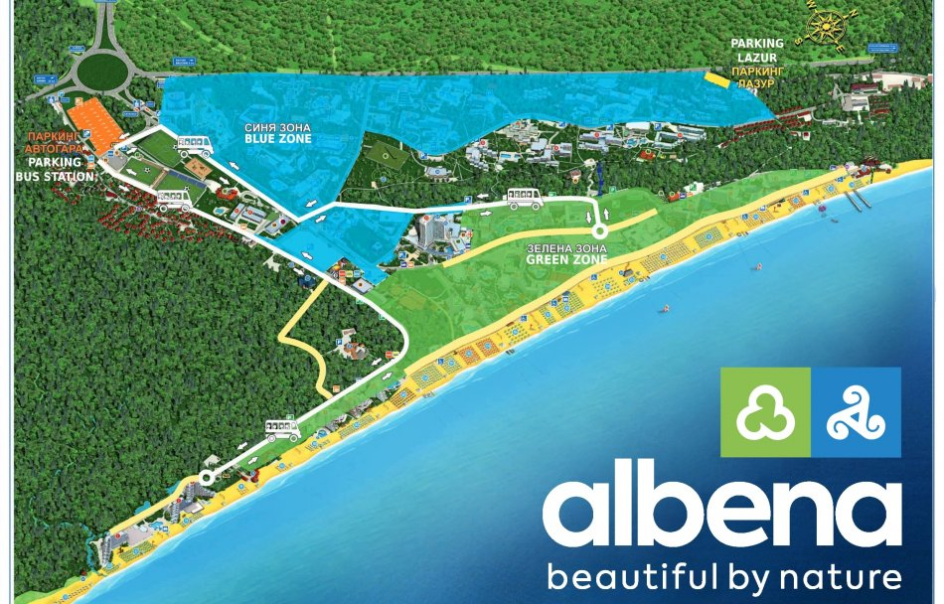

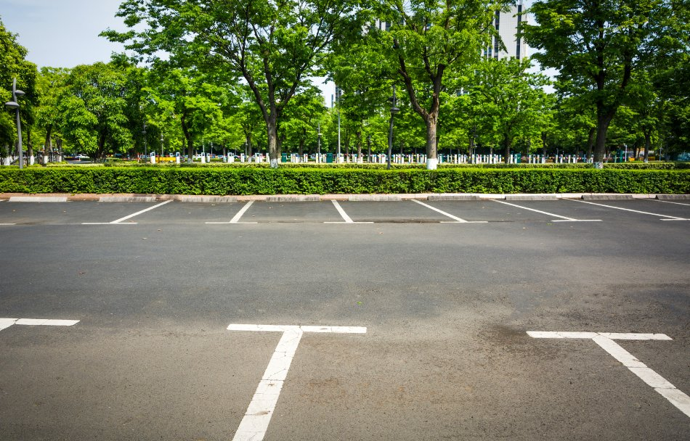

How to pay for parking in Albena?

You can pay in any of the Albena parking zones, no matter in which zone your hotel is
The payment methods for parking in Albena are the following:
- at the hotel reception
- at parking payment stations
- online by scanning your individual QR code
How to pay online?
- a QR code is printed on the individual ticket that you receive at the entrance to Albena Resort
- scan the QR code, open the website to which it refers and follow the payment process
- the payment methods are - debit / credit card, Google Pay, Apple Pay
The fee for parking in Albena resort is valid for 24 hours.
Before leaving the parking lot, make sure that you validated and paid for the ticket. In case you leave the resort with your car, you will have to pay the parking fee again.
If you intend to visit Albena for a day, the best option is to park your car at the bus station parking lot, which is located at the beginning of the resort, оn the right side.

How to take a card for multiple access in Albena?

The multiple access card entitles its holder to exit and enter an unlimited number of times within a prepaid period.
Guests staying in Albena Resort may request a multiple access card during their stay at the complex. The card request can be made to our friendly staff at the reception of the hotel of your accommodation. It would be necessary to pay in advance for the period of your stay in the parking zone of your choosing.
The card is valid for a specific area - Blue, Green, Bus station.

What means of transport does Albena offer?

Bicycles, taxi cabs, trains or electric transport are at your disposal.
You can go for a walk on foot from the bus station parking to the central beach, which will take you 10-12 minutes; you can take one of the touristic trains for a fee or benefit from one of the two free electric transport lines:
- Blue line: to the Maritim Paradise Blue Hotel & SPA, Ganvie Beach Club and the central beach.
- Yellow line: to Boryana, Nona, Elitsa and Mura Hotels and their nearest beach.

Which parking spot close to your hotel do you chose in Albena?

Here are some questions you can have during your stay in Albena and our answers for each of them.
My hotel is in the Blue Zone, where can I park my car?

The closest Blue parking lot to your hotel
For free: the first 30 minutes
Before leaving the parking lot, please make sure you validated and paid for your ticket at the hotel reception or at the Automated Pay Stations. The price per ticket is according to the current price policy (stated above), each ticket being valid for one single entrance and stay for 24 h.

The bus station parking lot
For free: the first 30 minutes
It’s located at the entrance of the resort, on the right. Before leaving the parking lot, please make sure you validated and paid for your ticket at the Automated Pay Stations. The price per ticket is according to the current price policy (stated above), each ticket being valid for one single entrance and stay for 24 h.
You have 2 free electric transport lines at your disposal:
- Blue line: to the Maritim Paradise Blue Hotel & SPA, Ganvie Beach Club and the central beach.
- Yellow line: to the Boryana, Nona, Elitsa and Mura Hotels and their nearest beach.

My hotel is in the Green Zone, where can I park my car?

The closest to your hotel Green Zone parking lot
For free: the first 30 minutes
Before leaving the parking lot, please make sure you validated and paid for your ticket at the hotel reception or at the Automated Pay Stations. The price per ticket is according to the current price policy (stated above), each ticket being valid for one single entrance and stay for 24 h.

The bus station parking lot
For free: the first 30 minutes
It’s located in the beginning of the station, on the right. Before leaving the parking lot, please make sure you validated and paid for your ticket at the Automated Pay Stations. The price per ticket is according to the current price policy (stated above), each ticket being valid for one single entrance and stay for 24 h.
In the bus station parking lot you have at your disposal 2 free electric transport lines:
- Blue line: to the Maritim Paradise Blue Hotel & SPA, Ganvie Beach Club and the central beach.
- Yellow line: to the Boryana, Nona, Elitsa and Mura Hotels and their nearest beach.
Where can I park my car if I stay for one day in Albena?

In Albena for a day
If you are planning to visit Albena for a day, the best option is to park your car in the bus station parking lot. It is located in the beginning of the resort, on the right. The first 30 minutes are free of charge. Before leaving this parking lot, please make sure you have paid your ticket at the Automated Pay Stations. The price per ticket is according to the current price policy (stated above), each ticket being valid for one single entrance and stay for 24 h.
From the bus station parking lot you can take the free shuttle buses, which have two routes:
- Blue route: to the Maritim Paradise Blue Hotel & SPA, Ganvie Beach Club and the central beach.
- Yellow route: to the Boryana, Nona, Elitsa and Mura Hotels and their nearest beach.
The walking distance from the bus station parking lot to the central beach is 10–12 minute.

