Umani Hotel & Beach 4*, Golden Sands: Opening July 2022

HOTEL DESCRIPTION

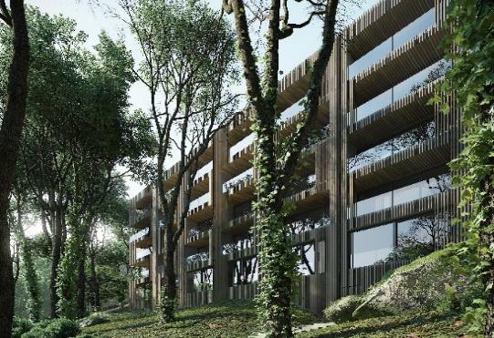 | 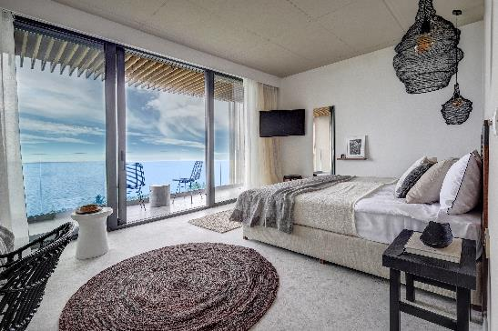

About Umani Hotel & Beach, Golden Sands

Hotel DETAILS
Number of rooms | 52 rooms & suites
Star rating (official) | 4*
Number of floors | 5
Elevators | 2 within the hotel, 1 at the outdoor parking
Pool | Seasonal outdoor pool with children’s section, sunbeds & umbrellas, free of charge for hotel guests (8.5 x 3.3 m)
Parking | Outdoor and underground parking available, free of charge for hotel guests (upon availability at time of arrival)
Internet | Free Wi-Fi available in the rooms and public areas
Restaurant | Sea Salt Restaurant: the main restaurant, with indoor and open-air seating, located at lobby level, offers international cuisine. Serves breakfast, lunch and dinner, and a class selection of wines, beer and spirits
Bars | The Concept Lobby Bar, Pool Menu available, Cake & Ice-cream booth;
Room Service | Available
For Kids | Indoor un-manned kids’ room available free of charge. Children’s section at the outdoor pool;  Please note that the hotel may not be the best choice for families with babies or toddlers due to the landscape and denivelation of the area. The beach is accessible via a trail with stairs, with no ramp for strollers. The hotel yard is also on a hill, with the outdoor pool and playground accessible via stairs or with the lift through the underground parking.
Accessibility | The hotel offers an accessible guest room, however the property and the nearby Umani Beach are not suitable for wheelchair and stroller access.
Beach | Umani Beach is located just a few minutes away and offers free sunbeds and umbrellas to Hotel Umani guests (1 umbrella per room and 1 sunbed pre person included in the rate). Access to the beach is via a path with stairs, thus not suitable for wheelchairs, strollers and physically challenged persons.

Umani Hotel & Beach is located in a quiet area of Golden Sands resort, Bulgaria, where the guests can enjoy both the lively spirit of the resort, and the tranquility of the surrounding trees and sea. Inspired by nature, Hotel Umani is designed for the ultimate comfort and relax. The name ‘Umani’ means ‘humans’ in Italian, and was precisely selected among all options as the unity of our concept is devised entirely around the guest experience.
Open in 2022, the 4* hotel offers 52 elegant rooms and suites with relaxed and natural ambiance, and captivating design. The sea view rooms reveal a fantastic panorama, while the park view rooms offer a quiet stay among the trees.
All rooms offer free Wi-Fi, a Nespresso machine, minibar, flat screen TV, air conditioning, safe box, and a balcony. Our guests are welcome to enjoy free of charge sunbeds and umbrellas at Umani Beach, outdoor seasonal pool (8.5 x 3.3 m, max depth 1.5 m) with integrated children's section, and free parking (upon availability at arrival).
Treat yourself to a culinary journey with our selection of local, Mediterranean and international dishes, hand-picked fish and seafood meals, wines, craft beers and more. The hotel features one restaurant in the hotel, a concept lobby bar, a selected pool menu for the outdoor pool, and a sweets booth.
The golden sand beaches are just one of the many attractions of the area. The rich history of the region, delicious cuisine, golf resorts, water sports & aquaparks, bustling night life, shopping options, and more await you. The city of Varna offers a wide variety of sights, museums, art, restaurants, shopping malls and clubs for every taste. Visit the Sea Garden for a relaxed walk and stunning sea views.
Be among the first to stay in one of the newest hotels in town!
Address: Dimitar Hadzhiyanev Str., Golden Sands, Bulgaria
Google Maps Link
Tel.: +359 888 100 164
Website: https://hotelumani.bg/

Services included
- Accommodation & selected meal plan
- Free of charge sunbeds & umbrellas at Umani Beach (1 beach umbrella per room and 1 sunbed per person)
- Free of charge parking for guests (upon availability at arrival)
- Access to the outdoor pool with sunbeds & umbrellas
- Beach towels upon request
- Wi-Fi access

Hotel Policies
Check-in time | After 14:00 on the day of arrival.
Check-out time | 12:00 upon day of departure.
Smoking | Smoking is not allowed.
Pets | No pets allowed

ROOM DETAILS
Room Type | UpStyle Double Room | Double Room with Sofa | Double Room ​
Photos | 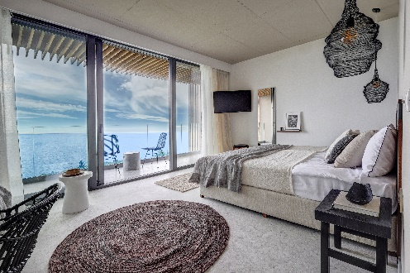 | 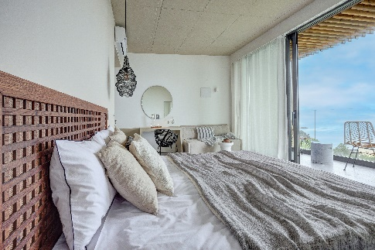 | 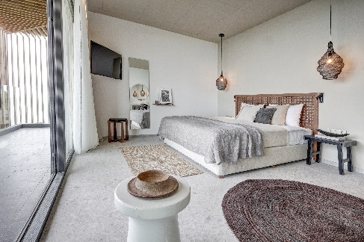
Size: | 33 sq.m. | 33 sq.m. | 28 sq.m.
View: | Sea or Park | Sea or Park | Park
Capacity (max) | 2 adults and 1 child | up to 4 guests, max. 3 adults or 2 adults + 2 children | 2 adults and 1 child *  *3 of our Double rooms do not offer a chair bed, capacity is max. 2 adults.
Beds: | 1 king size bed (1.80 x 2.00 m) and 1 convertible chair bed (0.80 x 1.90 m) | 1 king size bed (1.80 x 2.00 m) and 1 extendable double sofa (1.40 x 1.90 m) | 1 king size bed (1.80 x 2.00 m). Some of the rooms offer 1 convertible chair bed (0.80 x 1.90 m)
Bathroom: | 1 bathroom with shower and hair dryer | 1 bathroom with shower and hair dryer | 1 bathroom with shower and hair dryer
Room essentials for all room types:
 | Free Wi-Fi
 | Nespresso coffee machine
 | Minibar
 | Flat screen TV
 | Air conditioning
 | Safe deposit box
 | Balcony
ADDITIONAL SERVICES – ALL ROOM TYPES
- Quality toiletries & slippers
- Wake-up service
- Room Service – extra charge
- Laundry & ironing options – extra charge

UpStyle DOUBLE ROOM
Modern UpStyle room with refined design and exclusive sea views or a quiet view of the park, suitable for up to 2 adults and one child up to 11 years incl. The room with chic furniture and equipment allows you to enjoy superb views and the modern design of the vanity sink is just a complement and a stylish hallmark of the room. All UpStyle double rooms offer a spacious balcony, a king size bed (1.80 x 2.00 m), free WiFi, a flat screen TV, a minibar, a safe deposit box, and a convertible chair bed (0.80 x 1.90 m).
The bathroom is equipped with a shower and a hair dryer.
For your fresh mornings, a Nespresso coffee machine is available.
DOUBLE ROOM WITH SOFA
A spacious room for up to 4 guests (max 3 adults and 1 child up to 11 years or 2 adults and 2 children up to 11 years), with a stunning Sea view or a quiet Park view. Ideal for both couples and families, the rooms offer a king size bed (1.80 x 2.00 m), an extendable double sofa (1.40 x 1.90 m), a spacious balcony, free WiFi, a flat screen TV, a safe deposit box and a minibar.
The bathroom is equipped with a shower and a hair dryer. For your fresh mornings, a Nespresso coffee machine is available.

DOUBLE ROOM
Enjoy an outstanding quiet Park view room, offering a king size bed (1.80 x 2.00 m), free WiFi, a flat screen TV, a safe deposit box, a minibar and a balcony. Most rooms also feature a convertible chair bed (0.80 x 1.90 m)*. Maximum occupancy is 3 guests (max 2 adults and 1 child up to 11 years). The bathroom is equipped with a shower and a hair dryer. For your fresh mornings, a Nespresso coffee machine is available.* Three of our Double rooms do not offer a sofa and are suitable for up to 2 adults.

