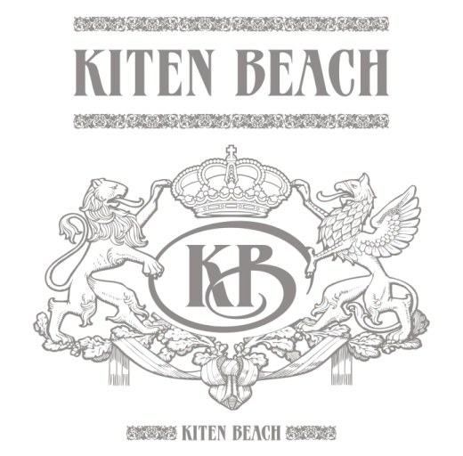 | Kiten Beach Hotel  Bulgaria, Kiten, 3 “Strandzha”Str.  +359 895523838  kiten_beach@abv.bg  www.kitenbeach.com
“Kiten Beach”Hotel

Аll inclusive package includes:
Restaurant:
- Breakfast on a buffet: 08:00 – 10:00 – hot drinks, milk, juice, water, tea, eggs, sausages, milk products, cornflakes, seasonal vegetables and fruits, deserts etc;
- Lunch on a buffet– 13:00 – 14:30 – soups, hot appetizers, dishes, grill, salads, seasonal vegetables and fruits, deserts etc;
- Dinner on a buffet – 18:30 – 20:00 – salads, grill, dishes from Bulgarian and International cuisine, seasonal vegetables and fruits, deserts etc.

Lobby & Pool Bar

- Drinks from the bar – 10:00 – 22:00 – hot drinks, juice, water, fizzy drinks from a machine, draft beer, quality Bulgarian alcohol /rakia, vodka, gin, whiskey, mint, mastic, rum/, wine /red and white/;
- After 22:00 all drinks in the bar are payable.
Included services:
- Outdoor swimming-pool;
- Sunbeds and umbrellas at the swimming-pool /according to availability/;
- Wi-fi in common areas;
- Cable internet in room;
- Safe in every room.

