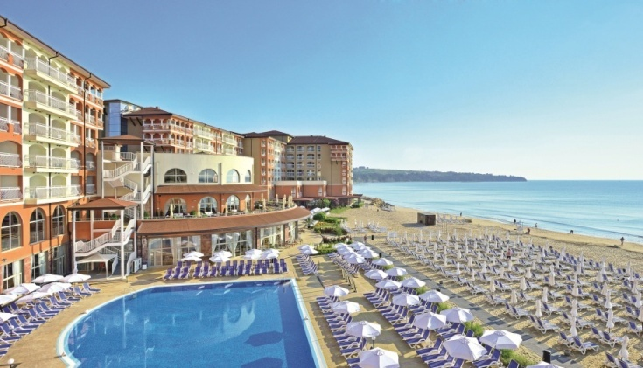
Accommodation:
The accommodation units are situated in two buildings located 100 m away from each other. Both buildings are connected by a bridge floating over a small river.
Each building is provided with a reception desk and a parking lot. Covered parking area is avilable only in one of the buildings.

Accommodation types:
Sol Luna Bay Resort offers spacious and tastefully decorated accommodation units where you can experience full comfort and relaxation.
Spacious and bright they are decorated in neutral colours and designed to offer full comfort and relaxation. Floor-to-ceiling windows allow abundant natural light into the room and reveal splendid views over the sea or the forested hillside.
There аrе the following main types of accommodation units available:
Double rooms and family suites are situated ONLY in the main hotel building.
Studios, one bedroom suites and two bedroom suites are situated ONLY in the Apart building.

Double rooms and studios:
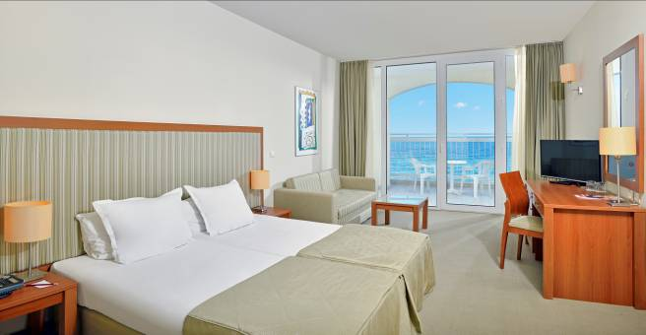
Double rooms (33 m²) are equipped with:
- 2 twin beds, which can be placed together to form a double bed.
- baby cot (on request and subject to availability).
- Sofa bed (140/180 cm when extended)
- Telephone
- Writing desk with chair
- Wardrobe
- Central air-conditioning with individual control of the room temperature
- Satellite TV with remote control
- Wi-Fi free of charge
- Mini-bar (extra charge)
- Safe ( extra charge)
- Bathroom with bathtub or shower
- Make-up mirror
- Hairdryer
- Liquid soap, shampoo (Body& Hair) and vanity kit
- Fresh-air windows
- Balcony/ terrace furnished with table, chairs and laundry dryer
The maximum occupancy is 2 adults and 1 child or 3 adults.
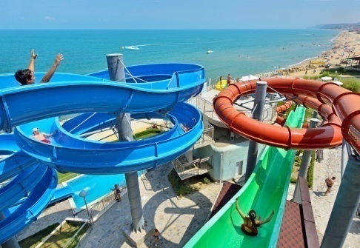

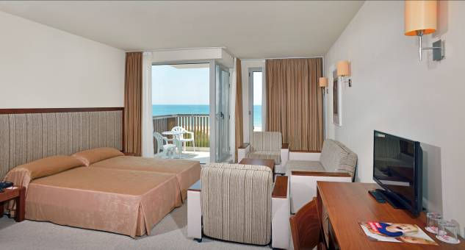
Studios (33 m²) are equipped with:
- 2 twin beds, which can be placed together to form a double bed.
- baby cot (on request and subject to availability).
- Sofa bed
- Telephone
- Writing desk with chair
- Wardrobe
- Individual air-conditioning
- Satellite TV with remote control
- Wi-Fi free of charge
- Mini-bar (extra charge)
- Safe ( extra charge)
- Bathroom with bathtub
- Make-up mirror
- Hairdryer
- Liquid soap, shampoo (Body& Hair) and vanity kit
- Fresh-air windows
- Balcony/ terrace furnished with table, chairs and laundry dryer
The studios are situated in the Apart building. The maximum occupancy is 2 adults and 2 children.

Family suites, one bedroom suites and two bedroom suites :
Especially attractive for families with children are the family suites and the one bedroom suites. Featuring warm and welcoming ambience they consist of two bedrooms with connecting door and provide more privacy during the best time of being together.

Family suites (53 sq.m) consist of standard double room with 2 twin beds put together as a double bed and one adjoining smaller bedroom with 2 separated twin beds. Floor-to-ceiling windows invite a lot of natural light into the both rooms. All family units are provided with a large private balcony or terrace, revealing a splendid view over the natural forested hillside or the sea.
Minimum capacity: 2 adults and 2 children above 2 years or 3 adults.
Maximum capacity: 4 adults plus 1 child on extra bed (sofa bed) and baby cot (on request subject to availability).
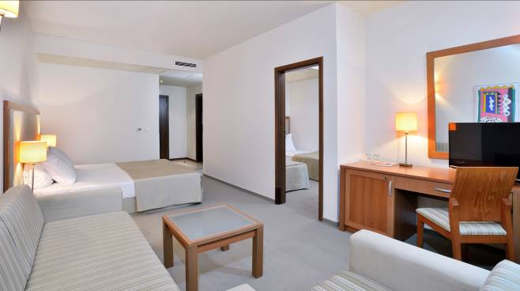
Family suites are equipped with:
- Telephone
- 2 Writing desks with chairs
- 2 Wardrobes
- Central air-conditioning with individual control of the room temperature
- Satellite TV with remote control
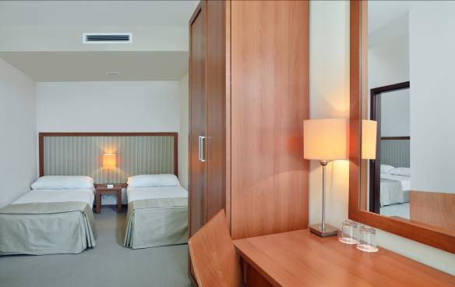
- Wi-Fi – free of charge
- Mini-bar (extra charge)
- Safe ( extra charge)
- 1Bathroom with bathtub or shower
- Make-up mirror
- Hairdryer
- Liquid soap, shampoo (Body& Hair) and vanity kit
- Fresh-air windows
- Balcony/ terrace with table, chairs and laundry dryer

One Bedroom Suite(53 sq.m) consists of living/bedroom area with extendible sofa and 2 extendible armchairs. Additional bedroom separated by door which offers 2 twin beds put together as a double bed.
Minimum capacity: 2 adults and 2 children above 2 years or 3 adults.
Maximum capacity: 4 adults plus 1 child and baby cot (on request subject to availability).

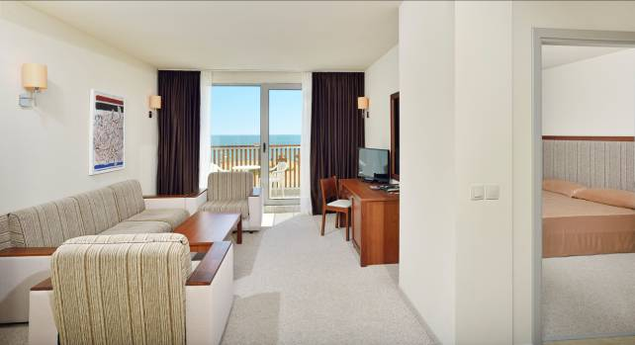
One Bedroom Suite are equipped with;
- Telephone
- Writing desks with chairs
- 2 Wardrobes
- Individual air-conditioning in each room
- Satellite TV set with remote control
- Wi-Fi – free of charge
- Mini-bar (extra charge)
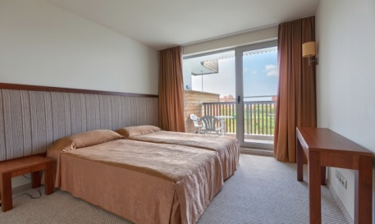
- Safe (extra charge)
- 1 Bathroom with bathtub
- Make-up mirror
- Hairdryer
- Liquid soap, shampoo (Body& Hair) and vanity kit
- Fresh-air windows
- Balcony/ terrace with table, chairs and laundry dryer
One bedroom suites are situated in the Apart building.

Two Bedroom Suites(65 sq.m) consists of living/bedroom area with extendible sofa and 2 extendible armchairs. Two bedrooms separated by door, each of them offers 2 twin beds put together as a double bed or separated.
Minimum capacity: 2 adults and 3 children above 2 years or 3 adults.
Maximum capacity: 4 adults and 2 children and baby cot (on request subject to availability) or 5 adults.

Two Bedroom Suites are equipped with:
- Telephone
- Writing desks with chairs
- 2 Wardrobes
- Individual air-conditioning in each room
- Satellite TV set with remote control
- Wi-Fi – free of charge
- Mini-bar (extra charge)
- Safe (extra charge)
- 1 Bathroom with bathtub
- Make-up mirror
- Hairdryer
- Liquid soap, shampoo (Body& Hair) and vanity kit
- Fresh-air windows
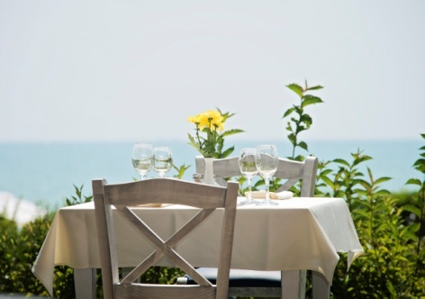
- Balcony/ terrace with table, chairs and laundry dryer.

Two bedroom suites are situated in the Apart building.

