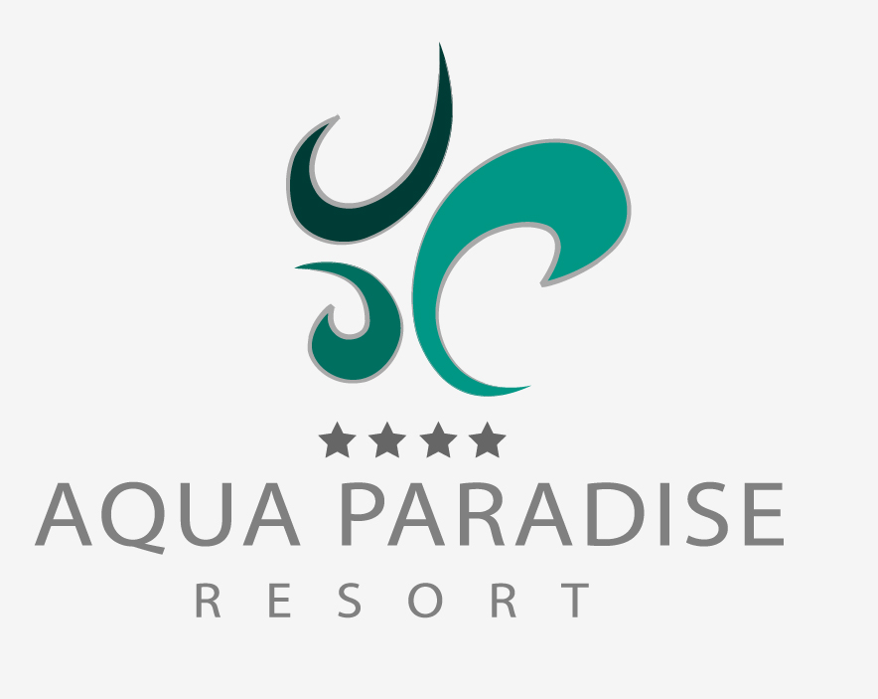

Fact sheet - Summer 2026

LIST FILLED IN/CHECKED BY: | DRAGOMIR STANCHEV – General Manager
DATE: | 09.09.2025
GENERAL INFORMATION
OFFICIAL NAME ACCOMMODATION | AQUA PARADISE RESORT
DEPOSIT REQUIRED | YES/NO: NO |  | AMOUNT:
GPS COORDINATES * | 42.656285 / 27.684330
ADDRESS | SUNNY BEACH AREA
IN TOWN/CITY/VILLAGE | Ravda, NESSEBAR
PHONE NUMBER | Reception: + 359 55 045 060; +359 879 99 77 99
EMAIL ADDRESS & WEBSITE | EMAIL: office@aquaparadiseresort.bg |  | WEBSITE: http://aquaparadiseresort.bg/
HOTEL GROUP / HOTEL CHAIN | NO
OFFICIAL CATEGORY (KEYS/STARS) | 4*
UNIQUE SELLING POINTS | ● FREE ENTRANCE TO THE AQUA PARK NEXT TO THE HOTEL COMPLEX
 | ● NEW COMPLEX WITH MODERN AND ECO-FRIENDLY ARCHITECTURE, NATURAL MATERIALS USED.
 | ●
MOST IMPORTANT TARGET GROUPS | YOUTH: not recommended | COUPLES: YES |  | FAMILIES: YES
YEAR OF CONSTRUCTION | 2017-2018
YEAR/SEASON OF LAST RENOVATION | 2018
RENOVATED AREAS | ALL
TOTAL NUMBER OF BUILDINGS | 3
MAXIMUM NUMBER OF FLOORS | 6
TOTAL NUMBER OF ROOMS | 434
TOTAL NUMBER OF LIFTS | 7
LIFT IN EVERY BUILDING | YES/NO: YES
RECEPTION | YES/NO: YES | 24/7 YES/NO: YES
CHECK-IN FROM: | 15:00H
CHECK-OUT TILL: | 11:00H
LATE CHECK-OUT: | YES/NO: UPON AVAILABILITY | CHARGEABLE/RATE: TBA
COURTESEY ROOM: | YES/NO: NO
LUGGAGE STORAGE ROOM: | YES/NO: YES
PETS ALLOWED | YES/NO: NO | FREE/RATE:
LOBBY | YES
GARDEN | YES
WHEELCHAIR FRIENDLY | YES/NO: YES | SPECIFY LIFTS/ROOMS/FACILITIES: TBA
LOCATION
ACCO AND SEA DIVIDED BY ROAD | YES/NO: YES | SPECIFY:
ACCO AND SEA DIVIDED BY BOULEVARD | YES/NO: YES | SPECIFY:
ON A HILL | YES/NO: NO | SPECIFY:
ON THE SEA (WITHOUT BEACH) | YES/NO: NO | SPECIFY:
ON THE SEA (WITH PUBLIC BEACH) | YES/NO: NO | SPECIFY:
ON THE SEA (WITH PRIVATE BEACH) | YES/NO: NO | SPECIFY:
NEAREST TOWN/CITY | NAME OF TOWN/CITY: RAVDA, NESSEBAR, SUNNY BEACH | METRES/KILOMETRES: 0.5 - 3.0 KM
NEAREST BEACH | NAME OF BEACH: RAVDA | METRES/KILOMETRES: 500M
TYPE OF BEACH (SAND, ROCKS ETC…) | SAND
PUBLIC TRANSPORT IN MTRS/KM | BUS: 1 km | METRES/KILOMETRES:
 | TRAIN: 25 km (Bourgas city) | METRES/KILOMETRES:
 | TAXI: YES | METRES/KILOMETRES:
DISTANCE IN MTRS/KM TO… | TOWN/CITY CENTRE 3.0 km | METRES/KILOMETRES:
 | NEAREST SHOPS 1.0 km | METRES/KILOMETRES:
 | NEAREST RESTAURANTS 1.0 km | METRES/KILOMETRES:
 | NEAREST BARS 1.5km | METRES/KILOMETRES:
TOURIST ATTRACTION 1: | NAME ATTRACTION: AQUA PARK, NEXT TO THE HOTEL | METRES/KILOMETRES: 50m
TOURIST ATTRACTION 2: | NAME ATTRACTION: | METRES/KILOMETRES:
TOURIST ATTRACTION 3: | NAME ATTRACTION: | METRES/KILOMETRES:
TOURIST ATTRACTION 4: | NAME ATTRACTION: | METRES/KILOMETRES:
SHUTTLESERVICE TO… | Hotel - Ravda – Nessebar - Hotel | FREE/PRICE: 2.5 Euro per person

ROOM FACILITIES
HOTEL ROOM
NAME OF ROOM TYPE | DBL STANDARD/Annex ; DBL SUPERIOR /Hotel
MINIMAL OCCUPATION | 2 pax
MAXIMUM OCCUPATON | 3 pax / 4 pax (in DBL Superior is possible 2 adt + 2 chd or 3 adt + 1 chd)
SIZE IN SQUAREMETRES | 27 -28 sq.m. –> DBL STD ; 32-35 sq.m. DBL SUPERIOR
SEPARATED LIVING ROOM | YES/NO: no
SEPARATED BEDROOM | YES/NO: no
TELEPHONE | YES/NO: yes
AIRCONDITIONING | YES/NO: yes | FREE/PRICE: FREE
TELEVISION | YES/NO: yes | SATELLITE/CABLE:
MINIBAR | YES/NO: no | FREE/PRICE:
REFRIDGERATOR | YES/NO: mini fridge – YES | FREE/PRICE: free
SAFE | YES/NO: yes | FREE/PRICE: free
COFFEE- & TEA FACILITIES | YES/NO: YES | FREE/PRICE: FREE
WIFI IN ROOM/APPARTMENT | YES/NO: yes | FREE/PRICE: free
BATH TUB | YES/NO: YES (in very limited number of rooms)
SHOWER | YES/NO: yes | WALK-IN SHOWER: YES/NO – yes
BATH TUB WITH SHOWER | YES/NO: no
HAIR DRYER | YES/NO: yes
BATHROBE | YES/NO: no
SLIPPERS | YES/NO: no
BALCONY OR TERRACE | YES/NO: yes
CHAIRS ON BALCONY OR TERRACE | YES/NO: yes
VIEW | TYPE: Random | FREE/PRICE: No
REMARKS

FAMILY ROOMS
NAME of ROOM TYPE | Family room in the contracts (Family Annex & Family Hotel)
MINIMAL OCCUPATION | As per contract: depends on the contract
MAXIMUM OCCUPATON | As per contract: depends on the contract
SIZE IN SQUAREMETRES | 56-62 m²
SEPARATED LIVING ROOM | YES/NO: see below
SEPARATED BEDROOM | YES/NO: Each Family room consists of 2 bedrooms and 1 living room.  Family room Hotel – The kid’s room is separated by a door; the parent’s room is with open space to the living room.  Family rooms in Annex buildings are with fully separated living room and bedrooms.
KITCHENETTE | YES/NO: no
OVEN | YES/NO: no
MICROWAVE | YES/NO: no
STOVE / COOKING PLATES | YES/NO: no | HOW MANY?
TOASTER | YES/NO: no
DISHWASHER | YES/NO: no
WASHING MACHINE | YES/NO: no
TELEPHONE | YES/NO: yes
AIRCONDITIONING | YES/NO: yes | FREE/PRICE: FREE
TELEVISION | YES/NO: yes | SATELLITE/CABLE: CABLE
MINIBAR | YES/NO: NO
REFRIDGERATOR | YES/NO: yes (mini fridge) | FREE/PRICE: free
SAFE | YES/NO: yes | FREE/PRICE: free
COFFEE- & TEA FACILITIES | YES/NO: yes | FREE/PRICE: FREE
WIFI IN ROOM/APPARTMENT | YES/NO: yes | FREE/PRICE: free
BATH TUB | YES/NO: yes, but in very limited number and only in Fam. rooms HOTEL
SHOWER | YES/NO: yes | WALK-IN SHOWER: YES/NO - yes
BATH TUB WITH SHOWER | YES/NO: no
HAIR DRYER | YES/NO: yes
BATHROBE | YES/NO: no
SLIPPERS | YES/NO: no
BALCONY OR TERRACE | YES/NO: yes
CHAIRS ON BALCONY OR TERRACE | YES/NO: yes
VIEW | TYPE: run of the hotel Random | FREE/PRICE: No
REMARKS | All Family rooms are with 2 separated bathrooms  There are also 1 bedroom APT furnished as the Family rooms, but with 1 separated bedroom, 1 bathroom and additional WC. Size of the unit:50-52 m2

FOOD & BEVERAGE FACILITIES
RESTAURANTS | NAME OF RESTAURANT | BUFFET OR À LA CARTE | TYPE OF DISHES / THEMES | INCLUDED IN CONCEPT
RESTAURANT #1: | MAIN | Buffet | International, theme nights 7 times per week | yes
RESTAURANT #2: | Adria Restaurant | Buffet | Italian | According to the number of minimum overnights stated in the AI concept. (pre-booking on spot required)
RESTAURANT #3: | Baltic Restaurant | À-LA-CARTE | Fusion | According to the number of minimum overnights stated in the AI concept. (pre-booking on spot required)
RESTAURANT #4:
RESTAURANT #5:
RESTAURANT #6:
RESTAURANT #7:
REMARKS

ALLERGY/DIET OPTIONS
YES/NO: yes | WHICH KIND: gluten free, vegan food, vegetarian food – to be requested in advance

BARS | NAME OF BAR | SELF SERVICE YES/NO | THEME/SNACKS/POOL | INCLUDED IN CONCEPT
BAR #1: | Snack/pool bar Adria | Yes |  | Yes
BAR #2: | Snack/Pool bar Baltic | Yes |  | Yes
BAR #3: | Lobby bar | No |  | Yes
BAR #4: | Café-bar | No |  | Yes
BAR #5: | Bowling bar | No |  | Yes
BAR #6: | Animation bar | No |  | Yes
REMARKS | At the lobby bar and the Bowling bar is possible to offer drinks with imported alcohol which are subject of extra charge

DISCO | YES/NO: no | INCLUDED IN CONCEPT YES/NO:
REMARKS
ROOMSERVICE | YES/NO: NO | INCLUDED IN CONCEPT YES/NO: No
REMARKS
CONCEPT
BASIC TYPES OF STAY | YES/NO: | BUFFET OR À LA CARTE
LODGEMENT (ROOM ONLY)
BED & BREAKFAST
HALF BOARD
FULL BOARD
REMARKS | All-inclusive

ALL INCLUSIVE CONCEPT | TIMES | BUFFET, À LA CARTE, SELF SERVICE
BREAKFAST
LATE BREAKFAST
LUNCH | SEE the ALL INCLUSIVE CONCEPT listed in separate document
DINNER
SNACKS
COFFEE, TEA & COOKIES
ICE CREAM
MIDNIGHT SOUP / SNACK
LOCAL SOFT- & ALCOHOLIC DRINKS
IMPORT DRINKS | ARE NOT INCLUSIVE
NOT INCLUSIVE
REMARKS

ULTRA ALL INCLUSIVE CONCEPT | TIMES | BUFFET, À LA CARTE, SELF SERVICE
BREAKFAST | N/A
LATE BREAKFAST | N/A
LUNCH | N/A
DINNER | N/A
SNACKS | N/A
COFFEE, TEA & COOKIES | N/A
ICE CREAM | N/A
MIDNIGHT SOUP / SNACK | N/A
LOCAL SOFT- & ALCOHOLIC DRINKS | N/A
IMPORT DRINKS | N/A
NOT INCLUSIVE
REMARKS

SWIMMING POOL FACILITIES
POOLS | FRESH OR SEA WATER | HEATED |  | SLIDES |  | THEME
POOL #1: | Fresh | Y/N | PERIOD: NO | Y/N | HOW MANY: 0 | Outdoor / Active area
POOL #2: | Fresh | Y/N | PERIOD: NO | Y/N | HOW MANY: 0 | Outdoor / Relax area
POOL #3: | Fresh | Y/N | PERIOD: NO | Y/N | HOW MANY: 0 | Outdoor / Relax area
POOL #4: | Fresh | Y/N | PERIOD: YES, (MAY; SEP & OCT) | Y/N | HOW MANY: 0 | Indoor
POOL #5: |  | Y/N | PERIOD: | Y/N | HOW MANY:
POOL #6: |  | Y/N | PERIOD: | Y/N | HOW MANY:
POOL #7: |  | Y/N | PERIOD: | Y/N | HOW MANY:
POOL #8: |  | Y/N | PERIOD: | Y/N | HOW MANY:
REMARKS

CHILDREN POOLS | FRESH OR SEA WATER | HEATED |  |  | SLIDES |  | THEME
POOL #1: | Fresh | Y/N |  | PERIOD: NO | Y/N | HOW MANY: 0 | Outdoor / Active area
POOL #2: | Fresh | Y/N |  | PERIOD: NO | Y/N | HOW MANY: 0 | Outdoor / Relax area kids’ section
POOL #3: | Fresh | Y/N |  | PERIOD: YES (MAY; SEP & OCT) | Y/N | HOW MANY: 0 | Indoor / section
POOL #4: |  | Y/N |  | PERIOD: | Y/N | HOW MANY:
POOL #5: |  | Y/N |  | PERIOD: | Y/N | HOW MANY:
POOL #6: |  | Y/N |  | PERIOD: | Y/N | HOW MANY:
POOL #7: |  | Y/N |  | PERIOD: | Y/N | HOW MANY:
POOL #8: |  | Y/N |  | PERIOD: | Y/N | HOW MANY:
REMARKS
LOUNGERS | YES/NO: YES |  | FREE/PRICE: free
MATRASSES | YES/NO: NO |  | FREE/PRICE: n/a
SUNSHADES | YES/NO: YES |  | FREE/PRICE: free
TOWELSERVICE | YES/NO: YES |  | FREE/PRICE/DEPOSIT: FREE/ Pool Towel Card service
REMARKS

BEACH FACILITIES
PRIVATE BEACH | YES/NO: NO
LOUNGERS | YES/NO: NO | FREE/PRICE:
MATRASSES | YES/NO: NO | FREE/PRICE:
SUNSHADES | YES/NO: NO | FREE/PRICE:
REMARKS | There is a public beach where local managements companies offer sun beds and sun-umbrellas for extra charge
INTERNET FACILITIES
WIFI PUBLIC AREAS | YES/NO: YES | FREE/PRICE: FREE | SPECIFY AREAS: lobby area, reception
INTERNETCAFE | YES/NO: YES NO | FREE/PRICE: TBA
REMARKS

KIDS FACILITIES
CLUB & ENTERTAINMENT | AGES | NUMBER OF DAYS A WEEK | AVAILABLE DURING WHOLE SEASON? | LANGUAGES
MINICLUB | 4-12 | 6 | YES/NO: YES | ENG, BUL, CZ
MIDICLUB |  |  | YES/NO: NO
TEENAGE CLUBS |  |  | YES/NO: NO
KIDS ENTERTAINMENT |  |  | YES/NO: YES - game zone, extra charge
REMARKS

MINIDISCO | YES/NO: YES
PLAYGROUND | YES/NO: YES
LUNA PARK | YES/NO: NO | FREE/PRICE:
BABY COTS | REQUEST AT BOOKING REQUIRED: YES | FREE/PRICE: FREE
BABYSIT SERVICE | REQUEST AT BOOKING REQUIRED: NO | FREE/PRICE: N/A
REMARKS

SPORT, RECREATION & RELAXATION FACILITIES
SPORT | YES/NO: | FREE/PRICE:
AEROBICS | NO
YOGA | YES
ARCHERY | NO
BASKETBALL | YES | FREE
VOLLEYBALL | YES | FREE
BEACH VOLLEYBALL | NO
BOCCIA / PETANQUE / JEU DE BOULES | NO
DARTS | YES | Extra charge
FOOTBALL | YES (mini football) | Free
TABLE FOOTBALL | YES | Charge – price TBA
BILLIARDS | YES | Charge – price TBA
TABLE TENNIS | YES | Charge – price TBA
TENNIS | YES | Charge – price TBA
SQUASH | NO
MINI GOLF | NO
BOWLING | YES | Charge – price TBA
GAME ROOM | YES | Charge – price TBA
DIVING CENTRE | NO
WATERSPORTS | At the public beach | Charge – price TBA
REMARKS & OTHER FACILITIES + COSTS

RELAXATION | YES/NO: | FREE/PRICE:
FITNESS / GYM | YES | FREE
HAMAM | YES | Charge – price TBA
SAUNA | YES | FREE
INDOOR POOL | YES | FREE
JACUZZI | YES | FREE
MASSAGES | YES | Charge – price TBA
BEAUTY TREATMENTS | YES | Charge – price TBA
HAIRDRESSER | YES | Charge – price TBA
REMARKS & OTHER FACILITIES + COSTS

ENTERTAINMENT | YES/NO: | NUMBER OF DAYS A WEEK
FOR ADULTS | Evening show programs from the animation team | 7
SHOWS | Evening show programs from the animation team | As per the program of the animation team listed in the hotel
LIVE MUSIC
REMARKS & OTHER FACILITIES + COSTS
OTHER FACILITIES
SHOPS | YES/NO: YES | NUMBER OF SHOPS: TBA
MINI MARKET | YES/NO: YES, charge
LAUNDRY & DRY SERVICE | YES/NO: YES, charge
MEDICAL SERVICE | YES/NO: YES, charge
PRIVATE PARKING | YES/NO: YES | FREE/PRICE: free
PUBLIC PARKING | YES/NO: NO | FREE/PRICE:
REMARKS / OTHER FACILITIES + COSTS

