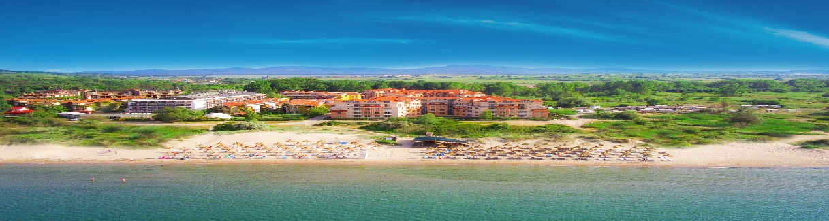
HACIENDA BEACH RESORT
Nestled in the warm embrace of “Golden Fish” Bay, 30 km south of Bourgas and 6 km from the Ancient town of Sozopol. Hacienda Beach Resort unveils serene and beautiful surroundings with sunny beaches and panoramic view of the sea.
Close to the hotel are situated the popular camping sites “Gradina” and “Golden Fish”, which are amongst the most desired places for summer vacation on Bulgaria’s southern Black Sea coast.

LOCATION  - GPS Coordinates: 42.698965.27.71709  - Distance to Airport: Bourgas-40км.; Varna-165км.; Sofia - 413км.  - Distance to nearby towns: Sozopol-4км.; Burgas-31км  - Distance to Bus Station: 500м. Bus to Sozopol Center  - Distance to „Golden Fish“beach -100м.; Beach in camping site “Gradina”-2.5 км |  |  | HOTEL DETAILS  - 4 stars  - Total Surface: 3600 м2  - Number of apartments: 200  - Build in 2012  - Last renovation: 2022  - 6 buildings by 4 flours  - Elevator – one in each building.

PARKING  - Secured parking with limited parking slots  - Price -7.70 Euro per day, per vehicle  - Advance reservation is not possible  INTERNET  - WiFi free of charge in the entire property |  |  | GENERAL SERVICES  - Room cleaning: every 2nd day  - Towels change: twice per week  - Bedsheets change: twice per week  - Amenities – once per stay  - Accepted Credit Cards: VISA § MasterCard  - Rent-a-car: Paid  - Doctor Visit: Paid, on request.  - Laundry - Paid

SWIMMING POOL AND BEACH  - Outdoor pool opening hours 09:00-18:00 hrs  - Sunbed and umbrella by the pool, free of charge and subject to availability. No advance reservation possible.  - Sunbed & umbrella at the beach- paid service |  |  | RECEPTION  - Check-in: 14.00 hrs  - Check-out: 12.00 noon  - Late Check-out subject to availability and payment  - Reception: from 08:00 to 12:00 Midnight

RESTAURANTS  - Main Restaurant “Atia” offers Buffet for Breakfast, Lunch and Dinner. Opening hours: 07:30-10:00hrs., 12:00-14:00hrs., 18:00-21:00 hrs |  |  | BARS  - Pool Bar: Opening hours 11:00-23:00 hrs.  - Snack Bar: Opening hours 11:00-17:00 hrs.  - In proximity to the hotel are located some iconic Beach bars, which could be visited for an extra charge.

CHILDREN  - Baby chairs in the restaurant: Free of charge  - Baby Cot, free of charge, on request  - Outdoor Children Playground: free of charge  - Outdoor Childrens Pool and Children animation |  |  | PET POLICY  - Dogs up to 5 kg are welcome.  Price: 10.23 Euro per day  - Must be requested in advance

1-BEDROOM APARTMENT  - Size: 40-62 sq.m.  - View: Park View  - Minimum occupancy: 2 pax  - Maximum occupancy: 2+3 / 3+1  - Comprised of Bedroom, Sitting room & Bathroom  - Bed types: Queen size bed and un-foldable Sofa bed |  |  | APARTMENT FACILITIES  - Balcony  - Air-Condition  - Phone  - TV  - Cable TV  - Safety Box  - Floor type: tiles  - Mini fridge  - Electric kettle  - Hairdryer  - Shower or Bathtub  - Amenities: once per stay  - Iron on request  *Please note that the apartments does not offer paid channels and CD or DVD players
2-BEDROOM APARTMENT
- Size: 70-85 sq.m.
- View: Park view
- Minimum Occupancy: 4
- Maximum occupancy: 4+2 / 5+1
- Comprised of two bedrooms, sitting room and one bathroom
- Bed types: two queen size beds and un-foldable sofa bed

DELUXE APARTMENT SEA VIEW  - Size: 60 sq.m.  - View: Sea view  - Minimum occupancy: 2  - Maximum occupancy: 2+1 / 3+0  - Comprised of bedroom, sitting room, bathroom and kitchen  - Bed types: queen size bed & sofa |  |  | MEDIA KIT  - Hi-resolution images ca be found and downloaded on https://haciendabeach.bg/media-kit/  - Virtual tour of the resort on the following link:  https://tourmkr.com/F1m1Re4Nmr  - Video: https://youtube.com/watch?v=8pJy2vDGsVY&feature=share  https://youtube.com/watch?v=nNbKCjcSHCs&feature=share

*Please note that the following services are not available at the resort: Safe on the reception, Room Service

HACIENDA BEACH ALL-INCLUSIVE PACКAGE

SUNBEDS & UMBRELLAS BY THE POOL  Sunbeds and umbrellas are located around the swimming pool and are subject to availability.  Swimming pool Opening hours 09:00 to 18:00 hrs  Please note that the beach front is managed by a concessioner and the usage of sunbeds and umbrellas at the beach is paid service.  SPORT ACTIVITIES AND ANIMATION  Outdoor Children Playground  Children animation  Outdoor fitness and Table tennis  OTHER SERVICES  Safety box free of charge in all apartments.  Wi-Fi Internet connection free of charge in all the hotel. |  |  | RESTAURANTS & BARS  All guests booked on All-Inclusive package will be given bracelets for identification.  Main Restaurant „Atia“  For Breakfast, Lunch and Dinner, the restaurant offers Buffet set up with Salad Bar, Soups, Appetizers, Main course, Fruits and desserts. There is a choice of Bulgarian non-alcoholic and alcoholic beverages, Beer and Wine, tea and coffee.  Opening hours:  Breakfast: 07:30 – 10:00 hrs.  Lunch: 12:00 – 14:00 hrs.  Dinner: 18:00 – 21:00 hrs  Pool Bar (Opening hours: 11:00 – 23:00 hrs.)  - The guests can enjoy Hot and cold beverages, Bulgarian non-alcoholic and alcoholic beverages, beer and wine.  Snack Bar (Opening hours: 11:00 – 17:00 hrs.)  - The Snack bar offers a choice of Ice cream and light snacks.

