Complex "Mistral" Saint Vlas
Children camp
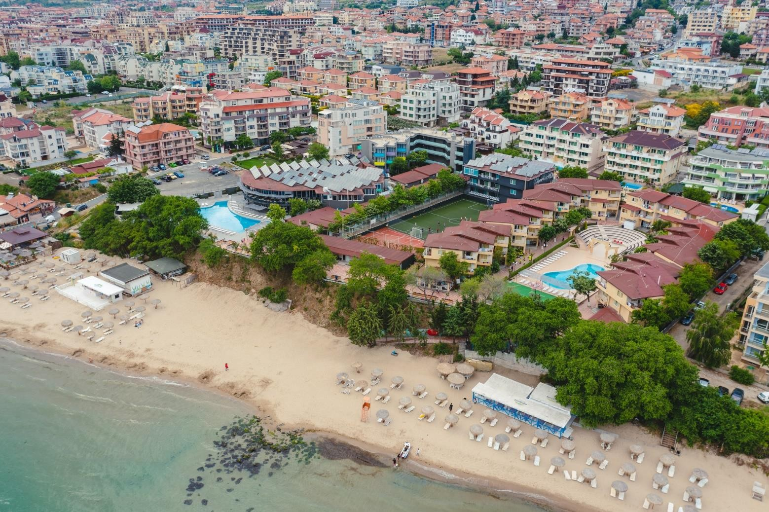

LOCATION

The complex is located on the seashore and at the foot of Stara Planina, in the resort town of Sveti Vlas, between some of the most popular resorts of Bulgaria: "Sunny Beach" and "Elenite".

The ancient and historical town of Nessebar is located 15 km from the complex and is on the UNESCO list, Burgas airport is 40 km away.

Complex "Mistral" was opened in 2000. The combination of sea and mountain air has a very beneficial effect on the health of children and adults with respiratory problems.

INFRASTRUCTURE
- 1 large pool (width - 12.00m; length - 25m; depth - 1.20-1.50-1.80m), 3 swimming corridors. Small pool (width - 6m; length - 16m; depth - 1.10m) with sunbeds and umbrellas
- Football field (35 m x 22 m with artificial grass), Volleyball and basketball field (22 m x 16 m)
- Indoor dance hall with laminate, walls with mirrors (300 sq.m.), we provide tatami, mats
- Open Amphitheater ( 800 seats)
- Amphitheater-style outdoor cinema (300 seats)
- Mini-golf, chess, table tennis, table chess, darts
- Animation
- Relaxation area
- Restaurant with a terrace with 400 seats
- 24-hour doctor's office on the territory of the camp. Working with medical insurance.
- In each room: air conditioning, wardrobe, TV, telephone, WC (bathroom and toilet), mini fridge, and mirror.

