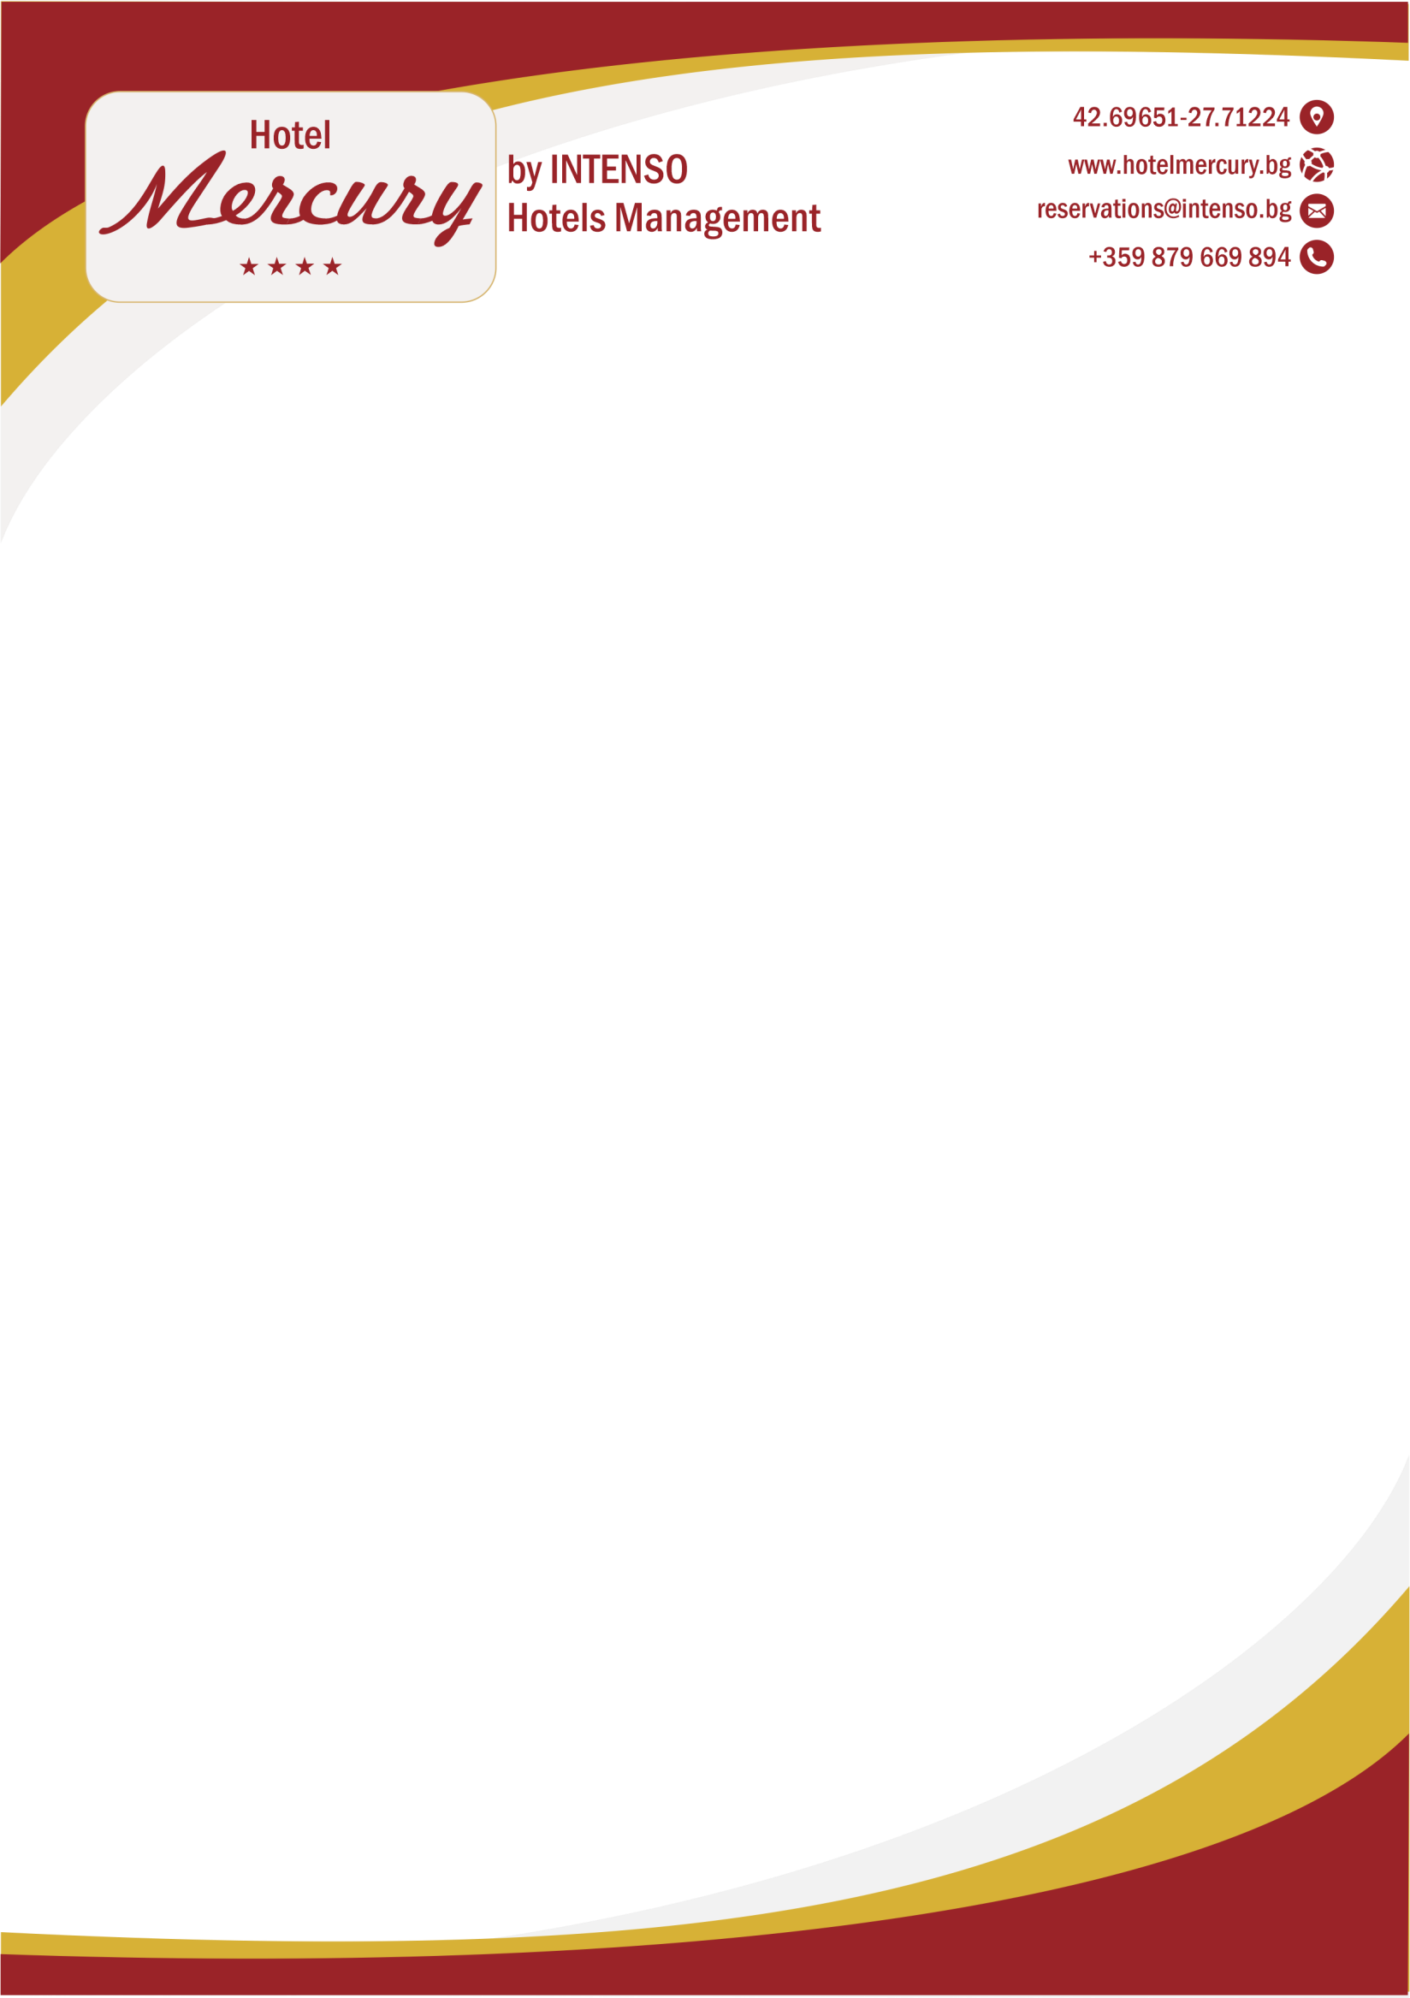

General Information
Opening Year | 2000 |  |  |  | Season | 2024 Summer Season
Last Renovation | 2021 |  |  |  | Concept | All Inclusive Premium
Category | 4 Stars |  |  |  | Heating-Cooling | Individual air conditioning in every room
 |  |  |  |  | For Handicapped Guests | Suitable in open area, handicapped room – no.
Total Area | 6200 m2 |  |  |  | Meeting- /Conference Room | Available, 40 pax capacity
Parking Lot | Open air parking, subject to availability, paid locally |  |  |  | Credit Cards | Visa, MasterCard,
Elevators | Available |  |  |  | Pets | Not allowed.
Check in time | 14:00 |  |  |  | Check out time | 12:00
Contact / Location Information
Address | Sunny Beach, Bulgaria |  |  |  | Bourgas Airport | 32 km
GPS | 42.69619000106784, 27.712737768888474 |  |  |  | Bourgas City Center | 40 Km
Phone | +359 879669885 |  |  |  | The Nearest Settlement | Nessebar – 5 km
 |  |  |  |  | Public Transport Connections | Taxi, bus
Web | https://hotelmercury.bg/ |  |  |  | Location of the beach | 150 m distance to the beach
 |  |  |  |  | Borders of the hotel | Hotel Barcelo, hotel Sun Palace
Accommodation
Number of Rooms | 130 rooms |  |  |  | Number of Beds | 260 regular beds
Number of Buildings | 1 Building |  |  |  | Number of floors | 4 Floors
Room Types | Double Standard room, Double Deluxe room, One-bedroom Apartment
Room Facilities
Rooms / Features |  | Double Standard Room |  | Double Deluxe Room |  | One-bedroom apartment
Number of Rooms |  | 112 |  | 10 |  | 8
m² |  | 26 m² |  | 26 m² |  | 48 m²
Person capacity |  | Min. 1 - Max. 2+2 / 3+1 |  | Min. 1 - Max. 2+2 / 3+1 |  | Min. 2+0 - Max. 2+2 / 3+1/4+0/4+1
Room Sections |  | 1 Sleeping Room |  | 1 Sleeping Room |  | 1 Living room, 1 bed Room, connecting door
Handicap Room |  | N/A |  | N/A |  | N/A
Bed Type |  | 2 regular Twin beds or 1 double bed, floating sofa or floating bed as an additional bed, |  | 2 regular Twin beds or 1 double bed, floating sofa or floating bed as an additional bed, |  | King size bed in the bed room, floating sofa and floating bed as an additional bed (in the living room) | Note: Only 2 twin or 1 regular bed available!!! 3 regular beds is not optional!!!
Short description |  | It has double or twin beds. It comes with individual air conditioning, furnished balcony or terrace, mini fridge, TV, WC and bathtub, hairdryer. Those rooms are available with garden or street view. |  | Luxurious rooms with Pool side view. It has double or twin beds. It comes with individual air conditioning, furnished balcony or terrace, mini fridge, LCD TV, WC and bathtub, hairdryer. Additional services: Full mini-bar equipment once upon arrival for the whole family with high quality beverages and snacks .Selection of quality body bathroom cosmetics, VIP set of towel and personal cosmetic tool, coffee and tea set, electric kettle, mineral  water) |  | It consists of 1 living room (with individual toilet) + 1 bedroom with double bed. It has double or twin beds. It comes with individual air conditioning, furnished balcony or terrace, mini fridge, LCD TV, WC and bathtub, hairdryer.
Balcony or Terrace |  | ✓ |  | ✓ |  | 2 Terraces (1 in living room, 1 in bedroom)
Shower/Bathtub |  | ✓ |  | ✓ |  | ✓
WC |  | ✓ |  | ✓ |  | 2 toilets (1 in living room, 1 In bedroom, with bidet)

Safe (Free) | At the reception, free |  | At the reception, free |  |  | At the reception, free
Telephone | ✓ |  | ✓ |  |  | ✓
TV - Satellite | ✓ |  | ✓ |  |  | ✓
Mini Fridge | ✓ |  | ✓ |  |  | ✓
Floor | Carpet floor |  | Carpet floor |  |  | Carpet floor
Hair dryer | ✓ |  | ✓ |  |  | ✓
Wi-fi – free of charge | ✓ |  | ✓ |  |  | ✓
Wardrobe | ✓ |  | ✓ |  |  | ✓
Air condition | Individual |  | Individual |  |  | Individual
Kettle | N/A |  | ✓ |  |  | N/A
Tea / Coffee | N/A |  | ✓ |  |  | N/A
Room Cleaning | Everyday |  | Everyday |  |  | Everyday
Linen Change | Every 4th day |  | Every 4th day |  |  | Every 4th day
Towel change | once per day, every day |  | once per day, every day |  |  | once per day, every day
All Inclusive Premium Food Concept
Place |  | Services |  |  | Opening Hours
Main Restaurant Mercury |  | Breakfast (Buffet) |  |  | 07:30 - 10:00 - buffet and includes soft drinks, tea, coffee, hot drinks, water, milk
 |  | Lunch (Buffet) |  |  | 12:30 - 14:30 - buffet and includes water, juice, soft drinks, draft beer, wine
 |  | Dinner (Buffet) |  |  | 18:30 - 21:00 - buffet and includes water, juice, soft drinks, draft beer, wine
Snack House at the swimming pool |  | Late breakfast and day – time snack  : |  |  | 10:00 – 17:00 - pizza, hot-dogs, cakes, pancakes, doner kebab, sandwiches, sides, salads, French fries. For Kids Popcorn machine, Sweet corn making machine
All Inclusive Premium Beverage Concept
Bars |  |  |  | Opening Hours
Lobby Bar Mercury |  |  |  | 10:00 - 23:00 soft drinks, draft beer and wine (local produce), selected brands of local and imported alcohol beverages, refreshing alcohol and non-alcohol cocktails, water, coffee, tea, hot drinks, milk
Cocktail Bar Mercury |  |  |  | 10:00 - 23:00 soft drinks, draft beer and wine (local produce), selected brands of local and imported alcohol beverages,  refreshing alcohol and non-alcohol cocktails, water, coffee, tea, hot drinks, milk
Swimming Pools
Pool Name |  | Area (m²) |  |  | Depth (cm)
Outdoor Pool |  | 190 m 2 |  |  | 180
Outdoor Children Pool section |  | 100 m 2 |  |  | 60
 |  | Free use – Sunbeds and Umbrellas at the swimming pool
 |  | Working time: 09:00 – 18:00 (lifeguard on duty)
Beach
Beach Properties |  | Beach Dimensions
Distance from the beach to the Hotel 150 m, fine sandy beach; |  | Length of the beach – 8km. No private beach available.
For Children
Play ground |  |  |  | Mini Disco
Kids Club |  |  |  | Sports Activities, Pool Games, Competitions, Creative Activities
Other Services
FREE | Gym ( 9:00 – 20:00 ) |  |  | Wi- Fi in the lobby and in the rooms of the hotel |  |  | Competitions, activities, theme parties and evening and day animation activities.
FREE | Evening animation shows. |  |  | Safety Deposit Box at the reception |  |  | Darts, chess, cards
FREE | Table tennis (deposit only) |  |  | Conference Hall, REP’s info room |  |  | Sunbeds and Umbrellas at the swimming pool
FOR A FEE | Early check in, late check out – upon availability |  |  | Parking (subject of availability)– 25 BGN per car per day |  |  | Laundry service, Taxi / rent-a-car
FOR A FEE | Beach Towel (Deposit only) |  |  | Health Service |  |  | Shops NEARBY THE HOTEL, Beauty salon, Hairdresser
Additional information
On arrival, the All Inclusive Premium package starts with lunch and ends with breakfast on the day of departure. Dress code – No barefoot and swim wear in the restaurant
It is not tolerated to reserve parasols and sunbeds by placing towels or other personal belongings. . Hotel management reserves the right to duly action against it.
Please, don’t bring any food or beverages into your hotel rooms.
Dry packages for late arrivals or early departures are available upon request. Sunbeds and loungers are not to be used for periods out of working time
No children should be in the fitness room (gym) without adult supervision
The hotel management reserves the right to make changes to the services provided if necessary in accordance with the C-19 measures.

