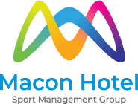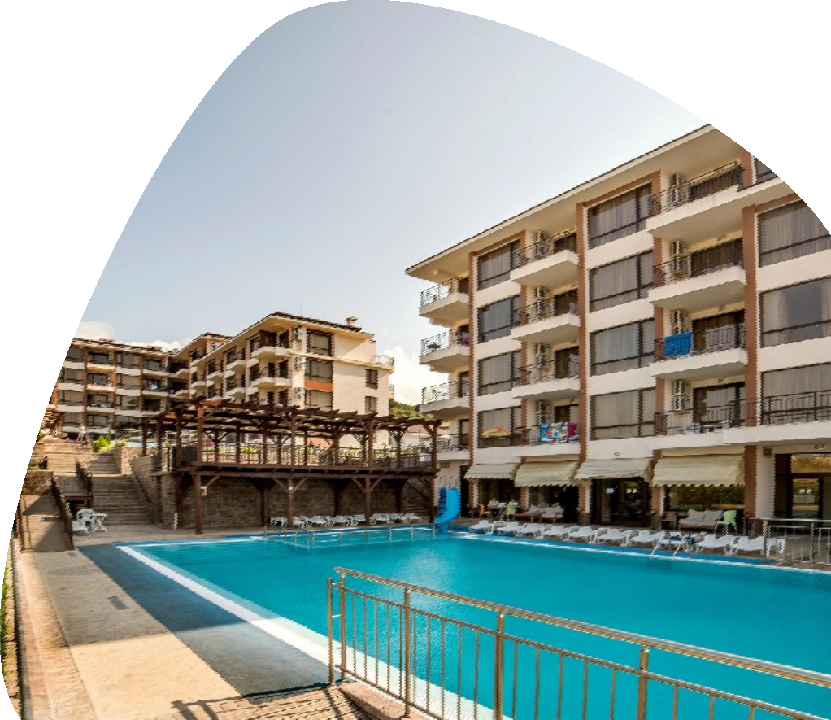

Hotel Macon

Macon – is a new modern hotel, which is located in young, actively developing resort town Sveti Vlas in Bulgaria. It has been operating since 2012 and includes 6 hotel buildings, 3 of which were opened in 2015.

The hotel is primarily focused on sports groups and offers everything you need for effective trainings and a good rest. Macon – is an ideal place for holding sport & training camps, fitness-tours, competitions, sport camps, as well as for individual travelers, who want to promote their health and improve their fitness.

Territory has been planned and divided such way, that all visitors feel comfortable. That’s why sport grounds are
separated from lounge zones, and for athletes’ and guests’ accommodation there are different hotel buildings.

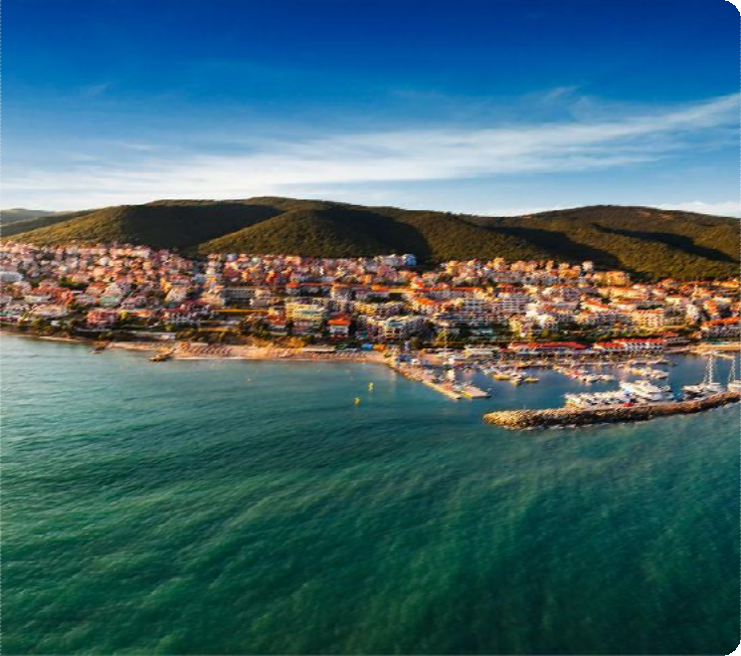Sveti Vlas

Sveti Vlas — one of the most picturesque resorts on the Black Sea coast of Bulgaria. Today this city is regarded as one of the best places for a peaceful holiday. With this, Sveti Vlas is just in 5-10 minutes drive from the youth resort Sunny Beach – the center of active nightlife.

In so far Sveti Vlas is one of Bulgaria's newest resorts, its tourism infrastructure is the most up to date. There are plenty of opportunities for leisure - water sports, sailing, sea and mountain walks, cycling, hiking routes.

Sveti Vlas

In 2006, the Marina Dinevi Yacht Port was built in the city, where two yacht regattas, retro motorcycle parades and other events are held. On the open stage of the amphitheater complex "Arena" are held theatrical performances, music and show programs.

The entire coast of Sveti Vlas is a natural Riviera. Beaches are wide, clean,
and covered with fine golden sand, with gentle slope to the sea.

Just in 10 km from Sveti Vlas there is Old Town of Nessebar - the famous ancient city “The Pearl of Bulgaria”, included in the list of the world cultural heritage.

The average air temperature in the summer months is + 27C, and the average water temperature is about + 26 ° C. Swimming season lasts from May to September.

Advantages

- Comfortable accommodation in shared rooms with all the facilities for 2-4 persons
- A variety of sports grounds for different types of sports
- Possibility for parents to stay at the same area with
Athletes
- Sports nutrition
- Varied entertainments program
- Sand beach with a gentle slope
- A plenty of modern attractions around the hotel
- Sunny Beach and Nessebar, Yacht port Marina in 10 minutes’ drive
- Private secured territory

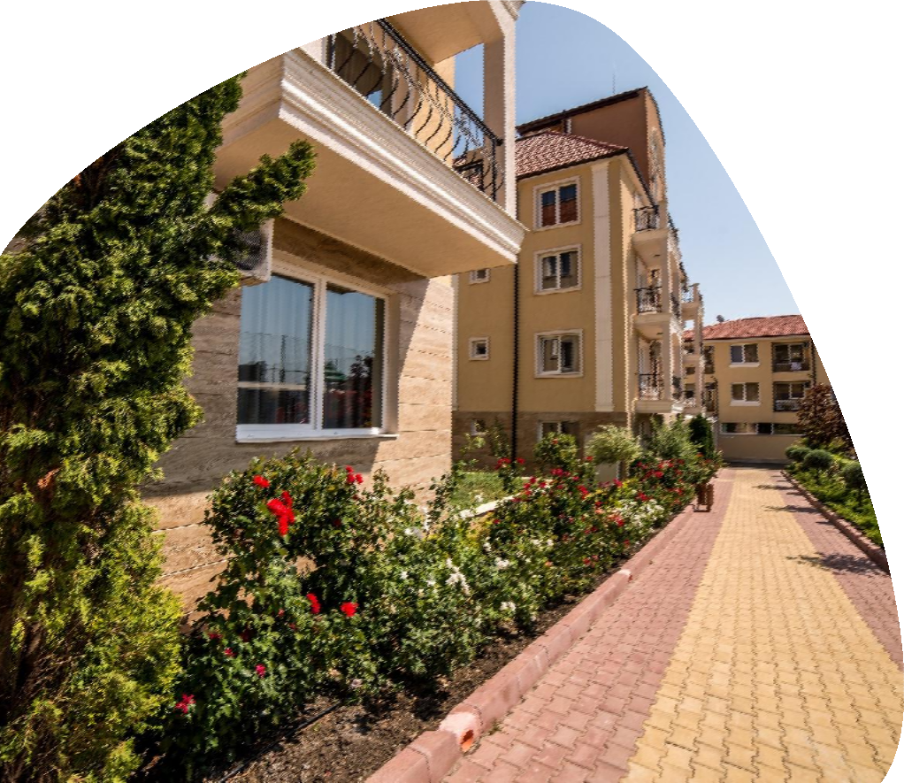

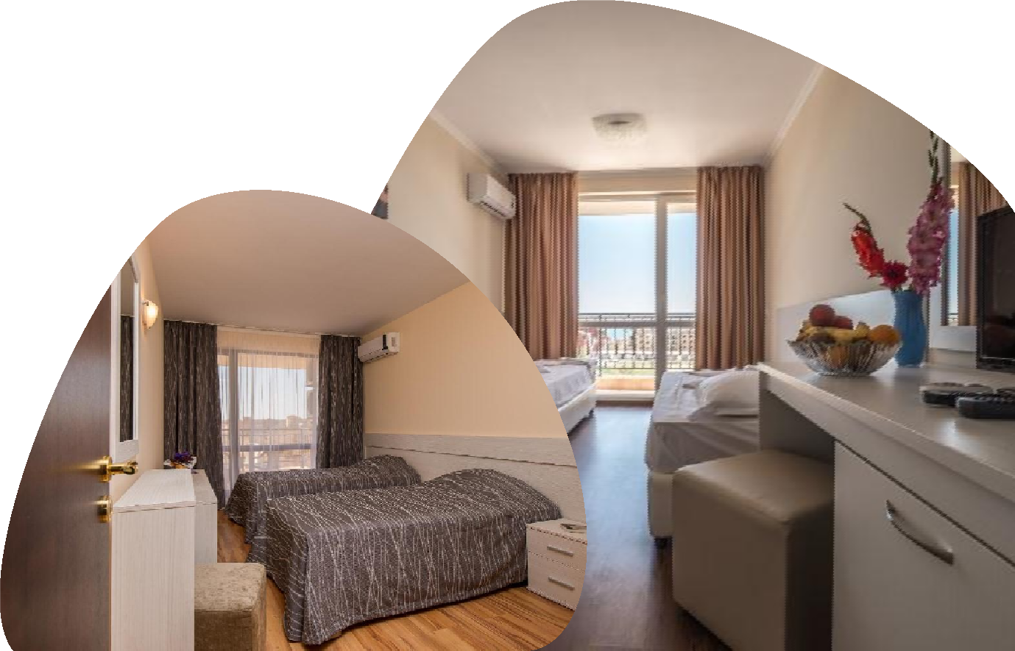
Hotel Rooms

For athletes, we offer accommodation in comfortable rooms with placement from 3 to 6 persons.

Each room has a bathroom with a shower and WC, a hairdryer, a terrace, air conditioning, a refrigerator, satellite TV.

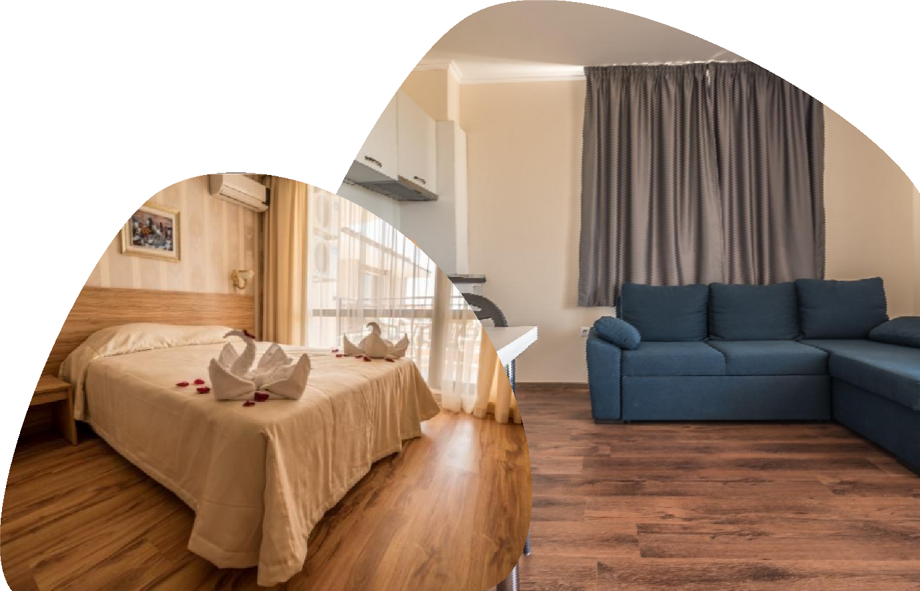

Hotel Rooms

For parents of athletes there is the possibility to stay in our separate building - Macon Residence. There are all conditions for comfortable rest with the whole family.

Spacious 2-rooms apartments with a fully equipped kitchen (fridge, cooker, dishwasher, kitchen hood), terrace, bathroom, air conditioning, satellite TV and furniture.

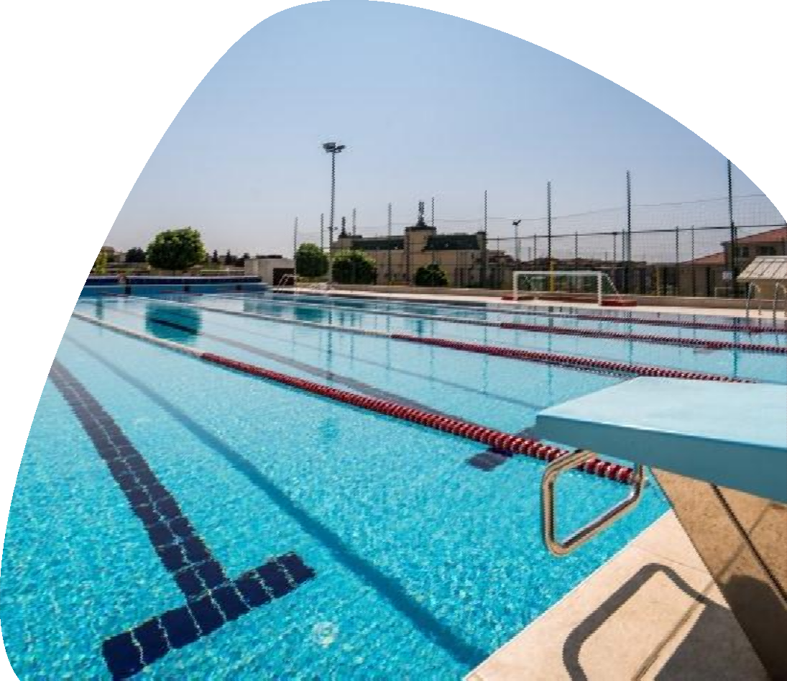

Swimming Pool

Basin size: 25 m*12,5 m (5 lanes); depth from 1,70 m to 2,20 m

- Equipment: starting blocks, hand rails, ladders,

water polo gates

- Sports, activities: swimming trainings (group and individual lessons), water polo, aqua- aerobics, synchronized swimming, scuba diving

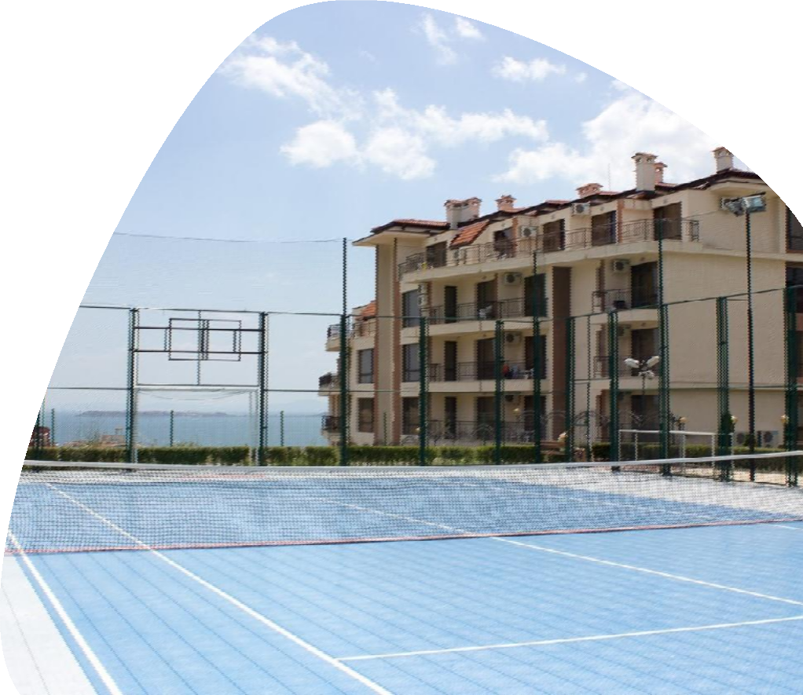
Court 1

- Sizes: 32 х 19,6 m

Specification: Coverage Multisport. The well- designed structure and texture of the coverage provides excellent elasticity, resilience, grip and provides complete protection of players against сricks and injuries

- Equipment: gates 3 х 2 m, basketball backboards 180 х 105 cm, basketball rims diameter 45 cm, net with volleyball markup

- Sports, activities: mini-football, handball, volleyball, basketball, inline hockey, fitness programs, modern dance styles, etc

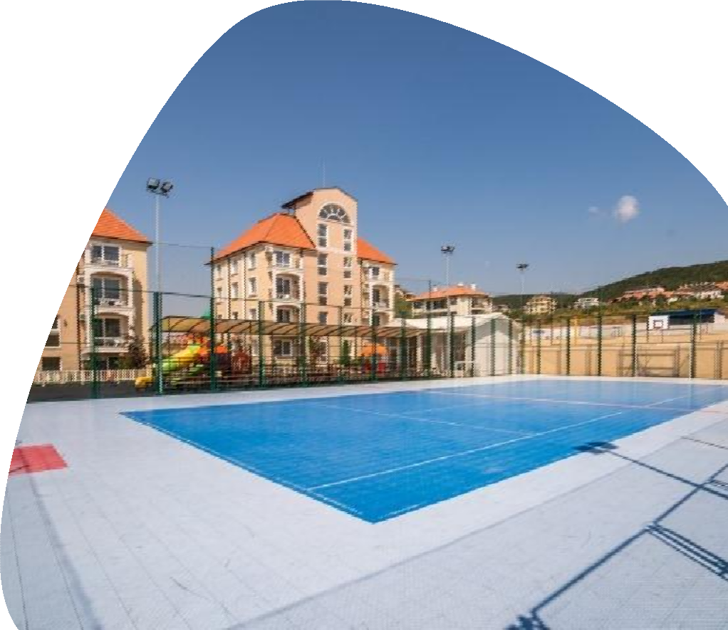
Court 2
- Sizes: 34 х 19,6 m

Specification: Coverage Multisport. The well- designed structure and texture of the coverage provides excellent elasticity, resilience, grip and provides complete protection of players against сricks and injuries.

- Capacity: up to 100 people

Equipment: gates 3 х 2 m, basketball backboards 120 х 90 cm, basketball rims diameter 45 cm, net with volleyball markup

- Sports, activities: mini-football, handball, volleyball, basketball, inline hockey, fitness programs, modern dance styles, etc

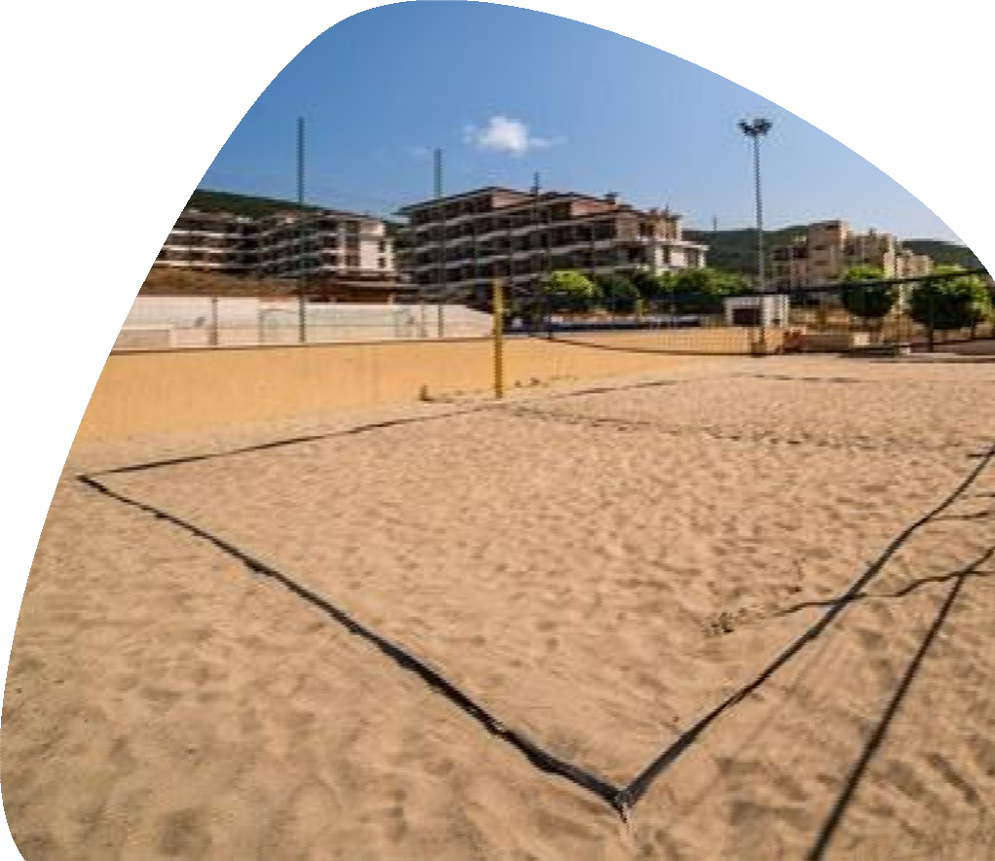
Beach Volley ground

- Sizes: 27 х 10 m

- Equipment: poles with height adjustment, safe

markup for beach volleyball

- Sports, activities: beach volleyball, bocce, fitness programs

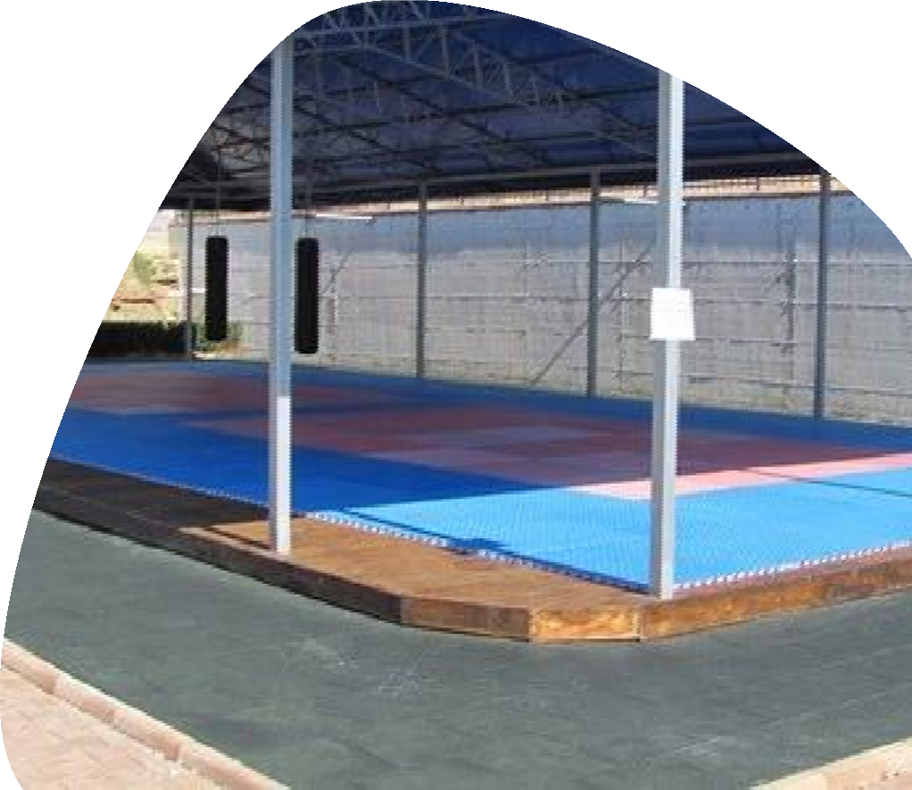

Combat 1

Sizes: 19 х 9 m, ceiling height 3-4 m

- Description: wooden platform, tatami, stationary awning against the sun and rain

- Capacity: up to 25 people

- Equipment: tatami, «Dovetail»

- Sports, activities: martial arts, combats, fitness programs, modern dance styles

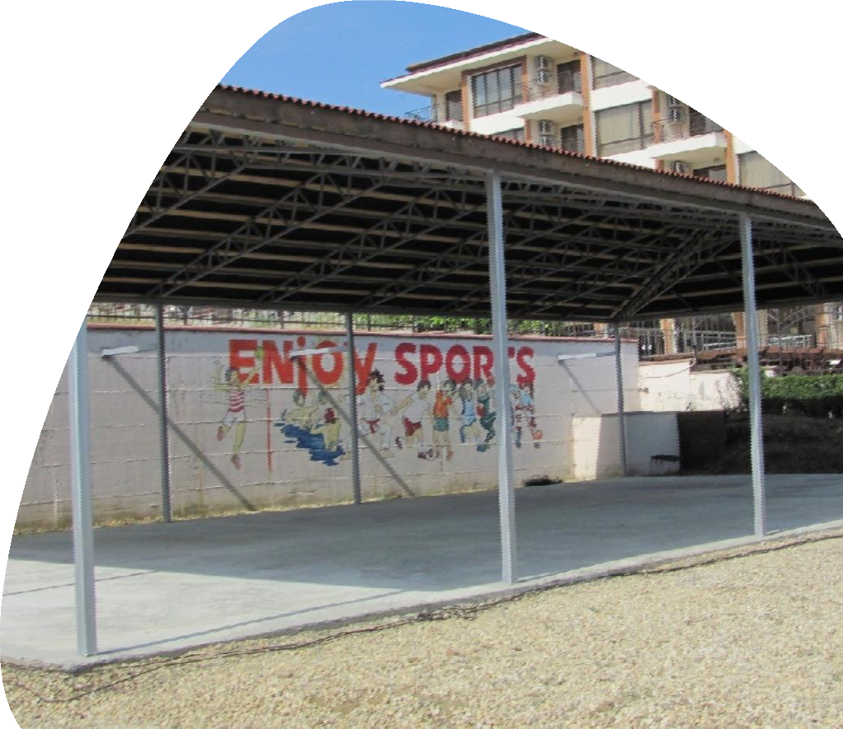

Combat 2

Sizes: 18 х 9 m, ceiling height 3-4 m

- Description: wooden platform, tatami, stationary awning against the sun and rain

- Capacity: up to 25 people

- Equipment: tatami, «Dovetail»

- Sports, activities: martial arts, combats, fitness programs, modern dance styles

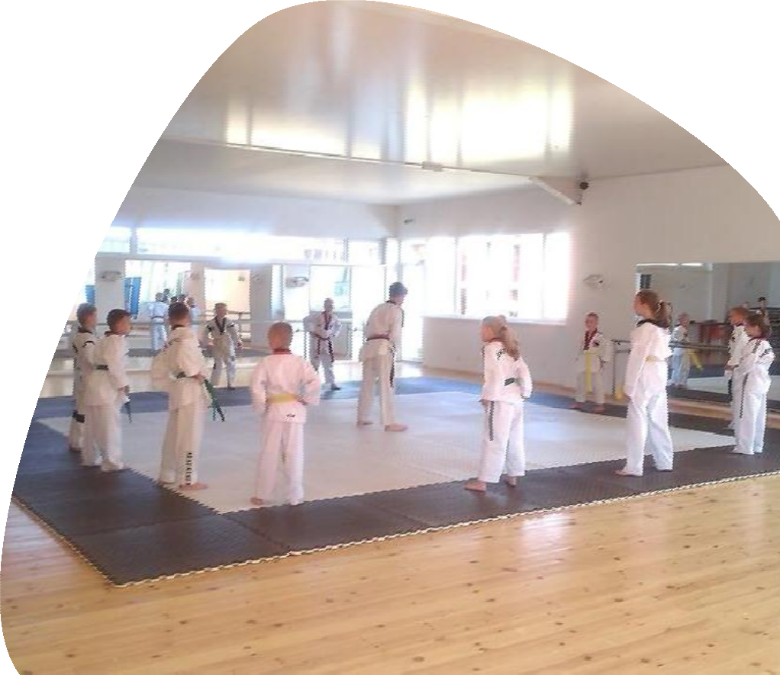

Sport Hall

Sizes: 16 х 13 m, ceiling height 3,2 m

- Description: spacious bright hall, sports parquet, mirrors, a ballet barre

- Capacity: up to 30 people

Equipment: judo tatami (mats 2 х 1 m - 24 pcs, 48 m2), a ballet barre, the punching bag, boxing wall pad, gymnastic carpet

- Sports, activities: boxing, kickboxing, judo and other martial arts, rhythmic gymnastics, modern dances, classical dance styles, Latin dances, fitness programs

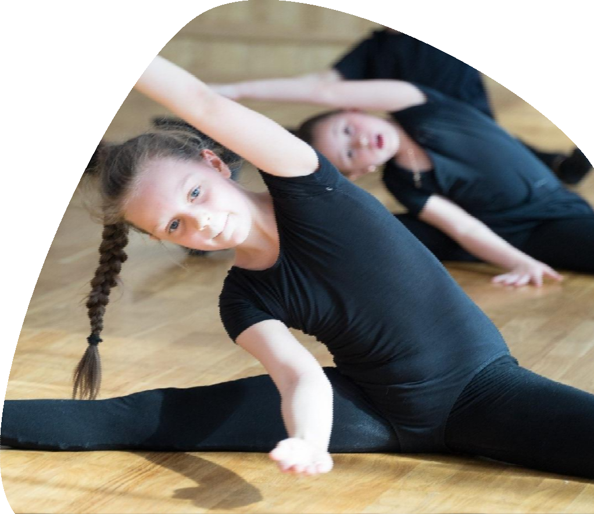
Sport studio

- Sizes: 6 х 6 m, ceiling height 2,4 m

- Description: sports laminate floor, wall with mirrors (mirror wall), air conditioning

- Capacity: up to 8 people

- Equipment: fitness equipment

Sports, activities: individual training and mini- groups in various types of sport, modern dance styles and fitness programs

Gym

Description: sport gym with weight training equipment, free weights, mirror wall and music equipment (there is air conditioning)

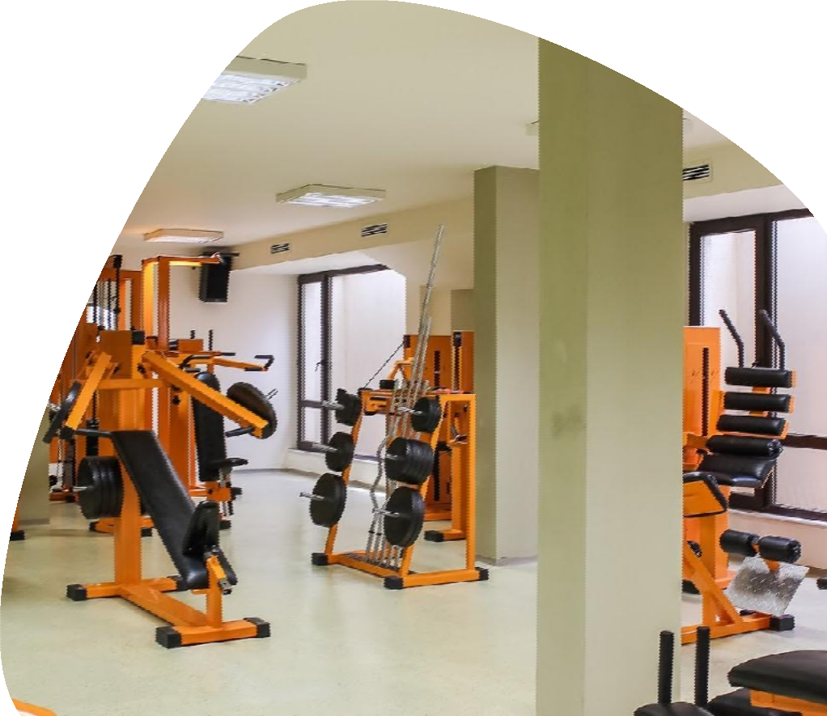Equipment:
- Сardiovascular equipment
- Treadmill DUNLOP Perfomance
– 2 pcs
- Exercise bike (Сycle)
- Elliptical trainer
- Weight training equipment, free weights
- Leg extension machine
- Bending legs lying (the hamstring)
- Leg retraction
- Hyperextension
- Bench for ABS
- ABS trainer (sitting)
- Bench for push-ups standard
- Bench for push-ups universal - 2pcs

- Smith machine
- Biceps trainer (sitting)
- Butterfly trainer
- Chest press trainer
- Chest press trainer inclined
- Shoulder press trainer
- Triceps trainer (sitting)
- Crossover (multifunctional power station)
- Dumbbell range (from 3kg to 28 kg)
- Rack with free weights (1- Olympic barbell 20kg, universal straight barbell 10kg - 2 pcs, curve barbell - 2 pcs, weight plates 260 kg)

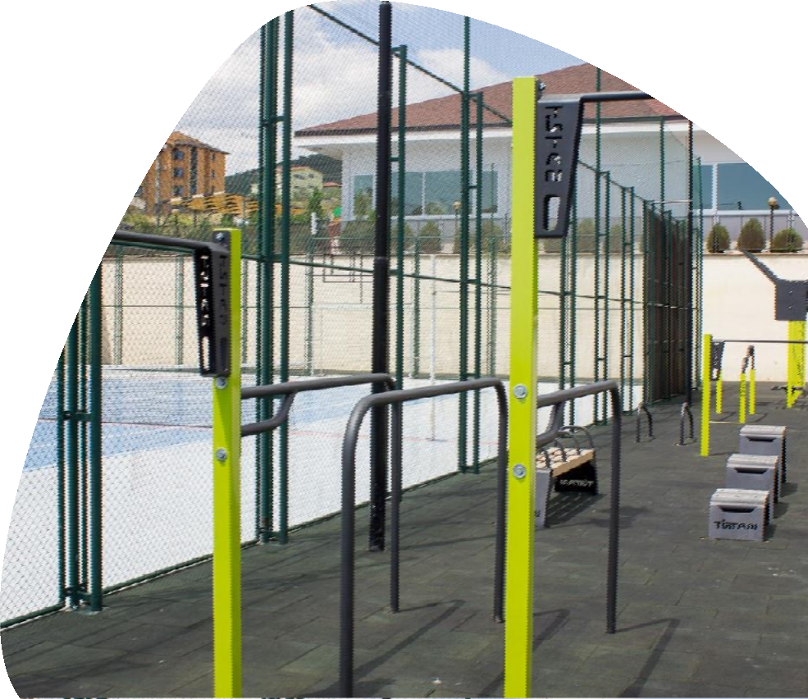

Street Workout

- Capacity: 30 people

Equipment: horizontal bars for chin up of different heights, under a different grip, bars (of different height, wide, narrow, parallel), bollards for jumping, handles, inclined bench for press

Bistro

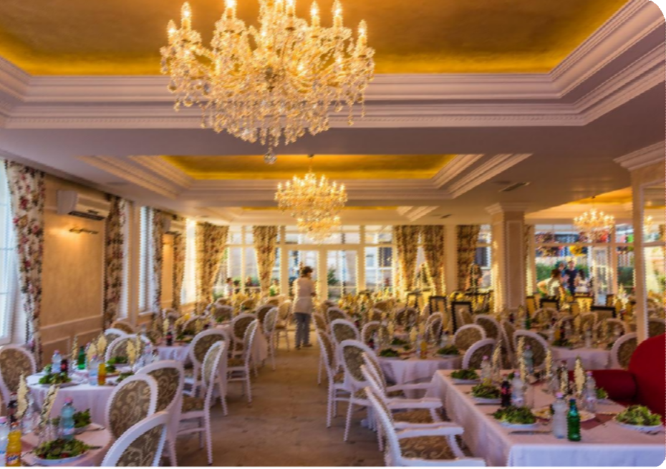Restaurant for athletes, which offers 3 meals in buffet style. Menu is designed by sports nutritionists in accordance with the loads in training time and meets all
requirements for the diet of athletes.

The capacity of the main hall is 100 seats, as well as a
spacious terrace for 60 people.

Everything that is needed in a sports restaurant: a variety of dishes, fresh food, a bright interior - visitors will find in the BISTRO Hotel Macon.

Macon Restaurant

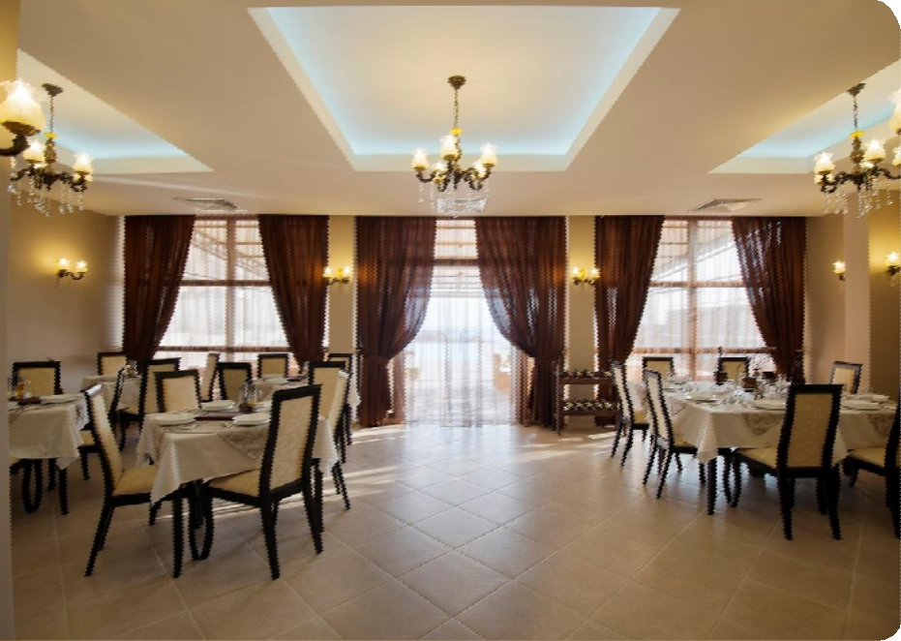Macon Restaurant is located in a separate building Macon Residence and is open for individual tourists.

Keeping up the hotel’s sports traditions, the restaurant offers a menu, which complies with all the rules of healthy eating: vegetables, fresh salads, fish, seafood, fresh juices, and herbal teas. And also provides a special menu for kids.

The bar opens after dinner and work until 1 a.m., where alcoholic and non-alcoholic drinks are offered.

It has a capacity up to 50 places and also has a small terrace
for 40 people.

Sladkarnica

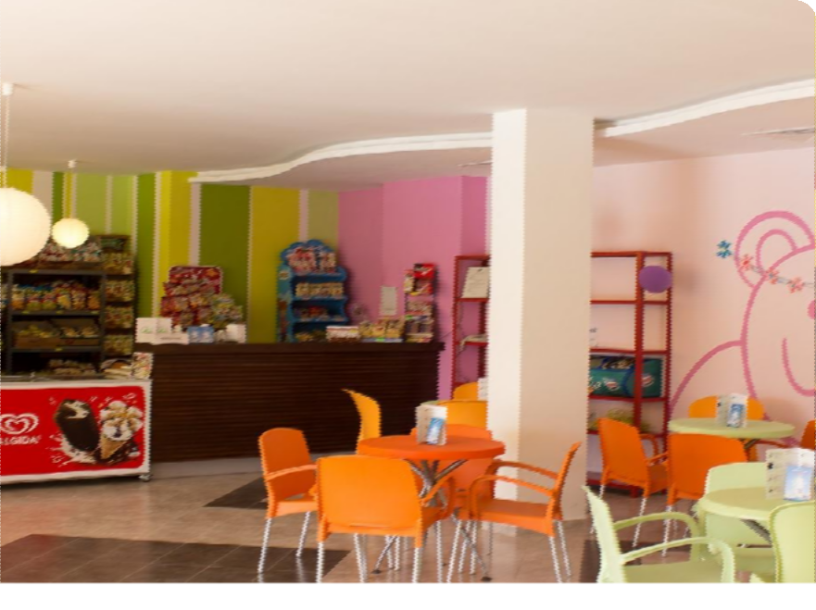Children's cafe Sladkarnica is a paradise for children and others... Adults will also find something to pamper themselves here.

It’s a cozy daytime cafe, where children enjoy their favorite desserts, and adults can drink freshly brewed coffee.

Sweets, fruit salads, ice cream, fresh juices, milkshakes – a paradise for sweet-tooth and the ones who like to treat themselves with tasty things.

Here you can celebrate the Birthday of Your child, if your child have a Birthday during your trip. And also we can organize a tasty snack for kids.

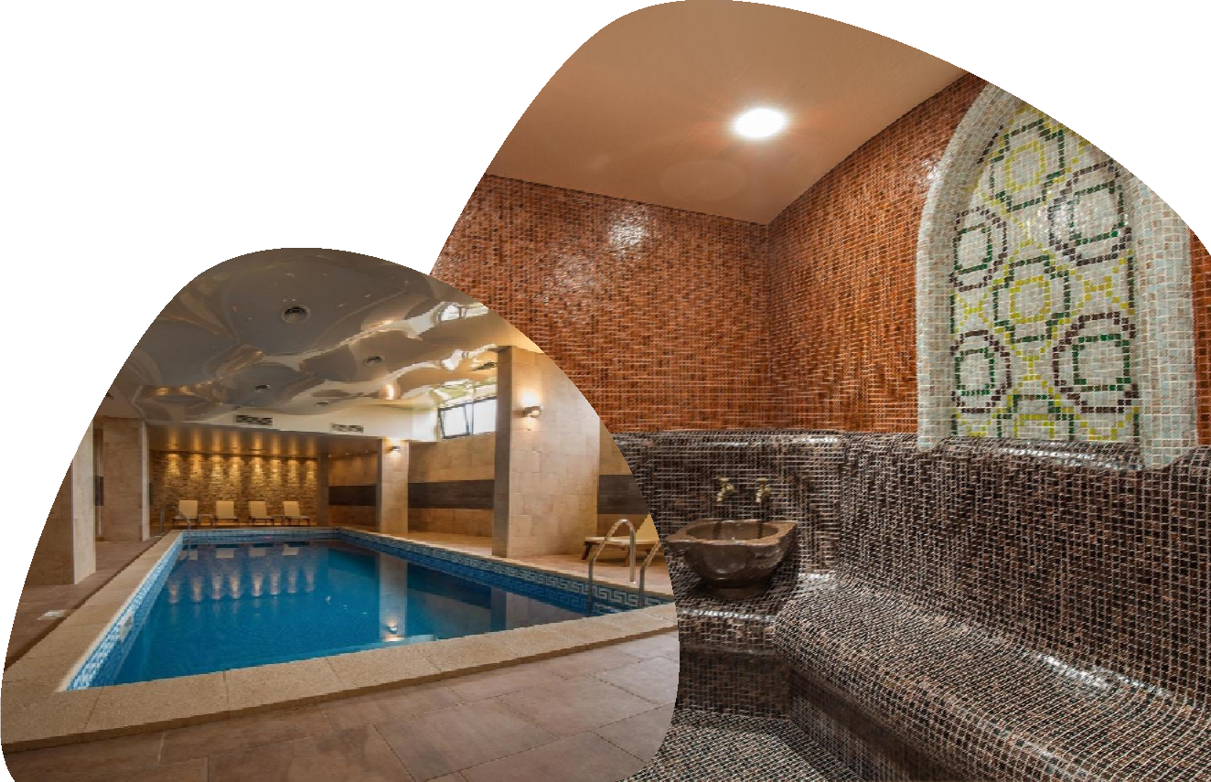

SPA

The correct recovery has a special importance for an effective training process. It allows to relax muscles, to detox the body from the metabolic products, and also balances the emotional state, so that athletes feels satisfaction and a rush of strength after exercise.

Hotel Macon has its own SPA-center that has everything necessary for recovery after a workout.

It includes 2 steam rooms (sauna and Turkish bath), Jacuzzi, swimming pool and massage rooms.

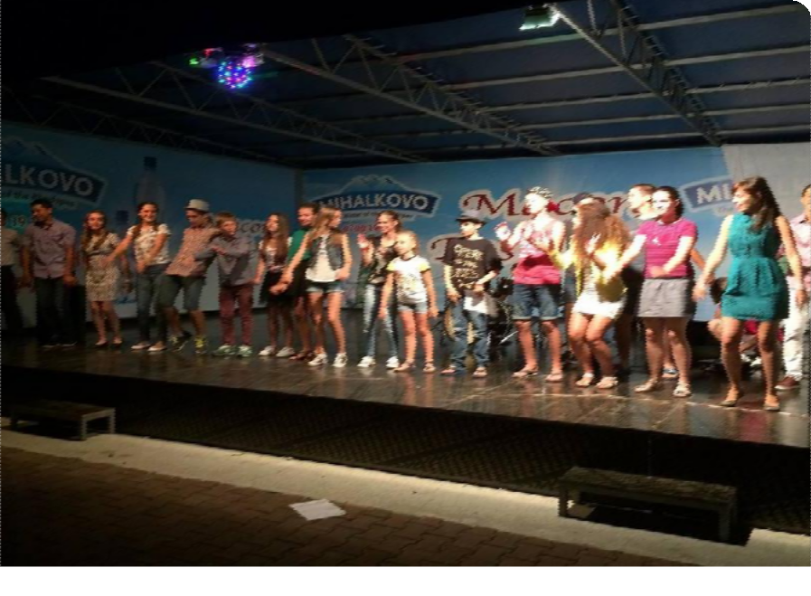Entertainment

The entertainment program at the Macon Hotel - is an explosive mix of various activities, which is organized to children by the hotel creative team.

It is designed to make your stay at our hotel joyfull, interesting and productive time for your child.

Entertainments are chosen for every taste and age:

  - Rich animation, which includes quests, outdoor and intellectual games, theme nights, mini-festivals, campfires

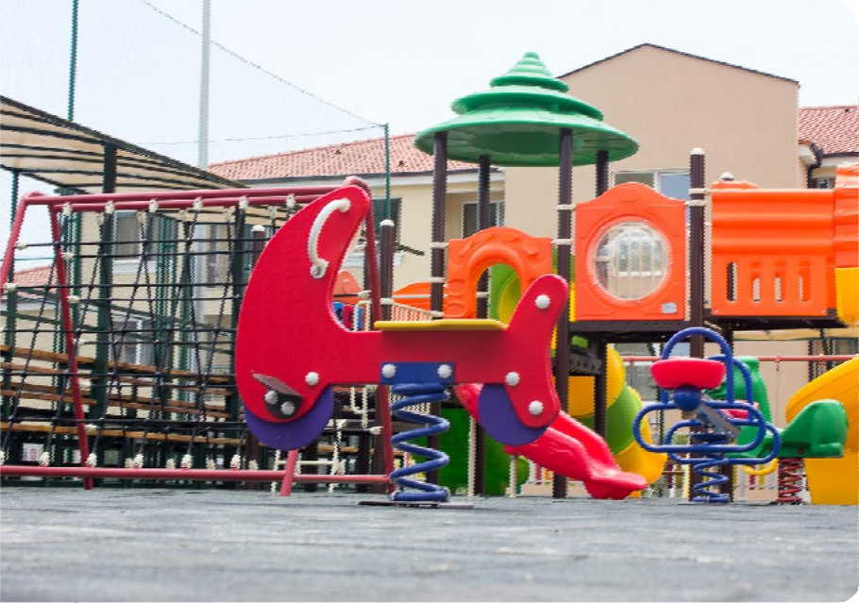Развлечения

  - Kids Club, where are held fascinating master classes in
crafts program, artistic skills, acting and improvisation.

  - Two modern children's playgrounds, which are equipped with a gaming complex. Suitable for children of different ages

  - Evening program on stage: discos, show-mixes, theatrical
performances, dance competitions

