
Apart-complex Cornelia
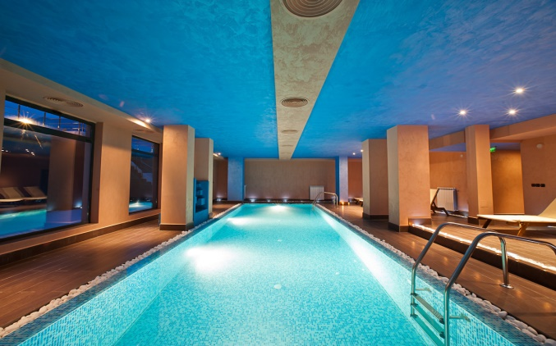
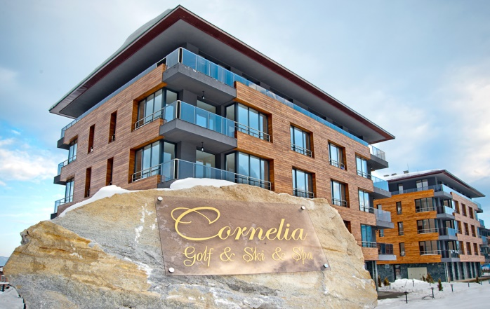

Location
Apartment Complex "Cornelia" is situated in a beautiful area at the foot of the Pirin with a unique view to the Ian Woosnam Golf Course in Razlog. It is 3 km away. from the center of the town of Razlog and 6 km. from the town of Bansko and the ski slopes. It consists of 2 parts - Cornelia Boutique Hotel & SPA and Cornelia Deluxe Residence, each with two buildings.
The complex offers its guests the comfort and privacy of modernly furnished double rooms, studios and apartments. This is a suitable place both for skiing holidays and complete relaxation, as well as for unforgettable summer adventure. The hotel is suitable for families with children, individual tourists and organized groups.
The site offers excellent conditions for organizing various corporate and personal events, organizing seminars and conferences, as well as cocktails, family celebrations, team buildings and other events.
The hotel guests can feel the atmosphere of traditional Bulgarian cuisine in the main restaurant, which is located in the first building of Cornelia Boutique Hotel & SPA, or spend some pleasant hours in the barbecue garden with the complex.
The modern spa center, which is located in Cornelia Boutique Hotel & Spa and is available to the guests of Cornelia Deluxe Residence, offers all the conditions for complete relaxation - indoor heated mineral water pool, dry Finnish sauna, aromatic steam bath, Russian showers, a relaxation area and professional massages.

Hotel amenities

- Restaurant
- Lobby bar
- Garden/ BBQ
- Outdor playground
- Mini football/ volleyball playground /summer-autumn period/
- Conference hall- for 40 pax, screen, multimedia
- Indoor swimming pool with mineral water
- Outdoor sunbeds, tents /summer season/
- Sauna
- Steam bath
- Russian showers
- Relax zone
- Massages /extra/
- Parking
- Free Wi-fi
- Shuttle bus to Gondola in Bansko /winter season/

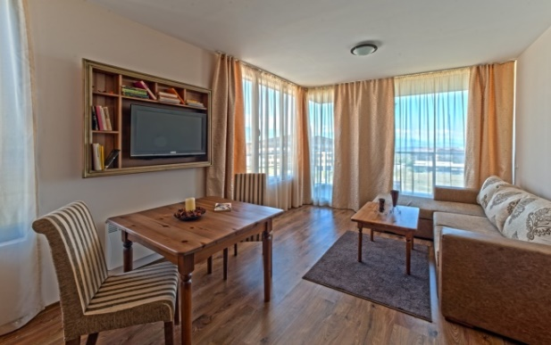
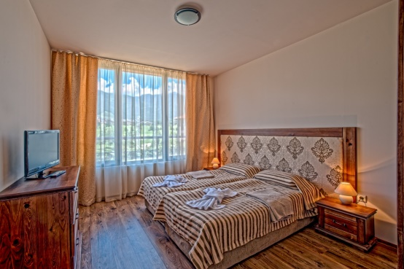
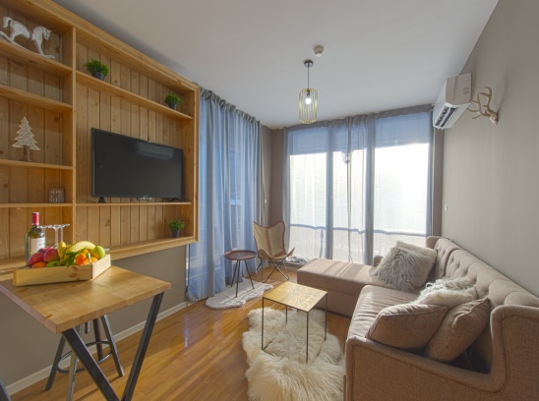
Accommodation
The complex has a total of 60 rooms with an area of ​​ 30 to 90 sq.m, including 10 double rooms, 10 studios, 30 one-bedroom apartments and 10 two-bedroom apartments.
Double Room - located mainly in the new Cornelia Deluxe Residence. It consists of one room with an entire bedroom or 2 bunk beds, a small desk, a bathroom with a toilet. ~ 25 sq. m.
Maximum capacity - 2 + 0 /2 adults /.
Studio - located mainly in Cornelia Boutique Hotel & SPA. It consists of one room with a bedroom and kitchen equipment, a single folding armchair for a child, a bathroom and a toilet. ~ 32-46 sq.m. Maximum capacity - 2 + 1/2 adults + 1 child until 11.99 years old /.
One-bedroom apartment - has two rooms - one bedroom and a living room with a sofa bed and kitchen equipment. Bath and toilet. ~ 56-66 sq.m.
Maximum capacity - 2 + 2 /2 adults and 2 children up to 11.99 years. or 3 adults/.
Family One-Bedroom Apartment - located in the new Cornelia Deluxe Residence. It has two rooms - one bedroom with a double bed or 2 bunk beds and another room with 2 additional single beds that are collected in the bedroom. Bath and toilet. ~ 56-66 sq.m.
Maximum capacity - 2 + 2 /4 adults /.

Two-bedroom apartment - has three rooms - two bedrooms and a living room with a sofa bed and kitchen equipment. Bath and toilet. ~ 86 sq.m.
Maximum capacity - 4 + 2 /4 adults and 2 children up to 11.99 years. or 5 adults/.

Equipment in the apartments

- Cable TV
- Refrigerator /some units/;
- Microwave / some units/;
- Hote plate / some units/;
- Electric kettle;
- Toaster;
- Bath with shower gabbing or bathhub;
- Hair dryer;
- Balcony /some units/;
- Cleaning – every day;
- Changing bed linen – every day

Baby cots- free of charge. Pets are not accepted.
The complex has enough parking spaces/ free parking area and free wireless internet for the guests of the hotel.

*You can find more pictures on following link:
https://www.dropbox.com/sh/qmegamjb8eugk6d/AADUgrmQGkI8xwyX4cJsIJmea?dl=0

* Pictures from Cornelia Dеluxe Residence:
https://www.dropbox.com/sh/99te3cqlmxgej1k/AACLgdo8yUrnXeePKS78uXW1a?dl=0

If you need more information, please do not hesitate to contact us!

