
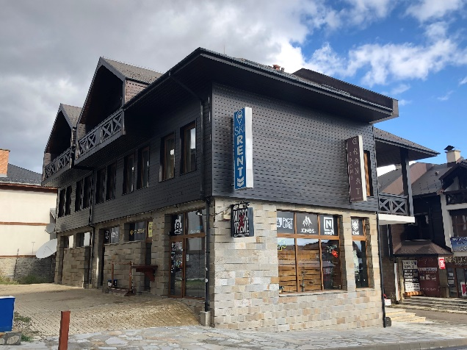

StayInn Granat Apartments is located at the foot of the Pirin Mountains, in the central and most attractive part of Bulgaria's most popular ski resort, Bansko. The property enjoys a prime location right next to the Gondola Lift Station and Kempinski Hotel Grand Arena Bansko, and is within walking distance of the lively restaurants, bars, and entertainment venues along the town's main street.
Its outstanding location is complemented by distinctive architecture, exceptional comfort, warm hospitality, excellent service, and personal attention to every guest.
StayInn Granat Apartments offers comfortable accommodation with beautiful views of either the Pirin Mountains or the centre of Bansko.
Guests can choose from Double Rooms (each with the possibility of an extra bed) and One-Bedroom or Two-Bedroom Apartments.
All accommodation units are fully equipped to ensure maximum comfort and feature central heating, a TV with cable channels, a minibar, an electric kettle, a coffee machine, complimentary high-speed Wi-Fi, and a private bathroom with toiletries.
The Two-Bedroom Apartment consists of two separate bedrooms, each with its own en-suite bathroom, connected by a spacious and comfortable living room with a fully equipped kitchenette for self-catering.
StayInn Granat Apartments offers private on-site parking for its guests.
The property is located close to Bansko's new town centre, where guests will find a wide selection of shops, bars, restaurants, ski equipment rental shops, and bicycle hire services. Airport transfers can also be arranged upon request at an additional charge.
StayInn Granat Apartments is open year-round and is an excellent choice for young travellers looking to enjoy skiing and nightlife, as well as for families with children and couples seeking a relaxing mountain holiday. The property offers everything needed for a comfortable and enjoyable stay.


