Kids Animation | Winter 2019 - 2020
St. Ivan Rilski Hotel & Apartments
Kids animation program (Suitable for children from 4 till 12 years old) - FREE animation activities
HOURS | MONDAY | TUESDAY | WEDNESDAY | THURSDAY | FRIDAY | SATURDAY | SUNDAY
10:00 -12:00 | 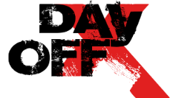 | 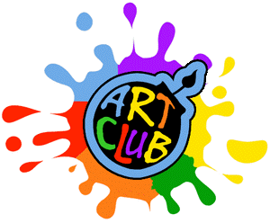 |   Making mask | 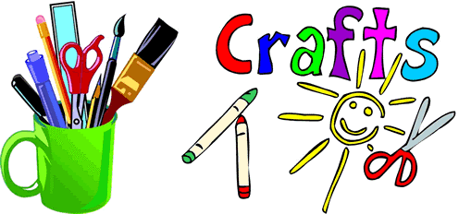 | 3D PAPER  CRAFT
16:00 – 18:00 |  | 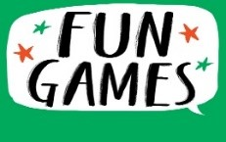 | 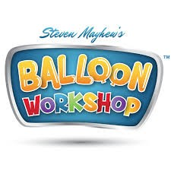 | 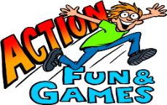 |  | 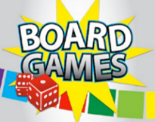
18 :00 –20 :00 |  | Fun  Challenges |  |  |  | Fun  Challenges
20 :00 –21:00 |  | 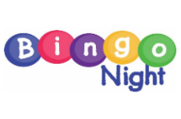 | 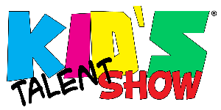 | 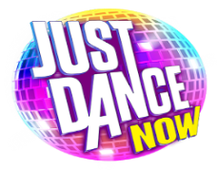 | 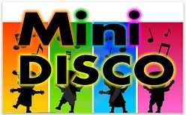 |  | 
21 :00 – 22:00
We offer also (additional charges apply): Coloring figurines, T-shirt painting, Handmade soap, Henna & Glitter tattoos, Face painting, Babysitting and Birthday parties!!!

