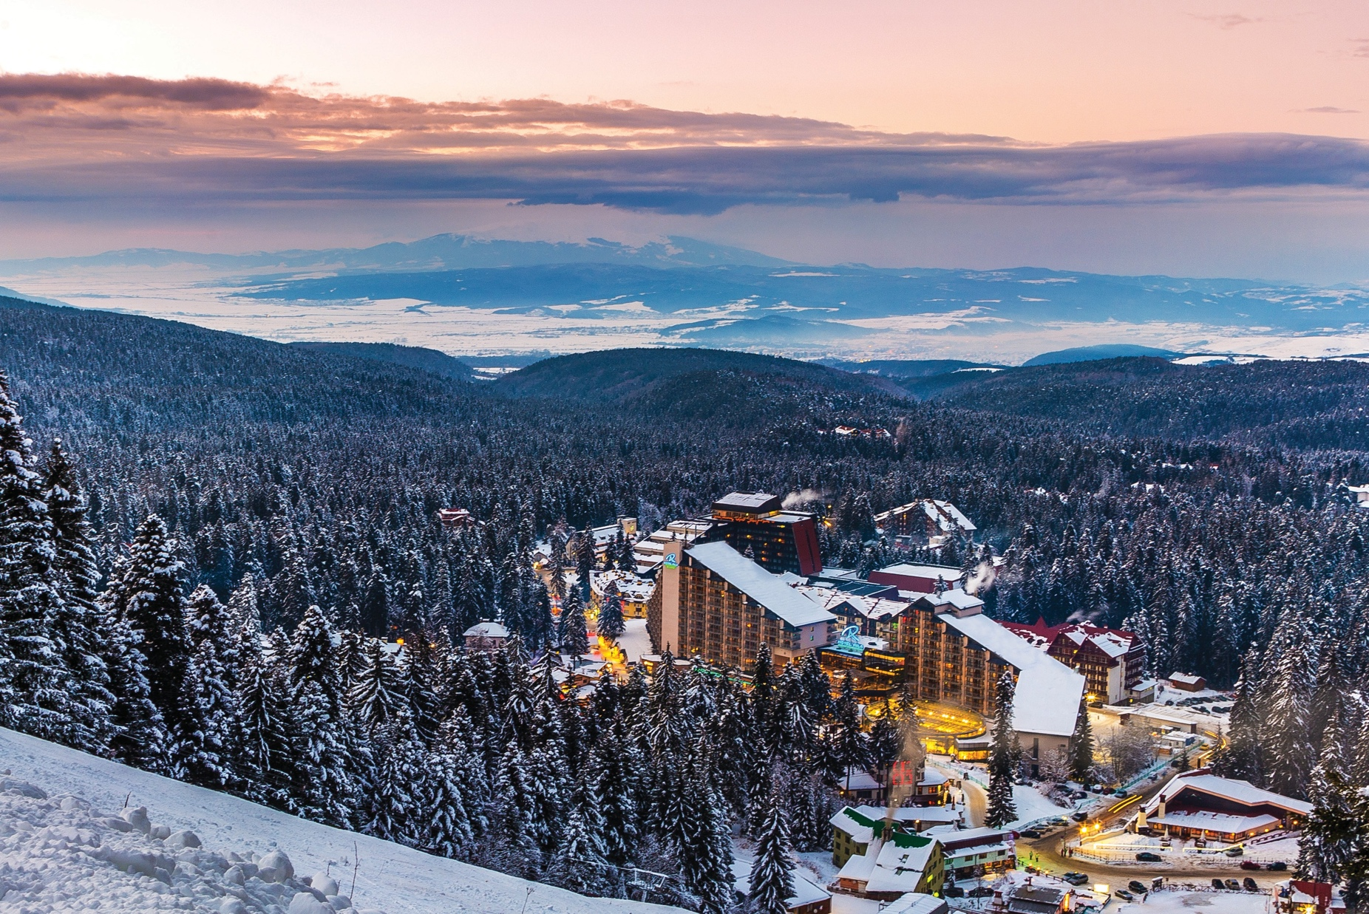

THE NEW FACE OF BOROVETS RESORT

THE RILA HOTEL
Situated at the foot of the ski slopes, the truly ski-in/ski-out Rila Hotel is a symbol of Borovets Resort. The 4*+ hotel was built in 1986 by a French contractor, following the model of the French ski resort - Les Arcs in the Alpine Savoie region. The Rila Hotel is located amidst the breathtakingly beautiful and unspoiled scenery of Rila Mountain, in the heart of Borovets, at an altitude of 1350 meters. After a complete renovation in 2015-19, the Rila welcomes its guests with a brand new look and feel.

LOCATION
Only 70km away from Sofia International Airport (50 min. drive), the hotel is located in the highest Bulgarian mountain range – Rila (2925m), among the stunning ancient pine trees of Borovets Resort. With its 120 years of history, Borovets is the first mountain resort to be established on the Balkan Peninsula, commissioned by the Bulgarian royal family, back in 1896.

ACCOMMODATION
Following a complete renovation of its rooms the Rila Hotel welcomes its guests with the elegant SUPERIOR and SIGNATURE rooms where modern alpine design meets comfort and functionality. The hotel offers:
- 116 double SIGNATURE rooms
- 2 SIGNATURE apartments
- 2 SIGNTURE maisonettes
- 180 SUPERIOR double rooms, of which 38 interconnecting
- 100 SUPERIOR family rooms
- 23 DELUXE apartments
- 5 SUPERIOR maisonettes
- 1 Vice-presidential maisonette
- 1 Presidential maisonette

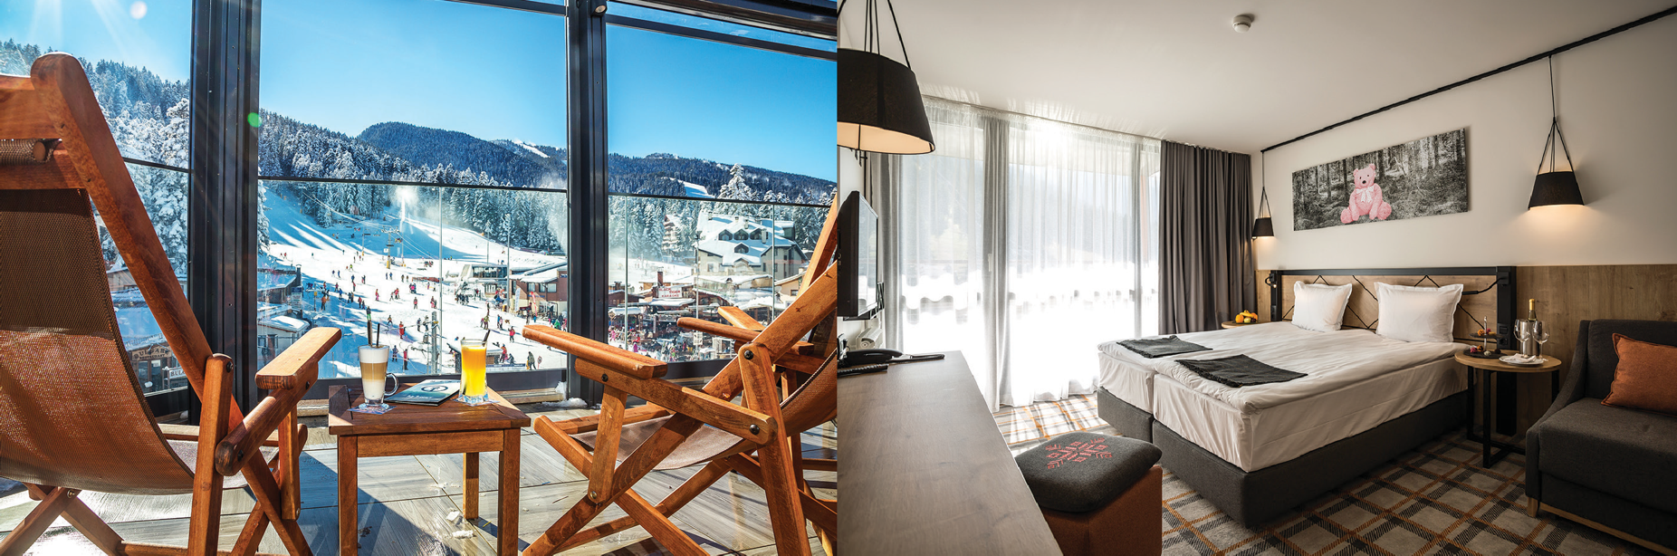
NEW!

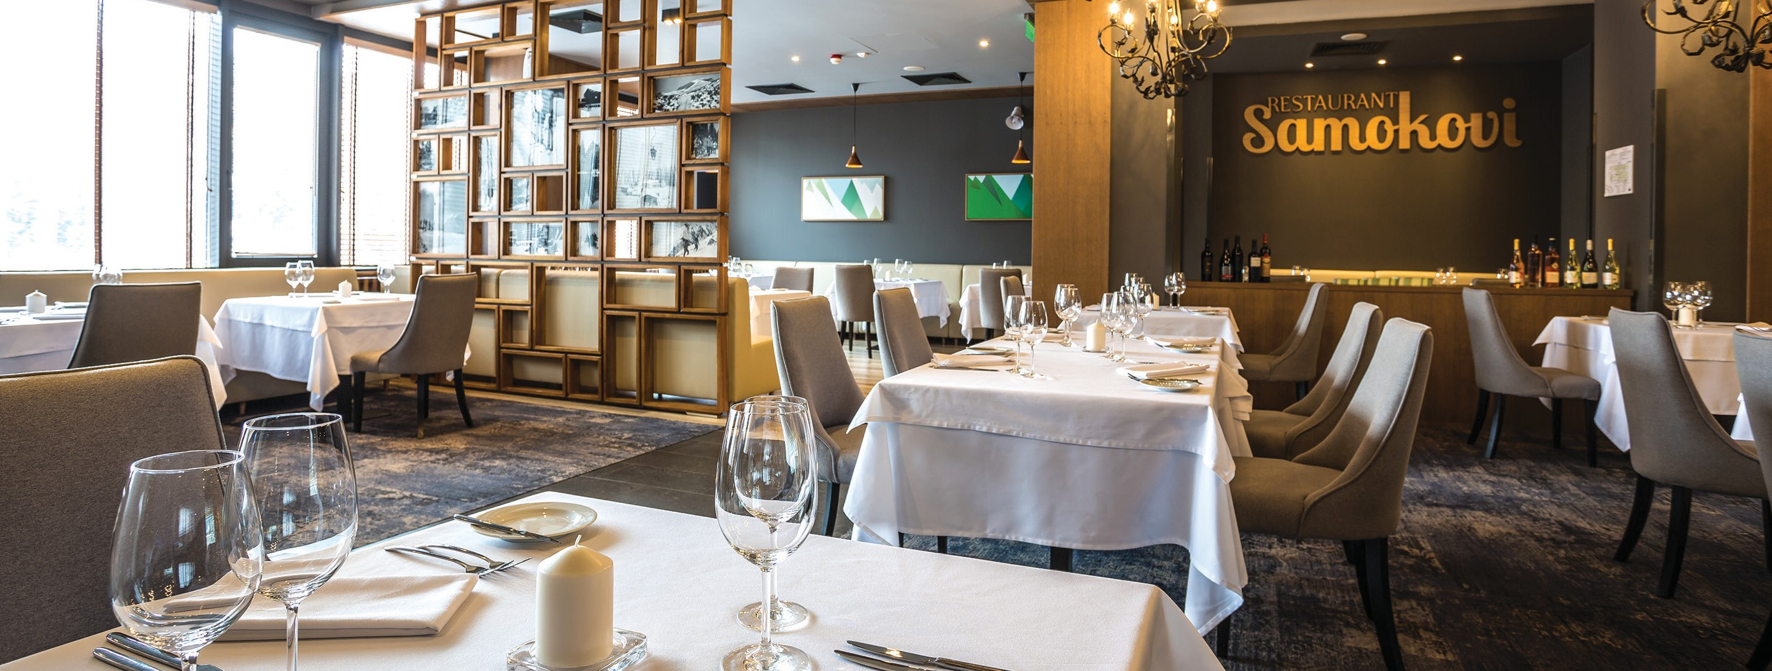
SERVICES AND FACILITIES
  - 24-hour Reception desk
  - Onsite, indoor and outdoor parking
  - Renovated SPA Center
  - 25-meter indoor heated swimming pool and two hot tubs
  - Gym, 4 saunas, steam room, cool room, Turkish bath, and 5 treatment rooms
  - State-of-the-art conference center, accommodating up to 1,300 delegates
  - Games hall “International”
  - Concierge and tour desk
  - Shops and beauty salon
  - Currency exchange desk, ATM
  - Adventure Center Bor osport
  - Ski pass and ski services ticket offices
  - Ski & snowboard rentals & storage depot
  - Kid’s Club and ski kindergarten
  - Room service

RESTAURANTS AND BARS
- Buffet-style restaurant Les Arcs, featuring modern alpine style
- Buffet-style restaurant Seasons, suitable for every season
- A-la-carte restaurant Samokovi, offering tempting local flavors from the Bulgarian and regional cuisine with an innovative twist, prepared by our Executive Chef with seasonal ingredients
- Lobby bar Champions Bar & Diner –
buzzing sports bar and restaurant for champions, right in the heart of the resort
* The Terrace Lounge - the place for après-ski in Borovets, with magnificent view of the slopes, hot cocktails and live party in the afternoon
* Night bar After Eleven offering the best
club music in the resort, variety of guest stars and plenty of good vibes

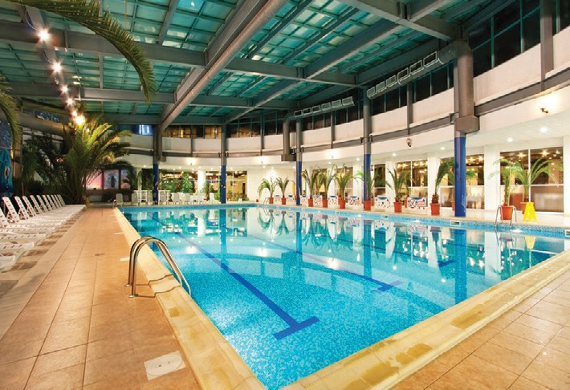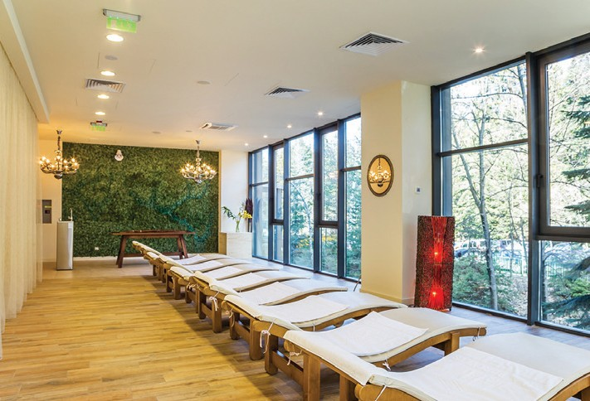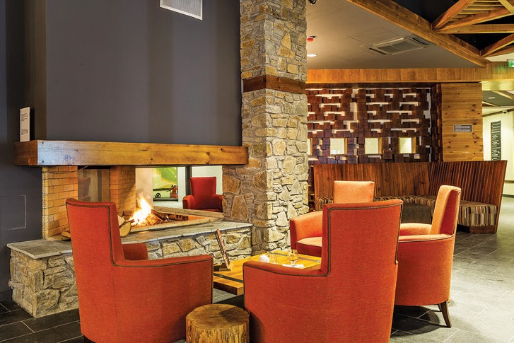

CONFERENCES AND EVENTS
The Rila Hotel conference center is the perfect place for corporate events such as conferences, trainings, workshops, cocktails, Christmas parties, as well as a range of other special events including weddings, graduation parties and birthday celebrations, among many others.
- 9 multifunctional conference halls with capacity from 10 to 700 delegates and total capacity up to 1,300
- Modern AV facilities
- Natural day light
- Personalised catering Ballroom “Rila” with:
- private lobby
- private bar
- terrace with direct access to the parking
- option to be split into two halls

THINGS TO DO
Just 50 m from the lifts, the Rila Hotel is the perfect place for skiing and snowboarding in the winter. Borovets offers:
- 58km ski slopes with 15 lifts
- Freestyle park – Fun Park Borosport
- Kids’ Park Borokids
- Untouched free-ride terrains and ski touring routes
- Borosport ski and snowboard school, with more than 150 professional instructors
During the summer season, Borovets offers:
- Borovets Mountain Bike Park with 7 mountain bike trails
- Half-day and full-day hiking tours
- Excursions to cultural and historic sites
- Rock climbing and alpinism
- Horse riding
- Rope town and Kid’s Park Borolandia
- Paragliding and much more

THE RILA HOTEL, BOROVETS 2010, BULGARIA +359 750 900 05 | rila@rilaborovets.com | www.rilaborovets.com

ROOM SPECIFICATIONS:
Beds and information  SIGNATURE Twin room: 2 twin beds; 1 extra bed (chair bed); minibar; bathroom with shower and hairdryer;  SUPERIOR Twin or King room: 2 Twin beds or 1 King bed, 1 single sofa; minibar; bathroom with shower and hairdryer; bed type is upon request and availability;  SUPERIOR Family room  1 King bed, 1 single sofa and 1 extra bed; minibar; bathroom with shower and hairdryer;  DELUXE Suite: 1 living room and 1 bedroom; living room: L-shaped sofa (not extendable); bedroom: 1 King bed, 1 sofa (in some units); minibar; bathroom with shower and hairdryer;  All rooms and suites have balconies overlooking the mountains or the pine tree forest, flat screen TV and telephone. The twin beds of Superior rooms can be pushed together or be separated. Safe deposit boxes available at Reception (extra charge). | Occupancy  Max: 2 adults and 1 child up to 11.99 years; accommodation of 3 adults not possible;  Max: 2 adults and 1 child up to 11.99 years; accommodation of 3 adults not possible;  Min. occupancy 1 adult and 3 children up to 11.99 years;  Max. occupancy: 2 adults and 2 children up to 11.99 years; accommodation of 3 adults not possible;  Max: 3 adults and 1 child up to 11.99 years;  Minibars are stocked upon request.

---------------------------------------------------------------------------------------------------------------------------------------------------------------------------------------
THE RILA HOTEL, BOROVETS 2010, BULGARIA +359 750 900 05 | rila@rilaborovets.com | www.rilaborovets.com

