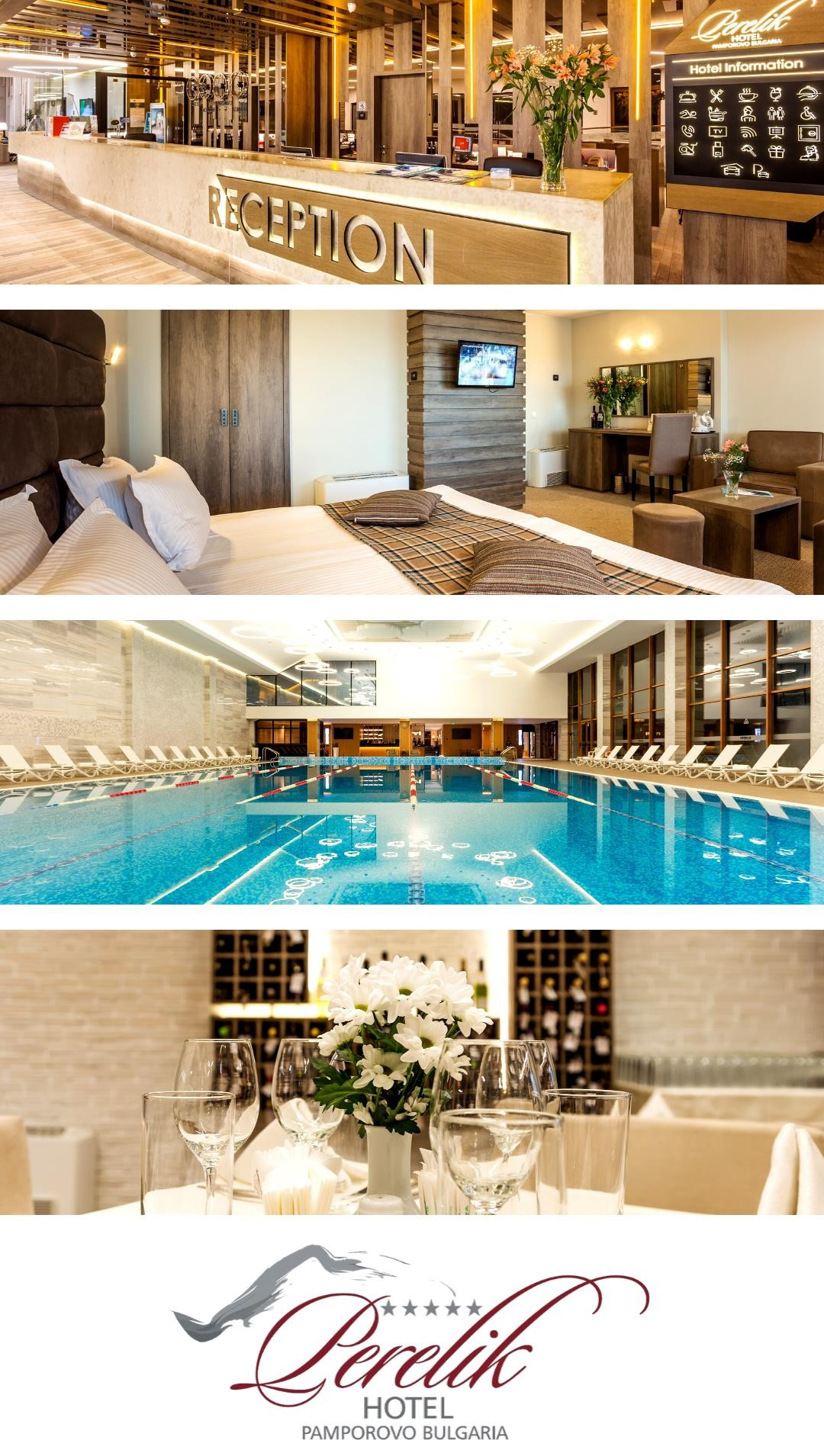

Description and services

The emblematic hotel complex Perelik 5* is situated in the central part of Pamporovo resort and is opposite Orlovetz hotel and at a distance with a quick access to the ski area. Its design follows a new modern trends which combines contemporary interior concepts in line with the beautiful Rhodopes, creates a feeling of calm and coziness.

During the winter season Perelik 5* hotel offers a free bus shuttle to the ski centre zone for its guests. In summer you can pick out from a variety of outdoor activities in the mountains and a brand new Adventure park “Yazovira”.

The hotel consist of 130 spacious and comfortable rooms in elegant design distributed as it follows:
- 92 junior suits with the possibility of extendable sofa bed, suitable for accommodation of: 2+2 (children)/ 2+1 (adult)
- 18 double junior suits, suitable for accommodation of 2 (adults)
- 9 one-bedroom apartments: 2+2 (adults)
- 11 two-bedroom apartments: 4+2 (adults)

All rooms and apartments are equipped with LCD TVs with a special selection of 60 channels in different languages. Five of them transmit a live stream connection from Pamporovo Mechi- Chal ski area.

Rooms and apartments facilities:
- LCD TV (60 channels)
- Mini bar
- Hot drinks amenities

- Hot water cattle
- Telephone
- Shower bath/bathroom with a shower
- Bathrobes and towels
- Cosmetic set
- Hair dryer
- Room services
- Safety deposit box

You can enjoy our special wine selection “Libera” from the famous Melnik region.

Additional hotel amenities:

- Storage for personal ski/snowboard equipment

- Scheduled transport to ski area Pamporovo – Mechi Chal

- Library reading corner

- Bank office and ATM

- Currency exchange

- Guest relations

- Connection with hotel Orlovetz 5*

- Free parking

- Garage (paid service)

- 24-hour security

- Kids room with animators – 15 BGN per child per day; small children up to 3 years old – only with a parent.

Restaurant

The largest restaurant located in Pamporovo has capacity of 400 seats and is suitable for special occasions such as festive dinners, cocktails, weddings, business meetings and other events.
One of the best advantages is its proximity to the brand new Pamporovo Convention Center.

Lobby bar

The lobby bar in Perelik hotel has a panoramic mountain view and is located close to the reception of Perelik hotel. The hotel lobby is elegantly transformed into a cosy corner with a rich library.

Body & Soul Spa Lounge

The newest spa centre in Pamporovo resort is located on three levels with total area of 2500 m². Body & Soul Spa Lounge combines sophisticated design, innovative technologies and a blissful atmosphere – not just a vacation, but a place to recharge and connect with nature.

Additional services

- Pamporovo Convention Centre
- Soccer field
- Tennis court
- Table tennis
- Lift tickets office
- Bowling bar

BODY & SOUL SPA LOUNGE

Body & Soul Spa Lounge is a truly special place – source of the healing power of the mountain.
The guests of Body & Soul Spa Lounge are able to use а semi-Olympic swimming pool, rasul bath, steam bath, herbal steam bath, infrared sauna, cedar sauna, herbal sauna, sauna steam room, finish sauna, jacuzzi, ice room, tropical showers and salt room.
The specially selected spa menu offers a wide range of personal procedures, beauty treatments and massages for achieving an overall wellness.

Level 1

Swimming pool and Nutrition Bar

The semi-Olympic-size pool (25m х 12m) in Perelik hotel is the largest one on the territory of Pamporovo resort (with 5 swimming halls). It is situated on the 1st level and has a temperature of 27 degrees throughout the whole season. The brand new Nutrition Bar for refreshing drinks and smoothies is in close proximity.

Turkish bath (Hammam)

The Turkish bath is a room with high humidity (50-70%) and a temperature of about 45 degrees. The heated benches have built-in special trays, which are filled with fresh water for body cooling. This process prepares the body for an exotic massage which takes place on a heated massage bed. Hammam’s visit improves blood circulations, helps with curing the insomnia and tones the skin.

Aroma steam bath

The moderate heat in the aroma steam bath in a combination with the specially selected aromas helps for skin care and regeneration. The blood circulation and cell structure are also improved.

Ice room

The perfect way to cool your body after a stay in the sauna is in this room with minus temperature. The ice room has beneficial effects on the body such as stimulating the blood pressure, toning and energizing the body.

Aroma herbal bath

The pleasant combination of aroma valuable herbs and flowers prepares the body for ultimate relaxation and purification. After a stay in the aroma herbal bath the body is detoxified from all accumulated harmful substances.

Infrared sauna

Infrared heat has the ability to penetrate gently through the skin and gives many health benefits to the body. The infrared salt sauna releases negatively charged ions, which purify the circulating air and help releasing the stress.

Cedar sauna

The combination of herb-saturated steam, served in a cabin of cedar, has many beneficial effects on the whole body. Thanks to the ecologically clean mountain cedar in the system the body's resistance is stimulated. The cedar sauna helps relieving the stress, stimulates vitality and has beneficial effects in the fight against extra weight.

Herbal sauna

The herbal sauna combines all the benefits of herbs, grasses and coniferous twigs. Unlike other rooms of this type, the herbal sauna injects herbal aromas that help for ultimate relaxation. The sauna creates the ideal bio climate, helping to slowly warm the body, which creates a beneficial effect on the circulatory system, as well as a detoxifying effect on the whole body.

Sauna steam room

After your stay at the sauna steam room the blood circulation is improved, as well as the recovery of the body in a whole new level. The skin is toned and purified. The beneficial effect of the procedure is being felt right now - you are relaxed and fresh.

Adventure shower

The perfect option after all the hot procedures at the Spa centre is a relaxing contrast stay in the adventure shower. Тhe various water jets from a thick cool fog to a tropical rain in huge drops affect both the emotional and the physical levels. The control in the room is carried out by an electronic module, who takes care of achieving a relaxing, emotional impact on the whole body.

Relax area with wooden baths

This area is the ideal place for rest and ultimate relaxation between the various treatments in the Spa centre, as well as a suitable for privacy corner. We recommend using the relax area with wooden baths after visiting the steam bath or sauna, as well as before starting the other procedures. The area has comfortable sunbeds, relaxing music and dimmed lights, which contribute to excellent relaxation and comfort.

Level 2

Fitness

The perfect place for an energetic workout with high-end Technogym equipment. It naturally complements the services offered in the SPA centre to achieve complete recovery and maintain optimal shape.

Finnish sauna

The Finnish sauna is a room with a high temperature of 90-110 degrees and humidity about
15%. It is equipped with heated volcanic stones which create steam in the room.

Relax Lounge

The ideal place for a retreat, recharge and ultimate relaxation. You can enjoy a beautiful view, a nice book and a detox drink from the Nutrition bar.

Massages

The wide range of massages are fully tailored to the individual needs of each client. This is the ideal place to clear your mind and feed your soul with positive energy.

Cosmetic and beauty treatments

The Spa centres offers cosmetic and beauty treatments for face and body. The customised, according to the individual needs of each client treatments, are accomplished with the luxury professional French cosmetics Anne Semonin. Anne Semonin's cosmetic collection of therapies combines aromatic essential oils, micro elements and sea ingredients with a fine French technique and a holistic approach in treating your individual needs. Each of Anne Semonin's therapies is adapted and personalized to the specific needs of your skin. The result is revitalized and renewed skin, ultimate relaxation and body comfort that energizes and balances the mind and spirit.

Level 3

Rasul bath

The pleasantly heated room with low humidity predisposes to the following healthy procedures: application of healing mud, herbal extracts and other cosmetic products on the skin. This supplementary health ritual helps to effectively remove toxins and detoxifies the body.

Salt room (Halotherapy)

A stay in the salt room has a calming and therapeutic effect on the body. Inhalation of vapors detoxificates, improves breathing, has a beneficial effect on dermatological problems, improve sleep quality and strengthen the body as a whole.

Horizontal showers

Similar to summer rain, the horizontal shower has a relaxing and calming effect, strengthens blood circulation and produce a sense of calm and well-being.

VIP Jacuzzi (service for two)

A genuine experience for two in a calm and secluded atmosphere in the company of fresh fruits, special wine selection and high-end Trussardi cosmetic set for hair and body. Request this additional service at the SPA reception.

PAMPOROVO CONVENTION CENTER

A space for new ideas

Pamporovo Convention Center is a contemporary new generation conference space based on 2 700 m². It is a well-planned and fully-equipped with the latest technology complex of 5 halls with different seating capacity, coming altogether to 1200 seats. The largest multi-functional hall ‘’Rodopi”, remarkable for the resort assembly hall, has seating capacity of 750 and can be split in 2 separate halls, 600 and 150 seats each. The other 4 halls are located next to the main one and have 50 to 90 seating capacity each.

The conference block halls are close to the main and the largest restaurant in the resort based in Perelik 5* hotel. The convention center is in a separate building wing, has its own entrance and is connected to the five-star Orlovetz hotel throughout a heated underground corridor. There are 2 underground garages below the halls and parking outside. The complex is accessible for persons with disabilities.

Pamporovo Convention Center features:

- Total seating capacity of 1100

- Contemporary design and fully-equipped with the latest technical sound and equipment

- Digital and interactive screens for your business

- Air conditioning and ventilation system

- In a close distance to the restaurant of Perelik 5* hotel (with capacity up to 400 seats)

- Underground heated corridor to Orlovetz 5* hotel

- Separated from the hotel guests’ areas

- Wardrobe

- 24-hour video surveillance
- A high-speed Wi-Fi connection
- Convenient logistic

